

**University of Jordan**

**Electrical engineering department**

Antenna and wave propagation

Project: Multiband and Wideband Microstrip Antenna May 2024

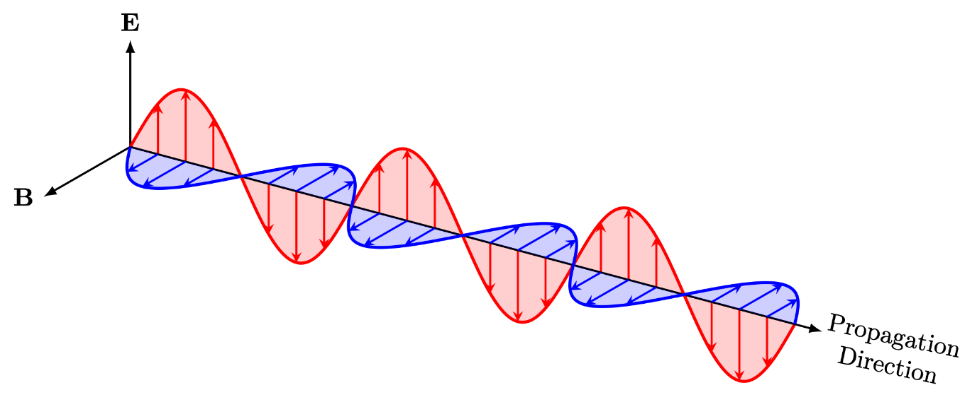

Instructor: Yanal AL Faouri

Student 1: Mohammad Ayman Al mardeni

Student 2: Ahmed Rafat Abu Siam

**Table of figures**

Figure ‎3.1. Top & Side & Bottom view of antenna 12

Figure ‎3.2. Effect of some selected parameters (a) Effect of SRR Height (z) on the Monopole Antenna design (b) Diameter (m) on the Monopole Antenna design 12

Figure ‎3.3. Fabricated proposed Monopole Antenna with Circular SRR (a) top plane (b) bottom plane 12

Figure ‎3.4. Simulated and measured S11 of Monopole 12

Figure ‎3.5. Simulated Surface Current Distribution of the Monopole Antenna with Circular SRR 13

Figure ‎3.6. Simulated and measured radiation patterns of the proposed monopole antenna with Circular SRR: E-plane (a) 2.09 GHz (c) 3.5 GHz (e) 4.9 GHz (g) 5.58 GHz; H-plane (b) 2.09 GHz (d) 3.5 GHz (f) 4.90 GHz (h) 5.58 GHz 13

Figure ‎3.7. The original shape with SRR 14

Figure ‎3.8. The original shape without SRR 14

Figure ‎3.9. Bottom view of current distribution at 2.75GHz 14

Figure ‎3.10. Bottom view of current distribution at 4.225GHz 14

Figure ‎3.11. Top view of current distribution at 5.925GHz 14

Figure ‎3.12. Top view of current distribution at 5.925GHz 14

Figure ‎3.13. Top view of current distribution at 4.225GHz 14

Figure ‎3.14. Top view of current distribution at 2.75GHz 14

Figure ‎3.15. S11 parameter where m=16, m=19, m=20, m=21, m=22, m=23 15

Figure ‎3.16. S11 parameter where q=2, q=3, q=4, q=5 15

Figure ‎3.17. Top view of current distribution at 2.75GHz 16

Figure ‎3.18. Bottom view of current distribution at 2.75GHz 16

Figure ‎3.19. Top view of current distribution at 4.225GHz 16

Figure ‎3.20. Bottom view of current distribution at 4.225GHz 16

Figure ‎3.21. Top view of current distribution at 5.925GHz 16

Figure ‎3.22. Top view of current distribution at 5.925GHz 16

Figure ‎3.23. Electric field & Magnetic field at 2.75GHz 17

Figure ‎3.24. Electric field & Magnetic field at 4.225GHz 17

Figure ‎3.25. Figure 17. Electric field & Magnetic field at 5.925GHz 17

Figure ‎3.26. Reflection loss from each design iteration in [3]. 18

Figure ‎3.27. Structure of Antenna in [3] 19

Figure ‎3.28. Approximation of the circular radiator radius in [3] 20

Figure ‎3.29 21

Figure ‎3.30. Step by Step structure in HFSS 22

Figure ‎3.31 23

Figure ‎3.32 23

Figure ‎3.33 24

Figure ‎3.34. The effect of changing the Ls done by paper in [3]. 24

Figure ‎3.35. The effect of Xg as seen by [3]. 25

Figure ‎3.36. The effect of Yg done by paper [3]. 25

Figure ‎3.37. Simulated effect of Ls. Ls=3mm can be considered the optimal but in general no significant effect. 26

Figure ‎3.38. The effect of Xg in HFSS seen whereas Xg increase, the resonance frequency shifts to higher value. 26

Figure ‎3.39. Effect of changing Yg. 26

Figure ‎3.40 27

Figure ‎3.41 28

Figure ‎3.42 30

Figure ‎3.43 Proposed antenna in [3] gain and efficiency results 30

Figure ‎3.44 Replicated antenna gain and efficiency. 31

Figure ‎4.1. Bottom view of proposed antenna 32

Figure ‎4.2. Top view of proposed antenna 32

Figure ‎4.3. Bottom view of antenna No:1 33

Figure ‎4.4. Top view of antenna No:1 33

Figure ‎4.5. S11 of antenna No:1 34

Figure ‎4.6. Top view of antenna No:2 34

Figure ‎4.7. Bottom view of antenna No:2 34

Figure ‎4.8. S11 of antenna No:2 35

Figure ‎4.9. Bottom view of antenna No:3 35

Figure ‎4.10. Top view of antenna No:3 35

Figure ‎4.11. S11 of antenna No:3 36

Figure ‎4.12. Top view of antenna No:4 36

Figure ‎4.13. Top view of antenna No:4 36

Figure ‎4.14. S11 of antenna No:4 37

Figure ‎4.15. Top view of antenna No:5 37

Figure ‎4.16. Top view of antenna No:5 37

Figure ‎4.17. S11 of antenna No:5 38

Figure ‎4.18. lg=2, lg=3, lg=4, lg=5, lg=6 39

Figure ‎4.19. lg=7, lg=8, lg=9, lg=10, lg=11 39

Figure ‎4.20. lg=7.5, lg=7.6, lg=7.7, lg=7.8, lg=7.9 40

Figure ‎4.21. lg=8.1, lg=8.2, lg=8.3, lg=8.4, lg=8.5 40

Figure ‎4.22. U=0.1, U=0.2, U=0.3, U=0.4, U=0.5 41

Figure ‎4.23. U=0.6, U=0.7, U=0.8, U=0.9, U=1 41

Figure ‎4.24. U=0.25, U=0.5, U=0.75, U=1 42

Figure ‎4.25. U1=0.1, U1=0.2, U1=0.3, U1=0.4, U1=0.5 42

Figure ‎4.26. U1=0.6, U1=0.7, U1=0.8, U1=0.9, U1=1 43

Figure ‎4.27. U1=0.25, U1=0.5, U1=0.75, U1=1 43

Figure ‎4.28. U2=0.1, U2=0.2, U2=0.3, U2=0.4, U2=0.5 44

Figure ‎4.29. U2=0.6, U2=0.7, U2=0.8, U2=0.9, U2=1 44

Figure ‎4.30. U1=0.25, U1=0.5, U1=0.75, U1=1 45

Figure ‎4.31. lu=2, lu=3, lu=4, lu=5 45

Figure ‎4.32. lu=3.5, lu=3.6, lu=3.7, lu=3.8, lu=3.9 46

Figure ‎4.33. lu=4.1, lu=4.2, lu=4.3, lu=4.4, lu=4.5 46

Figure ‎4.34. lu1=2, lu1=3, lu1=4, lu1=5 47

Figure ‎4.35. lu1=3.5, lu1=3.6, lu1=3.7, lu1=3.8, lu1=3.9 47

Figure ‎4.36. lu1=4.1, lu1=4.2, lu1=4.3, lu1=4.4, lu1=4.5 48

Figure ‎4.37. lu2=2, lu2=3, lu2=4, lu2=5 48

Figure ‎4.38. lu2=4.5, lu2=4.6, lu4.7=4, lu2=4.8, lu2=4.9 49

Figure ‎4.39. ls=15, ls=16, ls=17, ls=18, ls=19 49

Figure ‎4.40. ls=20, ls=21, ls=22, ls=23, ls=24 50

Figure ‎4.41. ls=17.5, ls=17.6, ls=17.7, ls=17.8, ls=17.9 50

Figure ‎4.42. ls=18.1, ls=18.2, ls=18.3, ls=18.4, ls=18.5 51

Figure ‎4.43. ws=0.1, ws=0.2, ws=0.3, ws=0.4, ws=0.5 51

Figure ‎4.44. ws=0.6, ws=0.7, ws=0.8, ws=0.9, ws=1 52

Figure ‎4.45. wf=1, wf=2, wf=3, wf=4 52

Figure ‎4.46. wf=2.5, wf=2.6, wf=2.7, wf=2.8, wf=2.9 53

Figure ‎4.47. wf=3.1, wf=3.2, wf=3.3, wf=3.4, wf=3.5 53

Figure ‎4.48. wss=3, wss=4, wss=5, wss=6, wss=7 54

Figure ‎4.49. wss=5.1 wss=5.2, wss=5.3, wss=5.4, wss=5.5 54

Figure ‎4.50. wss=5.6, wss=5.7, wss=5.8, wss=5.9 55

Figure ‎4.51. lf=1, lf=2, lf=3, lf=4, lf=5 55

Figure ‎4.52. lf=6, lf=7, lf=8, lf=9, lf=10 56

Figure ‎4.53. lf=11, lf=12 56

Figure ‎4.54. lf=9.5, lf=9.6, lf=9.7, lf=9.8, lf=9.9 57

Figure ‎4.55. lf=10.1, lf=10.2, lf=10.3, lf=10.4, lf=10.5 57

Figure ‎4.56. gg=0.1, gg=0.2, gg=0.3, gg=0.4, gg=0.5 58

Figure ‎4.57. gg=0.6, gg=0.7, gg=0.8, gg=0.9, gg=1 58

Figure ‎4.58. G=8, G=8.5, G=9, G=9.5, G=10 59

Figure ‎4.59. G=8.1, G=8.2, G=8.3, G=8.4, G=8.5 59

Figure ‎4.60. G=8.6, G=8.7, G=8.8, G=8.9 60

Figure ‎4.61. g1=2, g1=3, g1=4, g1=5 60

Figure ‎4.62. g1=6, g1=7, g1=8, g1=9, g1=10 61

Figure ‎4.63. g1=5.1, g1=5.2, g1=5.3, g1=5.4, g1=5.5 61

Figure ‎4.64. g1=5.6, g1=5.7, g1=5.8, g1=5.9 62

Figure ‎4.65. W=20, W=25, W=30, W=35, W=40 62

Figure ‎4.66. L=20, L=25, L=30, L=35, L=40 63

Figure ‎4.67. Final result of S11 64

Figure ‎4.68. Final result of Peak Realized Gain 64

Figure ‎4.69. Final result of Radiation Efficiency 65

Figure ‎4.70. Final result of Axial Ratio 65

Figure ‎4.71. Final result of voltage standing wave ratio VSWR 66

Figure ‎4.72. Final result of Z parameter 66

Figure ‎4.73Magnitude of current distribution Top view at 3.34GHz 67

Figure ‎4.74Magnitude of current distribution Bottom view at 3.34GHz 67

Figure ‎4.75Magnitude of current distribution Bottom view at 4.045GHz 67

Figure ‎4.76Magnitude of current distribution Top view at 4.045GHz 67

Figure ‎4.77. Magnitude of current distribution Bottom view at 6.145GHz 67

Figure ‎4.78Magnitude of current distribution Top view at 6.145GHz 67

Figure ‎4.79. Final result of radiation patterned at frequency 3.34GHz 68

Figure ‎4.80. Final result of radiation patterned at frequency 4.045GHz 68

Figure ‎4.81. Final result of radiation patterned at frequency 6.145GHz 68

Figure ‎4.82. 3D radiation pattern at 3.34GHz 69

Figure ‎4.83. 3D radiation pattern at 4.045GHz 69

Figure ‎4.84. 3D radiation pattern at 6.14GHz 69

Figure ‎4.85. vector current distribution at 6.145GHz at angel 0 deg. 71

Figure ‎4.86. vector current distribution at 6.145GHz at angel 90 deg. 71

Figure ‎4.87. vector current distribution at 6.145GHz at angel 180 deg. 72

Figure ‎4.88. vector current distribution at 6.145GHz at angel 270 deg. 72

Figure ‎4.89. Top view of right Up L slot antenna 73

Figure ‎4.90. Bottom view of right Up L slot antenna 73

Figure ‎4.91. S11 parameter Final design VS Right Up L slot design 73

Figure ‎4.92. Bottom view of Left Up L slot antenna 74

Figure ‎4.93. Top view of right Up L slot antenna 74

Figure ‎4.94. S11 parameter Final design VS Left Up L slot design 74

Figure ‎4.95. Top view of centre U slot right & left Up L slot antenna 75

Figure ‎4.96. Bottom view of centre U slot right & left Up L slot antenna 75

Figure ‎4.97. S11 parameter Final design VS center U slot Right & Left Up L slot design 75

Figure ‎4.98. Top view of Right Down L slot antenna 76

Figure ‎4.99. Bottom view of Right Down L slot antenna 76

Figure ‎4.100. S11 parameter Final design VS Right Down L slot design 76

Figure ‎4.101. Bottom view of Left Down L slot antenna 77

Figure ‎4.102. Top view of Left Down L slot antenna 77

Figure ‎4.103. S11 parameter Final design VS Left Down L slot design 77

Figure ‎4.104. Top view of centre U slot right & left Down L slot antenna 78

Figure ‎4.105. Bottom view of centre U slot right & left Down L slot antenna 78

Figure ‎4.106. S11 parameter Final design VS center U slot Right & Left Down L slot design 78

Figure ‎4.107. Top view of centre U slot right Up L slot left Down L slot antenna 79

Figure ‎4.108. Bottom view of centre U slot right Up L slot left Down L slot antenna 79

Figure ‎4.109. S11 parameter Final design VS centre U slot Right Up L slot Left Down L slot design 79

Figure ‎4.110. Bottom view of centre U slot right Down L slot left Up L slot antenna 80

Figure ‎4.111. Top view of centre U slot right Down L slot left Up L slot antenna 80

Figure ‎4.112. S11 parameter Final design VS center U slot Right Down L slot Left Up L slot design 80

(b) Figure 3.‎4.113. Electric field & Magnetic field at 2.75GHzBack Side 81

(c) Figure 3.‎4.114. Electric field & Magnetic field at 2.75GHzBack Side 81

(d) Figure 3.‎4.115. Electric field & Magnetic field at 2.75GHzBack Side 81

(f) Figure 3.‎4.116. Electric field & Magnetic field at 2.75GHzBack Side 81

(g) Figure 3.‎4.117. Electric field & Magnetic field at 2.75GHzBack Side 81

(h) Figure 3.‎4.118. Electric field & Magnetic field at 2.75GHzBack Side 81

Figure ‎4.119. Front SideFiFigure 81

Figure ‎4.120. Feed Width effect 83

Figure ‎4.121. PIFA1 Width 83

Figure ‎4.122. PIFA2 Width effect. 84

Figure ‎4.123. PIFA2 Length effect. 84

Figure ‎4.124. PIFA1 Length effect. 85

Figure ‎4.125. PIFA1 Feed Length effect. 85

Figure ‎4.126. PIFA2 Feed Length effect 86

Figure ‎4.127. PIFA1 Feed - Short Separation increases resonance frequencies as its increase. 86

Figure ‎4.128. PIFA2 Feed - Short Separation increases resonance frequencies as its decrease. 86

Figure ‎4.129. PIFA1 offset from PIFA2 feed 87

Figure ‎4.130. Rectangular DGS length effect 88

Figure ‎4.131. Rectangular DGS width effect 88

Figure ‎4.132. SRR radius Effect. 89

Figure ‎4.133. SRR separation slot Effect. 89

Figure ‎4.134. SRR thickness Effect. 90

Figure ‎4.135. Proposed Antenna Structure 90

Figure ‎4.136. Iteration 92

Figure ‎4.137. Iteration 2 92

Figure ‎4.138. Iteration 3 93

Figure ‎4.139. Iteration 4 93

Figure ‎4.140. The S11 plot shows the antenna resonating at 2.4GHz, 3.68GHz, 4.71GHz, and 5.8GHz, with respective 10dB bandwidths of 190MHz, 210MHz, 220MHz, and 470MHz. The 6dB bandwidths are 340MHz, 380MHz, and 2GHz (covering both the 4.7GHz and 5.8GHz resonances below -15dB). 94

Figure ‎4.141. The VSWR vs Frequency where the minimal VSWR at 2.4GHz, 3.68GHz, 4.71GHz, and 5.8GHz. In general a good VSWR is below 2. 95

Figure ‎4.142. Antenna Impedance Vs. Frequency. 96

Figure ‎4.143. Antenna Gain at 2.4GHz. 97

Figure ‎4.144. Antenna gain at 3.68GHz. 97

Figure ‎4.145. Antenna gain at 4.71GHz. 97

Figure ‎4.146. Antenna gain at 5.8GHz. 98

Figure ‎4.147. 3D Directivity plot at 5.8GHz 99

Figure ‎4.148. 3D – Directivity plot at 4.71GHz. 99

Figure ‎4.149. 3D – Directivity plot at 3.68GHz. 100

Figure ‎4.150. 3D – Directivity plot at 2.4GHz. 100

Figure ‎4.151. Current Distribution at 2.4GHz. 101

Figure ‎4.152. Current Distribution at 3.68GHz. 102

Figure ‎4.153. Current Distribution at 4.71GHz. 102

Figure ‎4.154. Current Distribution at 5.8GHz. 103

Figure ‎4.155. The figure clearly shows that all frequencies are linearly polarized as they all have axial ratio above 10dB. 104

Figure ‎4.156 105

**Lest of tables**

Table ‎3.1. Reproduced Antenna Dimension 12

Table ‎3.2. The summary performance of the proposed monopole [1] 13

Table ‎3.3. Parameters’ values of Antenna in [3] 20

Table ‎4.1. Antenna Dimension 32

Table ‎4.2. Summary performance 70

Table ‎4.3. The summary performance of the proposed monopole [1] 70

Table ‎4.4. PIFA proposed Dimensions. 81

Table 4.5 PIFA Performance Summary. ……………………………………………………………………….105

# Chapter 1: INTRODUCTION

Microstrip antennas are quite popular because they are small in size, are flat and can be easily inserted into various electronic gadgets. The antennae consist of metal patch or patches imparted on a dielectric known as a substrate, a ground plane is found at the rear. The broadcast as well as reception of electromagnetic waves is enabled through operation because of electromagnetic fields’ resonance between the patch and the ground plane.

Because they can accommodate numerous frequency bands and large bandwidths within of a single antenna structure, multiband wideband microstrip antennas provide increased versatility. To obtain broad characteristics, these antennas use a variety of strategies, including the use of several radiating patches, the incorporation of tuning components like slots or stubs, and the use of metamaterials. They can cover many frequency bands, so they are good for present-day wireless communication which includes Wi-Fi, Bluetooth, cellular networks, and satellite communications. Such antennas facilitate effective and versatile communication in a variety of applications from mobile devices to radar systems and satellite communication terminals because they cover broad areas and operate in multiple bands with efficiency. Microstrip antennas are very important to enable compact, high-performance wireless communication devices. They are particularly critical to the development of telecommunications and connectivity, largely because they enable miniaturized multi-band broadband designs in various applications.

Our goal to achieve three bands and each band is wideband (the bandwidth >500MHz) we made two design one slotted patch with split ring resonator and the second planer inverted F antenna.

# Chapter 2: LITERATURE REVIEW

**2.1 | A Novel Meander Bowtie-Shaped Antenna with Multi-Resonant and Rejection Bands for Modern 5G Communications.**

This paper describes a compact bowtie-shaped printed microstrip antenna with meandering arms to facilitate multiple fifth generation (5G) wireless applications. With its multiband capabilities and optimised rejection bands, the antenna, which is designed for a large legal range, makes wireless fidelity (Wi-Fi), sub-6 GHz, and ultra-wideband (UWB) 5G communications easier. Built on a FR-4 substrate, the antenna uses a shorting pin to couple the opposite side of the bowtie to a partial ground and a 50-Ω microstrip feed line to one side of the bowtie. Operating bands and rejection are improved by a microstrip line that meander and increases gradually. With six rejection bands, the antenna provides seven operating frequency bands, spanning from 2.43 GHz to 13.88 GHz. Additionally, a four-element design is explored to assess its multiple-input multiple-output (MIMO) characteristics [5].

**2.2 | Analysis And Design of Hexagonal Patch Antenna with Fractals for Wide Band Applications.**

This paper presented a microstrip patch antenna that can function well in a wide frequency range (3.5 GHz to 33.5 GHz). The antenna design includes a defective ground plane with a central slit and a circular patch that has been converted to a hexagonal shape. It was examined using HFSS. This small antenna has great promise for a variety of satellite, defence, and aerospace applications due to its excellent impedance bandwidth, which spans from 3.5 GHz to 33.5 GHz.

**2.3 | Compact 4-Port Wideband MIMO Antenna with Connected Ground, High Diversity Performance and Dual-Notched Filters.**

In this paper, a four-port multiple-input multiple-output (MIMO) multiband microwave access antenna optimised for UWB-X (3.10–12.0 GHz) band applications is presented. The antenna is small, measuring 0.68λo × 0.92λo, and has two notched bands. A pair of notched bands are incorporated into the radiating patch and microstrip feed line to mitigate interference from Wireless-Local-Area-Network (WLAN: 5.11–5.88 GHz) and Downlink–Uplink Satellite (DUS: 7.28–8.36 GHz, respectively. Measurements of the 4 x 4 MIMO antenna verify the simulation results, which demonstrate mutual coupling suppression below −15.0 dB attained by ground connections and employing a cross-shaped parasitic patch. The suggested MIMO antenna meets ITU information and communication technology standards with diversity parameters (ECCmax = 6 × 10−4, DGmax = 9.99 dB, TARCmax = −27.0 dB, CCLmax = 0.015b/s/Hz, MEG≈−3.0 dB) and maximum gain efficiency of 5.92dBi and 0.95 (95%) correspondingly.

**2.4 | Printed Monopole Antenna Loaded with Circular Split Ring Resonators (CSRRs) for multi-band Operations.**

This paper presents a printed monopole antenna with circular SRR forms to improve compactness and multiband operation. The antenna consists of an SRR structure on the ground plane and a rectangular patch element on the top plane that is fed via a microstrip line. According to experimental results, the monopole antenna covers the WLAN (5.2/5.8 GHz), 5G (3.5 GHz), and UMTS (2.09 GHz) bands with its circular SRR on the defective ground plane. The suggested antennas' fabricated prototypes underwent measurement and validation. The single wideband monopole antenna's integration with the SRR results in multiband features, which have benefits for compactness, ease of construction, and multiband capabilities.

**2.5 | Low-Loss Paper-Substrate Triple-Band-Frequency Reconfigurable Microstrip Antenna for Sub-7 GHz Applications.**

A low-cost paper substrate is used to design a reconfigurable antenna. Using photo paper as a substrate instead of other substrates decreases the network complexity and makes designing antennas for inkjet printing considerably easier. To increase the bandwidth and add more bands, C- and U-shaped radiators have been used. The antenna was able to function at various frequency bands (1.91–6.75 GHz) by alternating between the primary radiator and the C- and U-shaped radiators using two PIN diodes. The analysis of antenna bending was conducted due to the flexible substrate used in the proposed design. The antenna under consideration demonstrated a peak gain of 3.42 dBi and an efficiency exceeding 60%. As a result, this paper’s substrate antenna is well-suited for effective utilization in mobile bands and multiple wireless applications.

**2.6 | DESIGN OF A MIRROR STAIRS MULTIBAND MICROSTRIP ANTENNA USING DEFECTED STRUCTURES**

DGS and DMS techniques are used to design a mirror stairs microstrip multiband antenna that resonates at 3.97, 6.95, 9.22, 11.98, 12.99, and 15.47 GHz. The fabricated proposed multiband microstrip antenna operates at frequencies 3.96, 7, 9.18, 11.66, 12.95, and 15.4 GHz with a return loss of -28, -19, -25, -20, -35 and -25dB. The DGS and DMS provide a better bandwidth around the operating frequencies (0.254 GHz with (6.4%), 0.54 GHz with (7.71%), 0.32 GHz with (3.48 %), 0.5 GHz with (4.2%), 0.4 GHz with (3.1%), 0.919 GHz with (6.63%). Finally, the suggested antenna can be used for multi-band applications such as Wi-Fi, Bluetooth, mobile phone, satellite. The bandwidth of the antenna can be improved by using various shapes of DGS and DMS.

# Chapter 3: RESEARCH REPRODUCE

Printed Monopole Antenna Loaded with Circular Split Ring Resonators (CSRRs) for Multi-band Operations

Ahmad Rafat Abu Siam

Group2 - 0190927

Dep. of Electrical Engineering

Amman, Jordan

[ahmerrafat1902@gmail.com](mailto:ahmerrafat1902@gmail.com)

The paper present rectangular patch with defected ground and with Split Ring Resonator SRR to achieve compact size and multiband the presented antenna covers the Universal Mobile Telecommunications System (UMTS) (2.09 GHz), 5G (3.5 GHz), and Wireless Local Area Network (WLAN) (5.2/5.8 GHz) bands [1].

CIRCULAR SRR METAMATERIAL UNIT CELL DESIGN AND ANALYSIS

Because of their special characteristics, they are essential in the design of sophisticated electromagnetic devices. When subjected to external electromagnetic fields, the concentric rings with splits that make up these unit cells produce magnetic resonances. Designing metamaterials with negative refractive indices is made possible by the resonances' creation of negative permeability. Novel applications including perfect lenses, cloaking devices, and small antennas with improved performance are made possible by this feature. To achieve certain resonance frequencies and raise the metamaterial structures' overall effectiveness, recent research has concentrated on improving the geometrical parameters of circular SRRs. For example, changes in the ring size, gap width, and substrate composition can have a big effect on the unit cells' electromagnetic response and resonance behaviour. Analytical and numerical methods, including finite element method (FEM) simulations, are commonly used to design and analyse these SRRs, providing detailed insights into their electromagnetic interactions and guiding practical implementations [2].

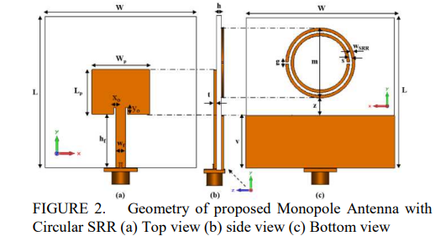

Figure ‎3.1. Top & Side & Bottom view of antenna

Table **Error! Use the Home tab to apply 0 to the text that you want to appear here.**‑1. Reproduced Antenna Dimension

|  |  |  |  |
| --- | --- | --- | --- |
| Parameter | Dimension  (mm) | Parameter | Dimension  (mm) |
| L | 45 | G | 0.50 |
| W | 45 | V | 15.70 |
| Wp | 17.1 | Z | 5.00 |
| Lp | 13.3 | S | 0.80 |
| Xo | 0.60 | M | 16.00 |
| Yo | 2.00 | T | 0.035 |
| Hr | 15.90 | H | 1.60 |
| Wf | 2.93 | WSRR | 0.80 |

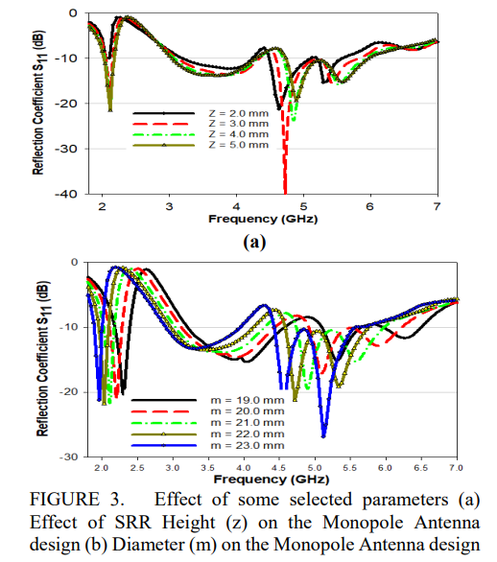Thus, the parameter values of m at (m = 21.00 mm) and z ( z = 4.00 mm) were selected based on the parametric studies. To validate the simulation, all the design parameters were fabricated and tested. The simulated and the fabricated, measured results were discussed. Subsequently, measurements of the reflection coefficient .99, the radiation patterns and gain were conducted. Figure 3 shows the fabricated prototype of the monopole antenna with the circular SRR.

Figure ‎3.2. Effect of some selected parameters (a) Effect of SRR Height (z) on the Monopole Antenna design (b) Diameter (m) on the Monopole Antenna design

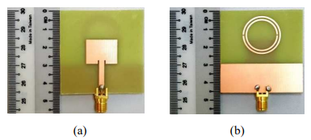

Figure ‎3.3. Fabricated proposed Monopole Antenna with Circular SRR (a) top plane (b) bottom plane

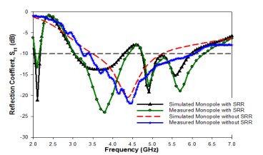

Figure ‎3.4. Simulated and measured S11 of Monopole

Figure 3.4 comparison between simulation and measurement we can see it is the same with vary shift in 5.8GHz

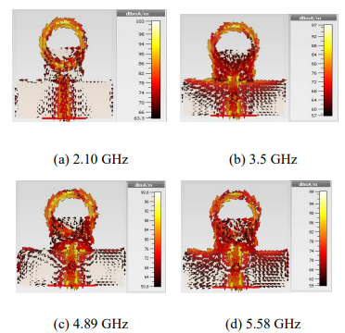

Figure ‎3.5. Simulated Surface Current Distribution of the Monopole Antenna with Circular SRR

Figur 3.5 show the curent distripution at different resonant frequancy (a) 2.10GHz

(b)3.5GHz, (c)4.89GHz, (d)5.58GHz

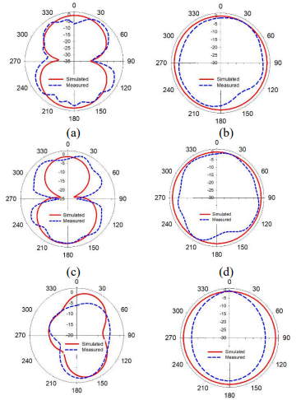

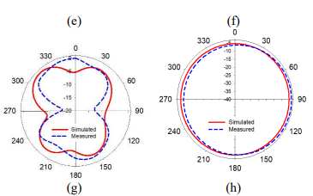

Figure ‎3.6. Simulated and measured radiation patterns of the proposed monopole antenna with Circular SRR: E-plane (a) 2.09 GHz (c) 3.5 GHz (e) 4.9 GHz (g) 5.58 GHz; H-plane (b) 2.09 GHz (d) 3.5 GHz (f) 4.90 GHz (h) 5.58 GHz

Table **Error! Use the Home tab to apply 0 to the text that you want to appear here.**‑2. The summary performance of the proposed monopole [1]

|  |  |  |  |  |
| --- | --- | --- | --- | --- |
| Monopole Antenna with Circular SRR | | | | |
| Frequency (GHz) | 2.09 | 3.5 | 4.90 | 5.58 |
| Working Bandwidth | (2.05-2.15) 100 MHz | (3.02-4.40) 1.380 GHz | (4.74 -6.27) 1.530 GHz | |
| Gain (dB) | 1.76 | 2.33 | 2.90 | 1.96 |
| Radiation Efficiency % | 73.29 | 80.34 | 26.94 | 56.74 |

**The reproduce simulation of the paper**

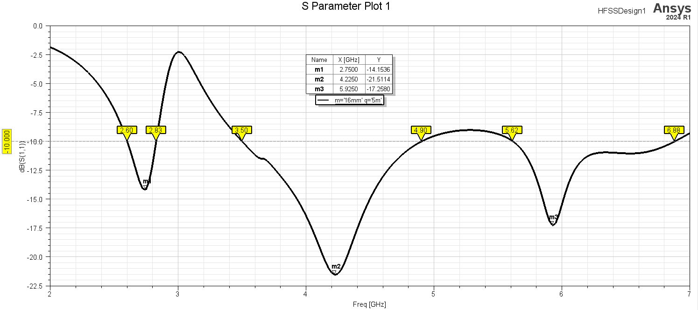

Figure ‎3.7. The original shape with SRR

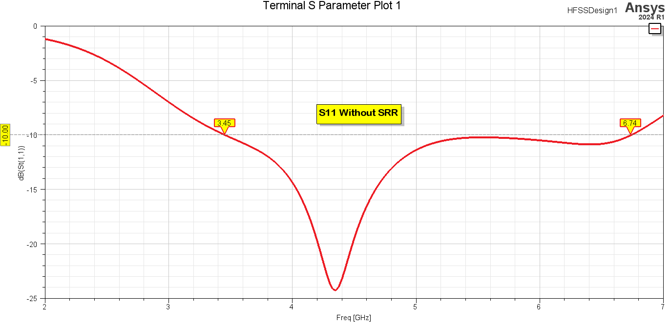

Figure ‎3.8. The original shape without SRR

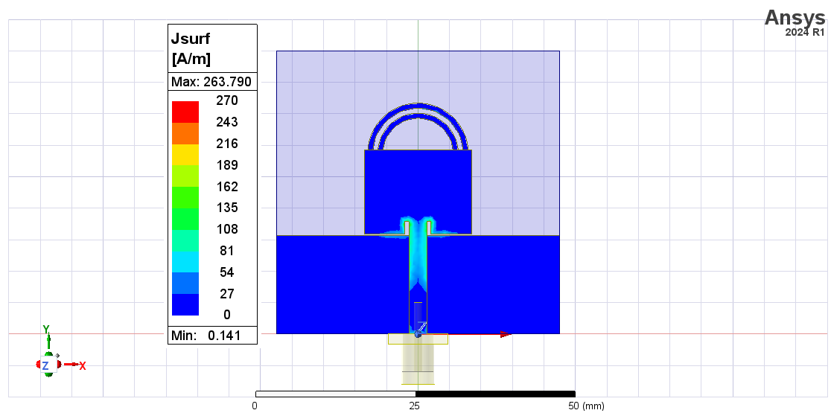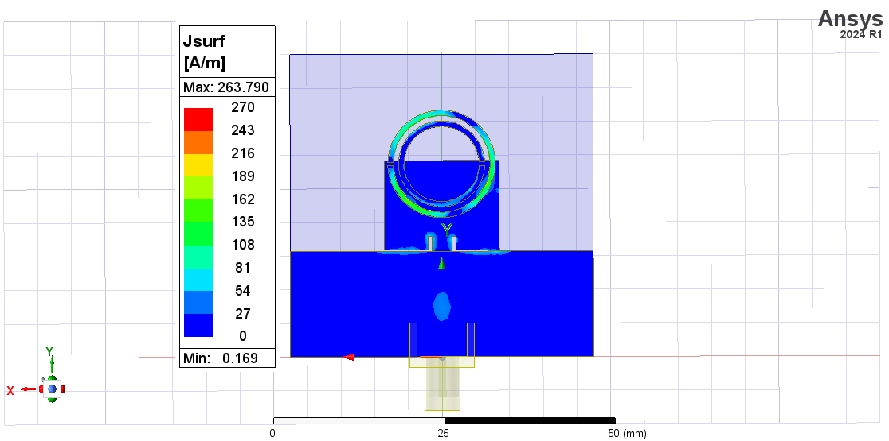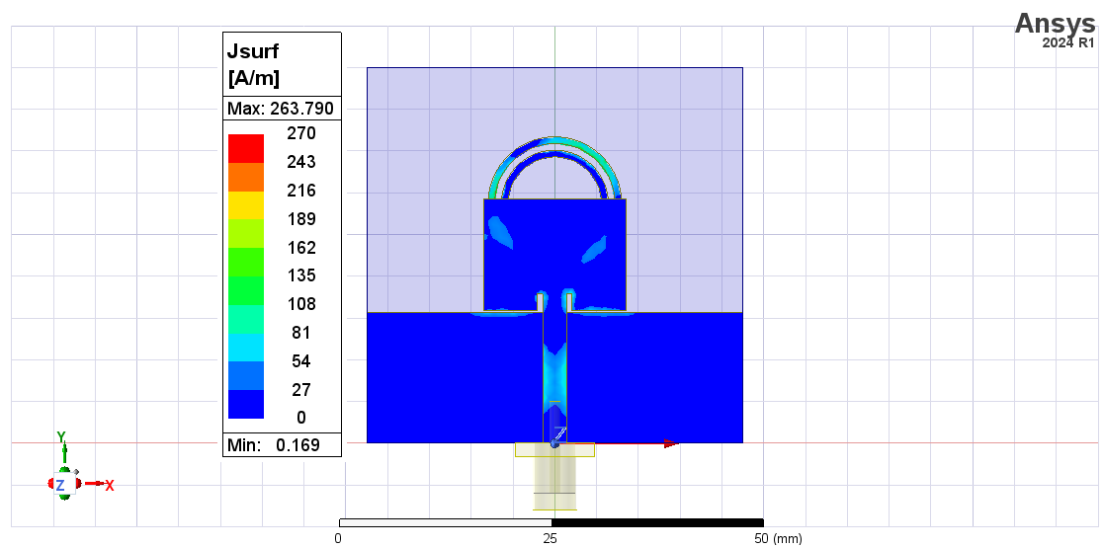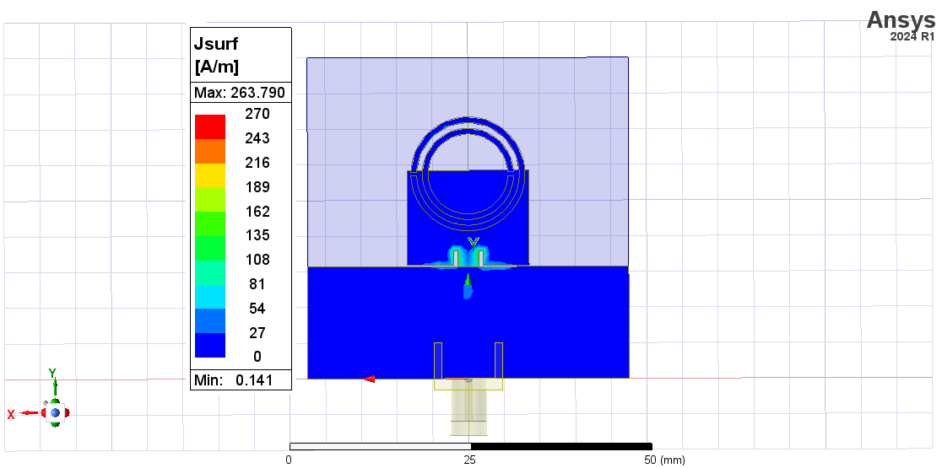

Figure ‎3.9. Bottom view of current distribution at 2.75GHz

Figure ‎3.10. Bottom view of current distribution at 4.225GHz

Figure ‎3.11. Top view of current distribution at 5.925GHz

Figure ‎3.12. Top view of current distribution at 5.925GHz

Figure ‎3.13. Top view of current distribution at 4.225GHz

Figure ‎3.14. Top view of current distribution at 2.75GHz

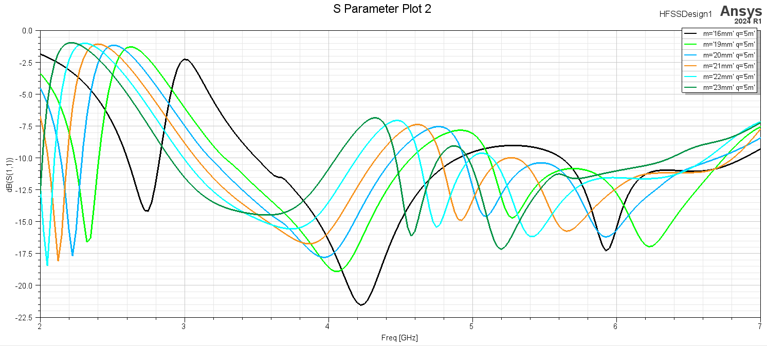

Figure ‎3.15. S11 parameter where m=16, m=19, m=20, m=21, m=22, m=23

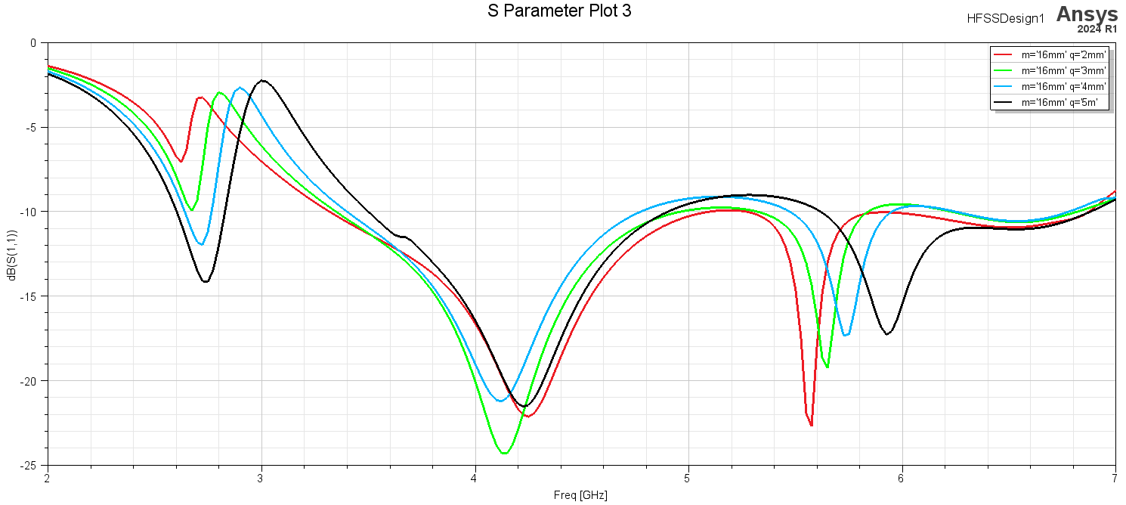

Figure ‎3.16. S11 parameter where q=2, q=3, q=4, q=5

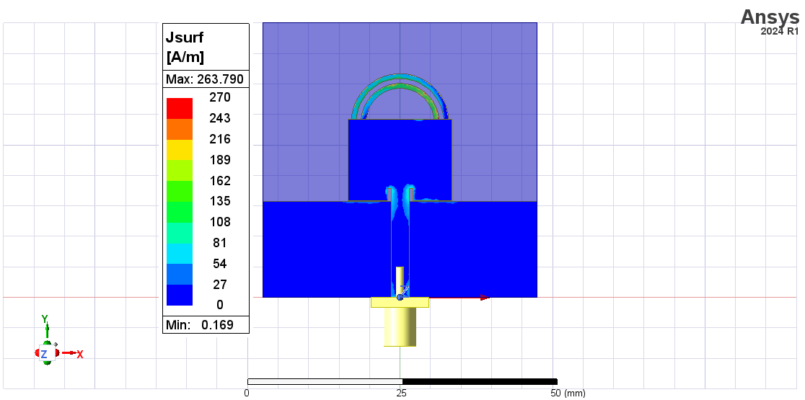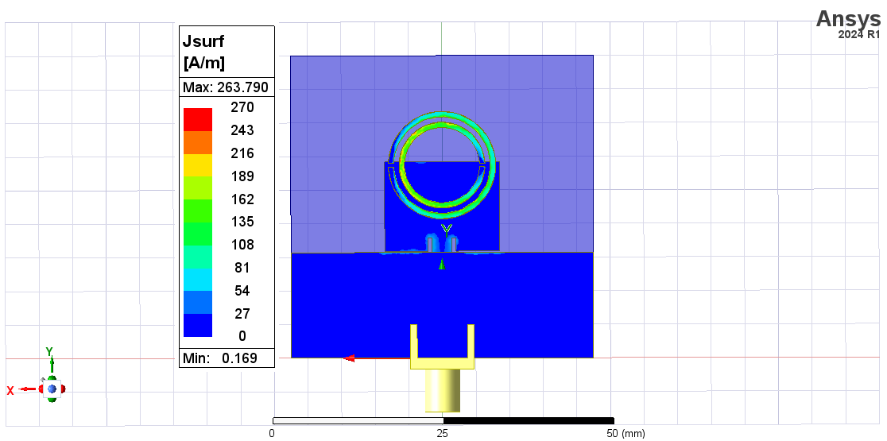

Figure ‎3.17. Top view of current distribution at 2.75GHz

Figure ‎3.18. Bottom view of current distribution at 2.75GHz



Figure ‎3.19. Top view of current distribution at 4.225GHz



Figure ‎3.20. Bottom view of current distribution at 4.225GHz



Figure ‎3.21. Top view of current distribution at 5.925GHz

Figure ‎3.22. Top view of current distribution at 5.925GHz

Ther is difference in scale the paper shows the current distribution in dBmA/m.

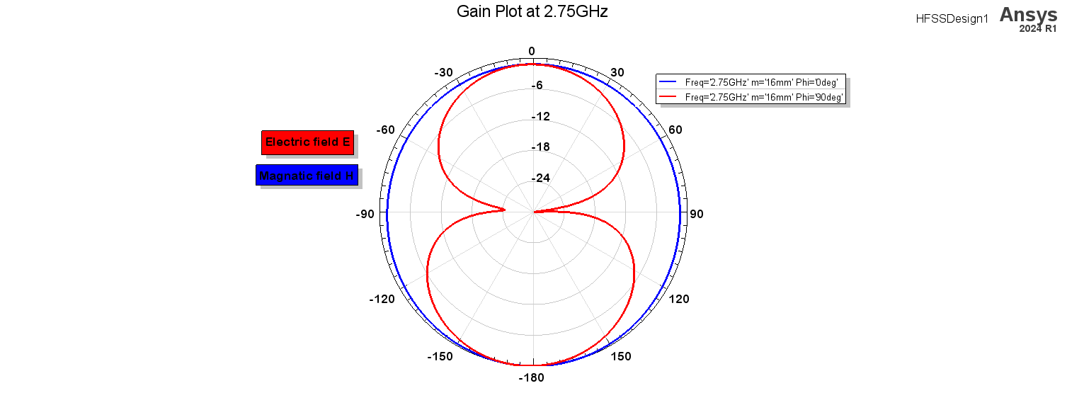

Figure ‎3.23. Electric field & Magnetic field at 2.75GHz

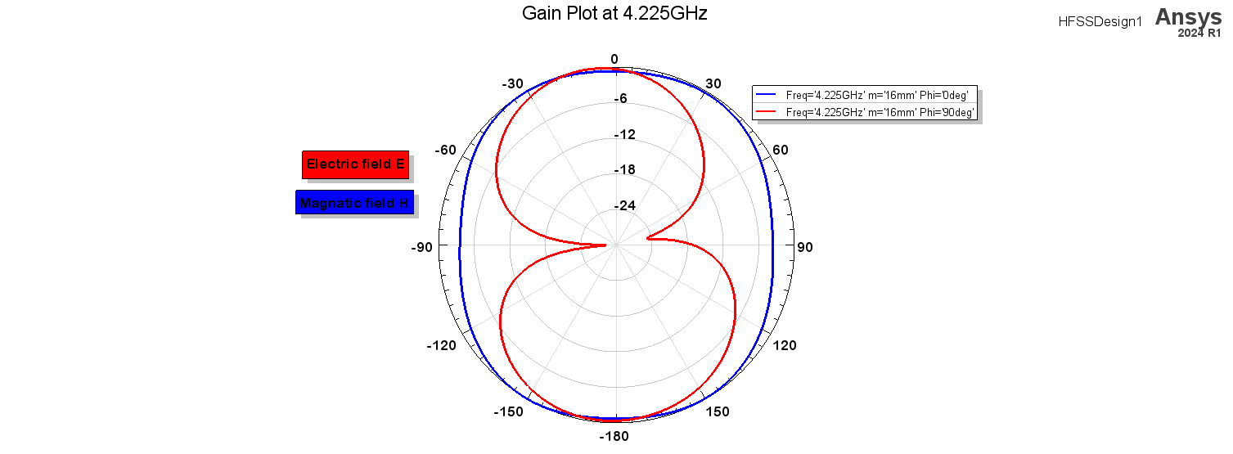

Figure ‎3.24. Electric field & Magnetic field at 4.225GHz

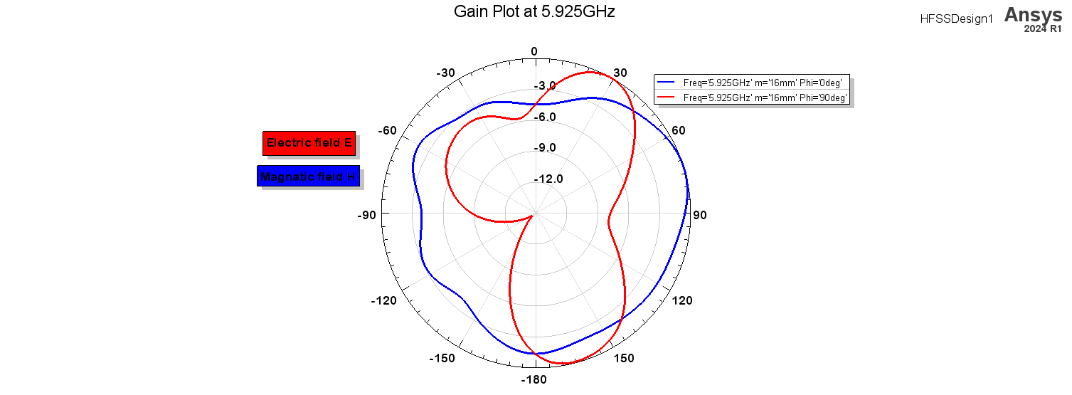

Figure ‎3.25. Figure 17. Electric field & Magnetic field at 5.925GHz

**Reproduce for Multiband and Wideband ‘C-Shaped’ Monopole Antenna for 5G and WLAN Applications**

Mohammad Ayman Mardeni

Group2 - 0207316

Dep. of Electrical Engineering

Amman, Jordan

[mohammadmardeny33@gmail.com](mailto:mohammadmardeny33@gmail.com)

**Abstract – The work described in [3] will be replicated in this report. It comprises "C-shaped" radiators with a rectangular tuning stub and circular radiators on each corner. A 50 ohm microstrip feedline feeds this structure, allowing for the achievement of two resonances at 3.9GHz and 6.6GHz with a 76% (3.30-7.35)GHz bandwidth. Instead of using a 10dB bandwidth, the study in [3] considers a 6dB bandwidth, yet in the functional bands of interest, it can achieve efficiency of about 85% and gain of about 2.25dBi with about omnidirectional patterns. While we employed the ANSYS-provided HFSS simulation design, the paper in [3] employs the CST simulation programme [4].**

**Keywords —** 5G, WLAN, FR-4 Substrate, C-Shaped radiators and Circular radiators, Paper Reproduce.

1. **Antenna dimensions and Design**

The paper in [3] uses an antenna in three stages: the first iteration adds a single C-shaped radiator to obtain single resonance frequency in 3.9GHz in the 2-8 GHz range. The second adds another C-shaped radiator to obtain another band at 6.6GHz and  the final iteration adds a tuning stub to give better matching to cover the 5G and WLAN bands as shown in figure 1.

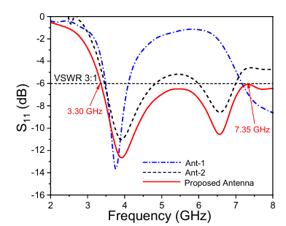

Figure ‎3.26. Reflection loss from each design iteration in [3].

The paper in [3] proposes The following parameters in figure 2 and table 1.

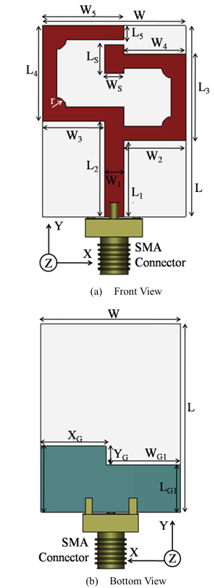

Figure ‎3.27. Structure of Antenna in [3]

Table **Error! Use the Home tab to apply 0 to the text that you want to appear here.**‑3. Parameters’ values of Antenna in [3]

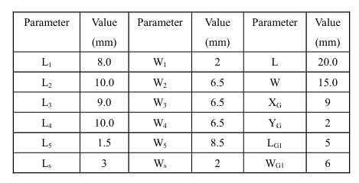

The paper in [3] does not clearly specify the radius of the circular radiator so an initial guess has been made according to figure 3.27.

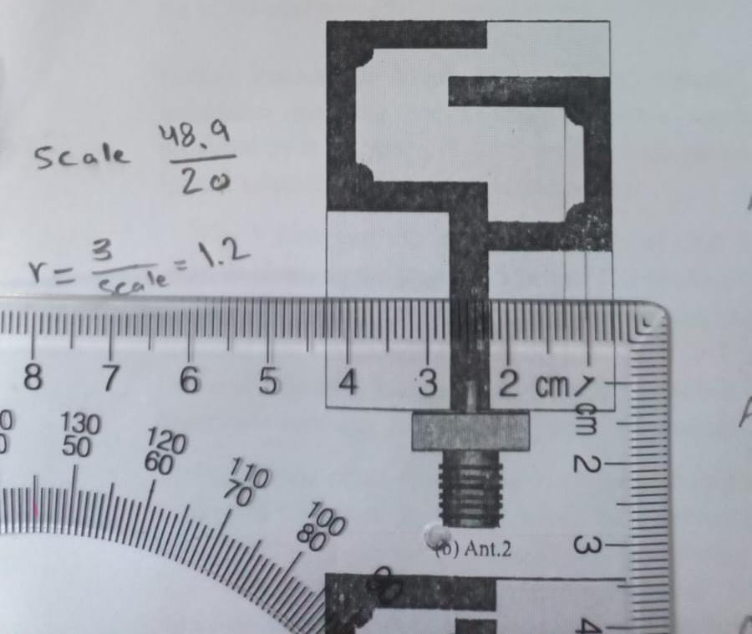

Figure ‎3.28. Approximation of the circular radiator radius in [3]

To avoid making the stub collide with the top C-shaped radiator, we can shift the stub according to the procedure below.

Let the stub down shift x  (below the c-shaped edge), and the stub upshift y (above the c-shaped upper edge). If the distance between the stub and the upper above C-shaped resonator is equal to that down shift, x, then:

x+ L5+y=Ls ---(1)

And,

y+x+L5=L-L3-L1 --- (2)

Note that from (1) and (2):

Ls=L-L3-L1 --- (3)

Testing the assumption by using (3) we note that:

Ls =3 = L-L3-L1 =3, True assumption

Hence, the down shift, x, by measurement is approximately 0.408997 mm. as figure 4 explains below:

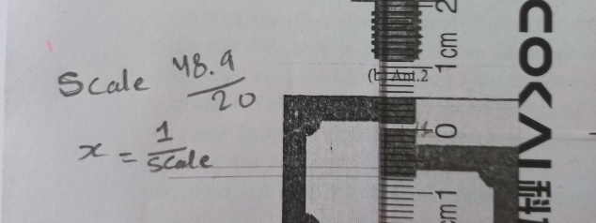

Figure ‎3.29

The substrate used in [3] is FR-4, 20mm x 15 mm area, and has a height of 0.8mm thickness. Which provides compactness to the design and good integration to many wearable and mobile wireless devices.

For the first stage of the antenna design, see figure 5, simulated S11(dB) is shown in figure 6 for the reproduction and in figure 1 for the paper results for various iterations of the design . For the other stages see figures 7 and 8.

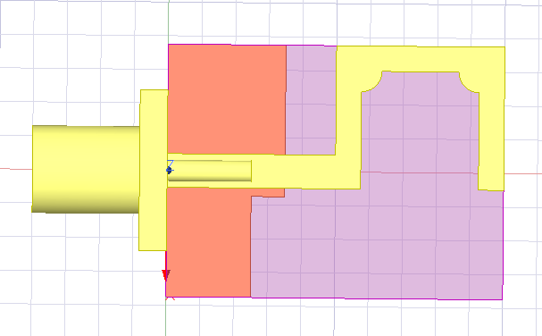

1. Iteration 1

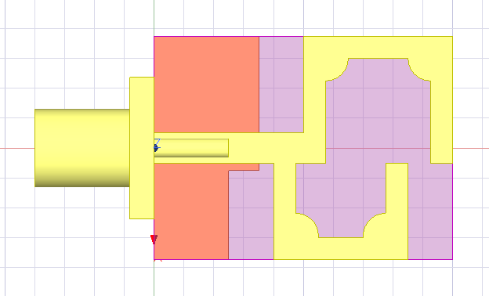

1. Iteration2

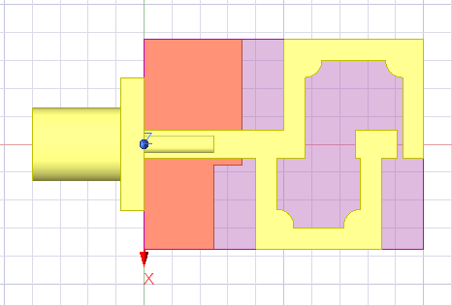

Figure ‎3.30. Step by Step structure in HFSS

( c ) Iteration 3

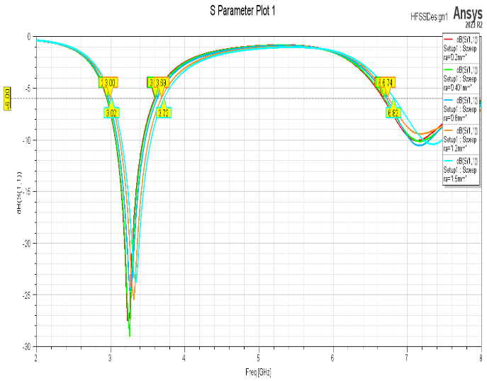

Figure ‎3.31

Iteration 1 reflection loss vs frequency simulation for various circular radiator radius, it can be seen that as the radiator radius increases the resonance frequency increases as a fine tuning mechanism of the resonance frequency. The iteration 1 antenna can generally generate a resonance around 3.35GHz at (3.00-3.72) GHz 6dB bandwidth.

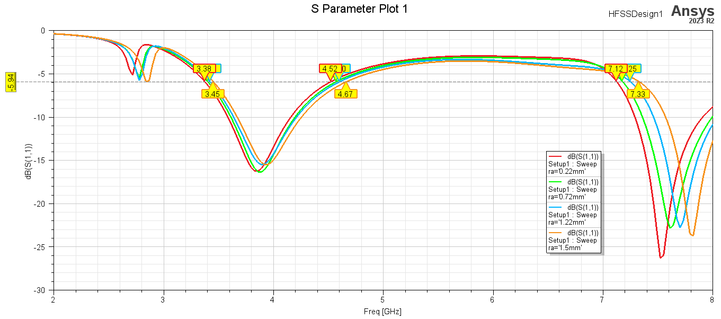

Figure ‎3.32

Iteration 2 with various circular radiator radii, we now introduce another clear resonance about 7.5GHz with 6dB bandwidth of (3.38-4.67)GHz at 3.9GHz and (7.12 - 8.00)GHz at 7.5GHz resonance. with the same effect of increasing circular radiator as seen in iteration 1.

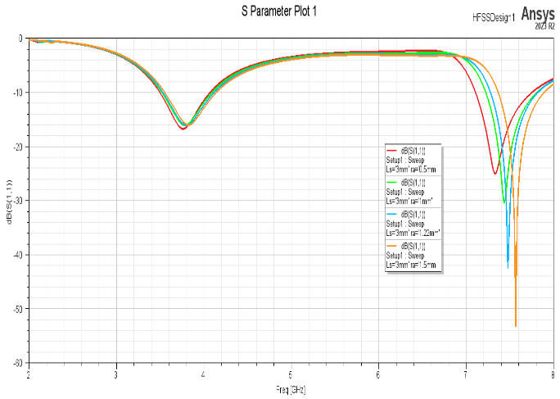

Figure ‎3.33

The figure 8 shows The final stage design in [3] replicated in HFSS under various circular radiator radii. where the range proposed in [3] is still not covered.

**II. Parametric Investigation**

The Paper in [3] also verifies the effect of the added stubs effect on the reflection loss “matching with 50 ohm feed under 2-8 GHz range” by controlling the following parameters: The Ls, Xg and Yg.

The Ls in [3] was visualized under 2mm to 5mm and paper [3] found that 3mm was the optimal.

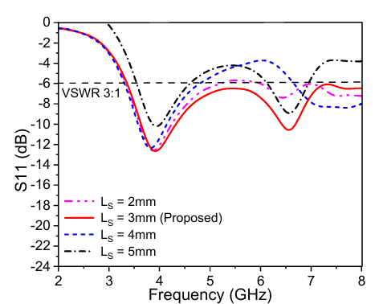

Figure ‎3.34. The effect of changing the Ls done by paper in [3].

The effect of changing Xg is done by [3] by changing from 3mm to 12mm and they found the 9mm was the optimal.

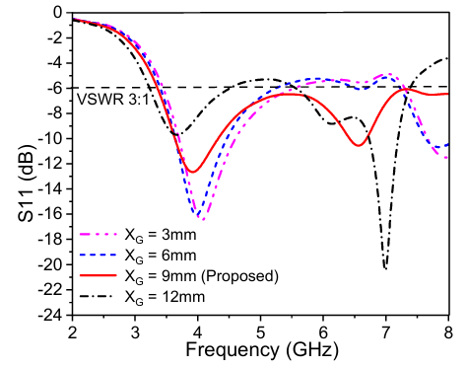

Figure ‎3.35. The effect of Xg as seen by [3].

The Yg was investigated in the range 0mm – 3mm and paper in [3] found that 2mm was the optimal.

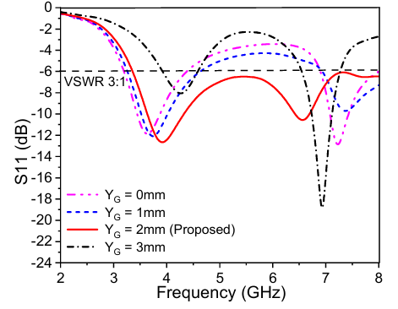

Figure ‎3.36. The effect of Yg done by paper [3].

By doing parametrized optometric analysis we investigated the paper in [3] results regarding Ls, Xg, and Yg effects in HFSS simulation software:

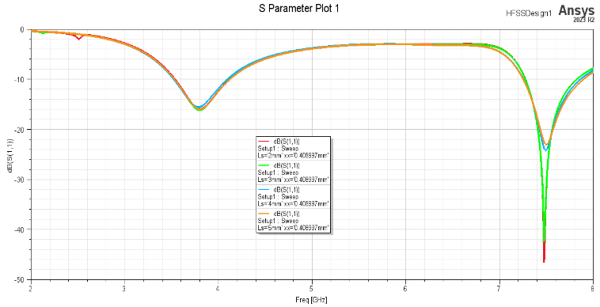

Figure ‎3.37. Simulated effect of Ls. Ls=3mm can be considered the optimal but in general no significant effect.

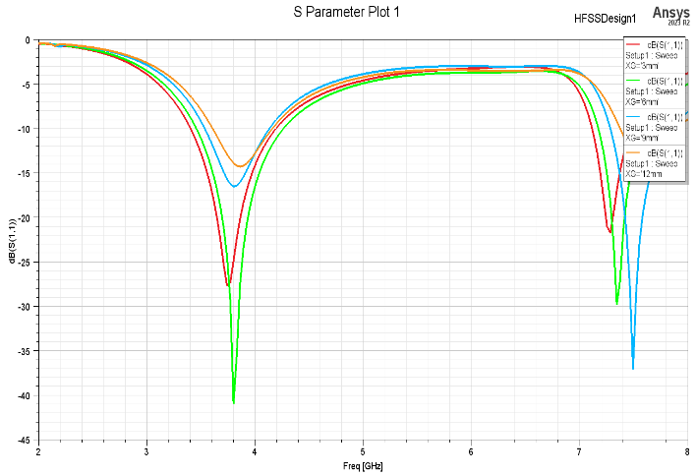

Figure ‎3.38. The effect of Xg in HFSS seen whereas Xg increase, the resonance frequency shifts to higher value.

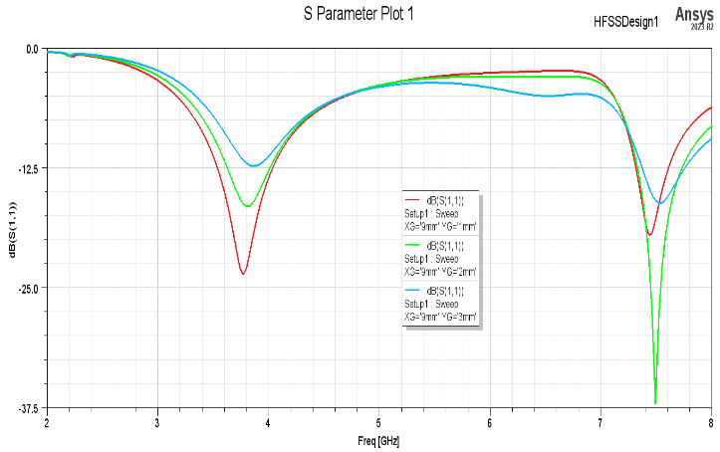

Figure ‎3.39. Effect of changing Yg.

**III. Proposed Antenna Performance**

The Antenna proposed by [3] uses the software described in [4] which is different from the simulation used by this report “HFSS 2023”.

1. **Reflection Loss performance (S11)**

The paper in [3] using [4] achieved the results described in Figure 15 while HFSS achieved the results described in Figure 16.

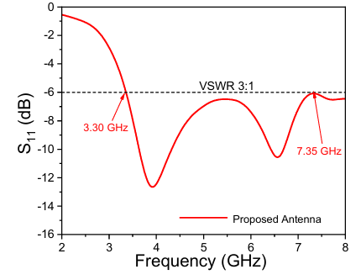

Figure ‎3.40

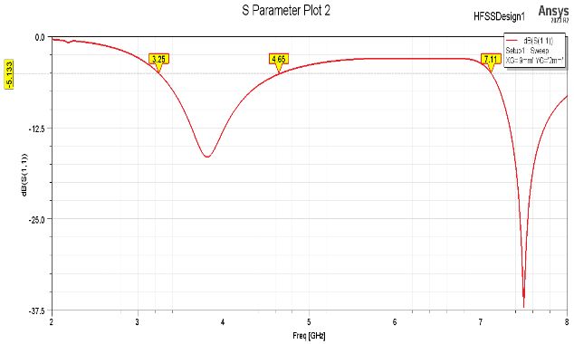

Figure 3.39.

1. **Radiation performance**

The Antenna in [3] exhibits an omnidirectional radiation pattern at 3.9GHz and 6.6GHz. see figure 17. The antenna simulated by this report resonates at 3.8GHz and 7.49GHz. And exhibits the radiation patterns seen in Figure 18.

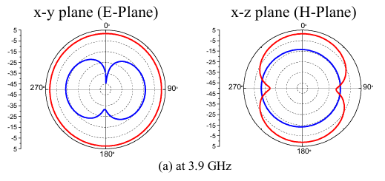

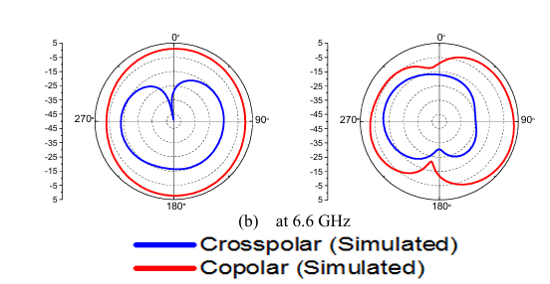

Figure ‎3.41

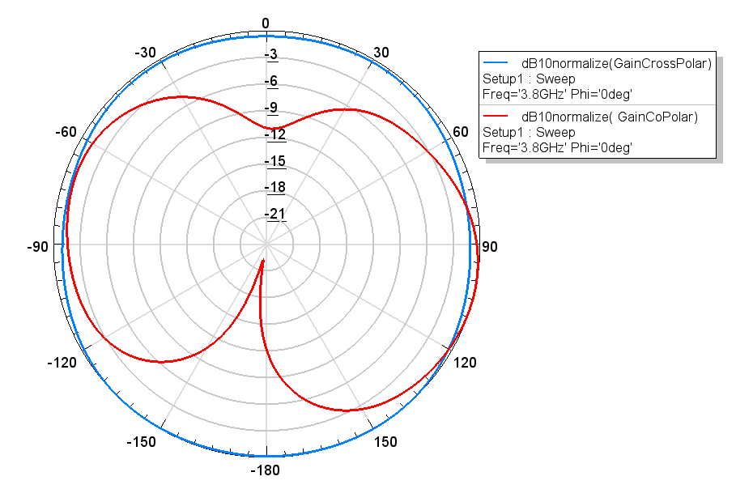

1. E-Plane at 3.8GHz
2. H-Plane at 3.8GHz

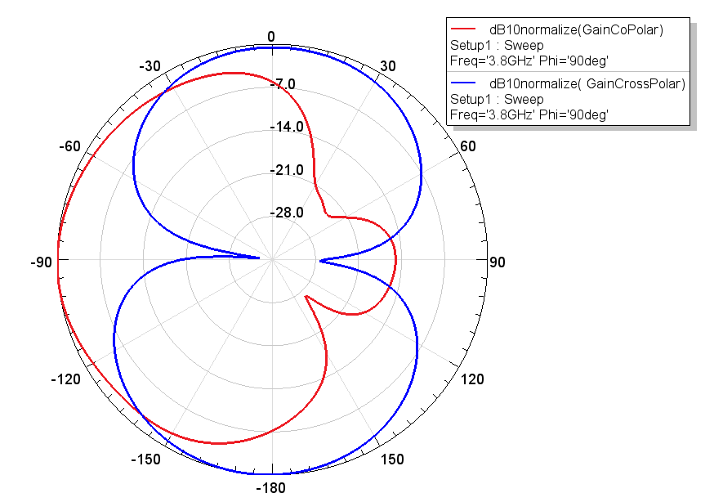

1. E-Plane at 6.6GHz

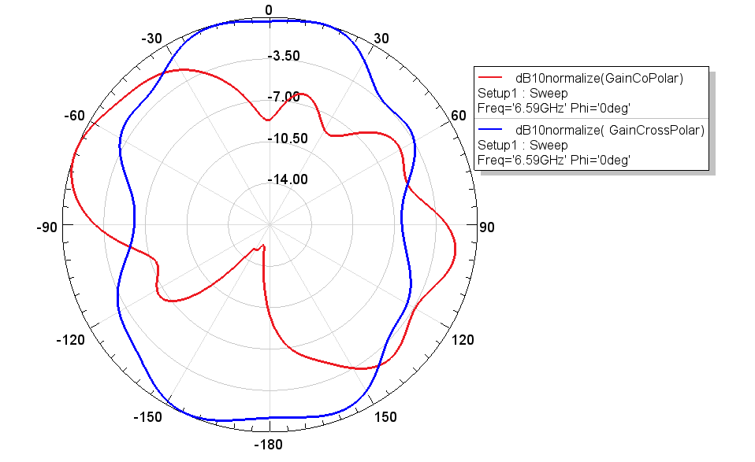

1. H-Plane at 6.6GHz

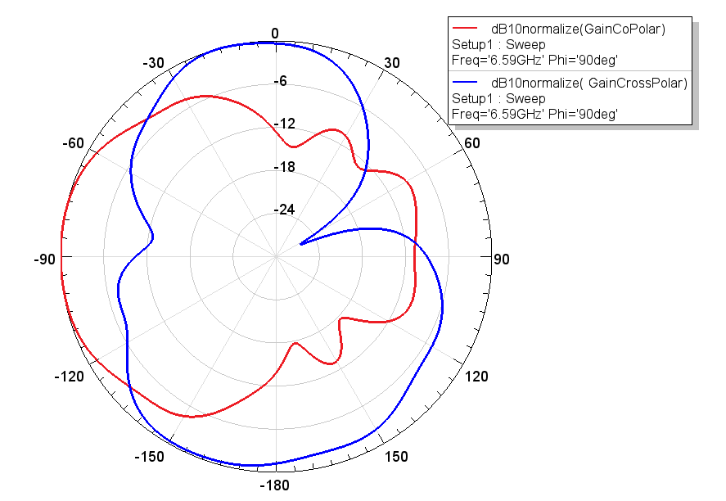

1. E-Plane at 7.4GHz

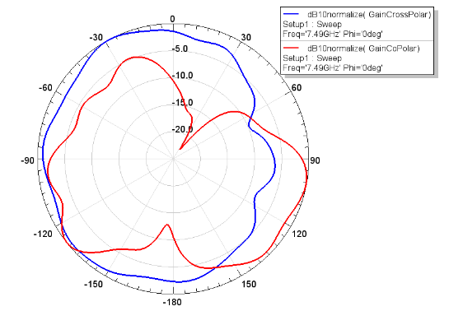

1. H-Plane at 7.4GHz

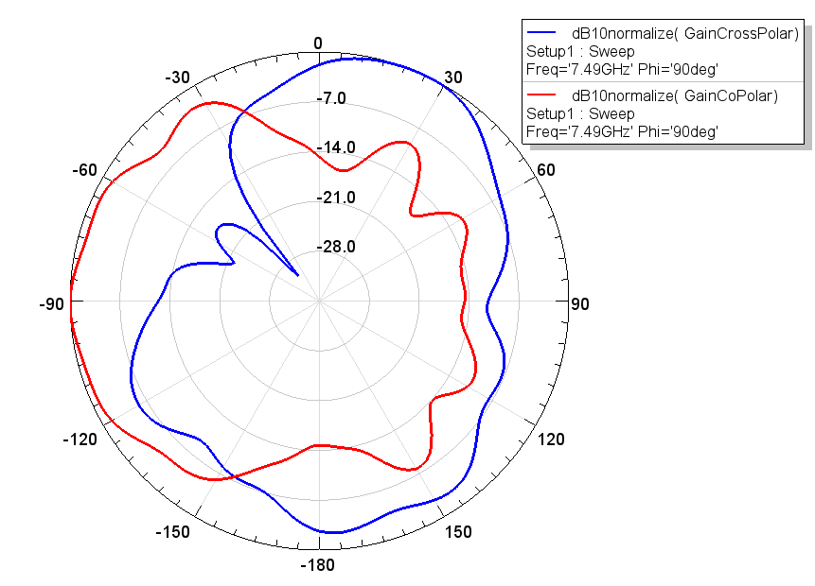

Figure ‎3.42

1. **Gain And Efficiency**

The proposed antenna in [3] gain and efficiency are described in figure 19. The antenna in [3] shows to has about 2.25dBi antenna gain and 85% efficiency across all the suggested bands. The replicated antenna in this report shows efficiency and gain results in figure 20.

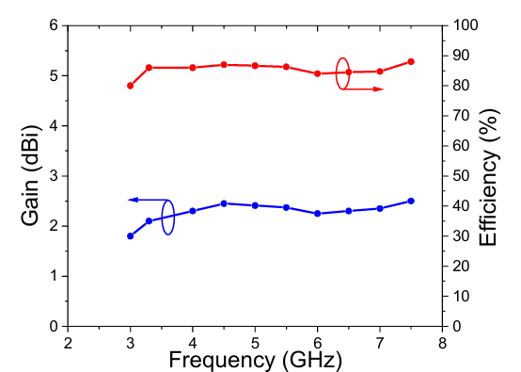

Figure ‎3.43 Proposed antenna in [3] gain and efficiency results

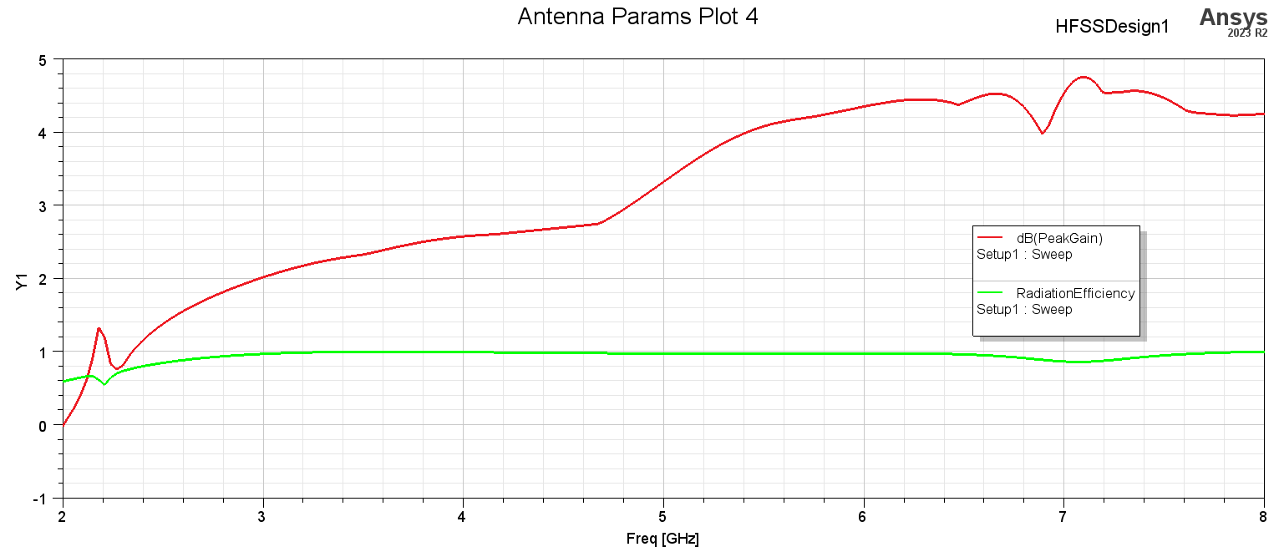

Figure ‎3.44 Replicated antenna gain and efficiency.

**IV. Conclusion**

The proposed antenna has bandwidth of 76% (3.30 - 7.35)GHz at 3.9GHz resonance and 6.5GHz resonance. The replicated antenna differs in bandwidth and slight variation in resonance frequency 3.8GHz and 7.49GHz in addition to the bandwidth covers (3.3 - 4.4)GHz about the 3.8GHz resonance and (7.15-8)GHz about the 7.49GHz while not covering the in-between range. The explanation may be due to the difference in simulation software and the tolerance in the 5G range covered in [3] is not enough as it was close to the 6dB reflection loss line.

# Chapter 4: DESIGNING PROPOSED ANTTENAS

**First design**

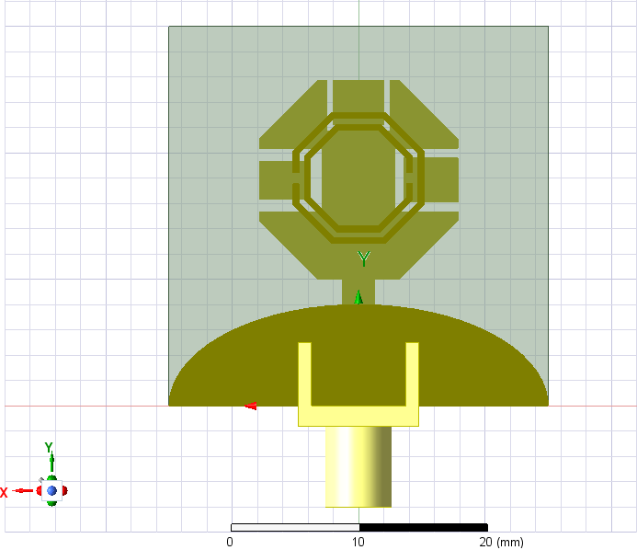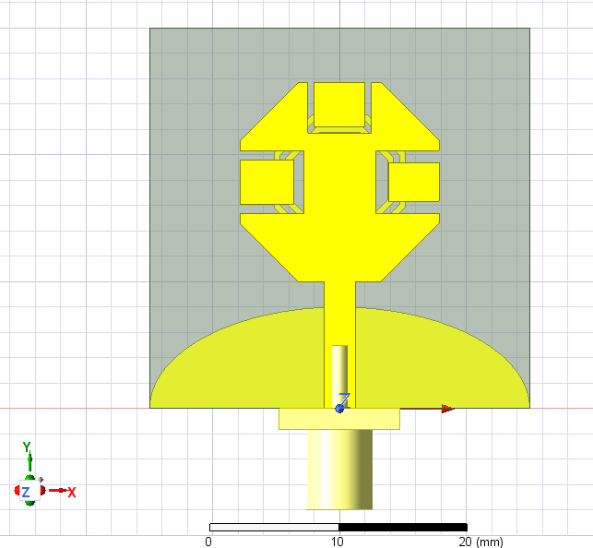**Top view Bottom view**

Figure ‎4.1. Bottom view of proposed antenna

U

wss

W

Figure ‎4.2. Top view of proposed antenna

3ws

gg

U2

g1

U1

ls

lg

G

L

lf

wf

Table **Error! Use the Home tab to apply 0 to the text that you want to appear here.**‑4. Antenna Dimension

|  |  |  |  |
| --- | --- | --- | --- |
| **Parameter** | **Dimension(mm)** | **Parameter** | **Dimension(mm)** |
| **L** | **30.00** | **U** | **0.50** |
| **W** | **30.00** | **U1** | **1.00** |
| **G** | **8.50** | **U2** | **0.75** |
| **lg** | **8.00** | **lu** | **4.00** |
| **lu2** | **5.00** | **lu1** | **5.00** |
| **ls** | **18.00** | **lf** | **10.00** |
| **wss** | **5.00** | **ws** | **0.50** |
| **gg** | **0.90** | **g1** | **5.60** |
| **wf** | **2.5** | **----** | **----** |

**Steps of design**

**Iteration No:1**

**Top view Bottom view**

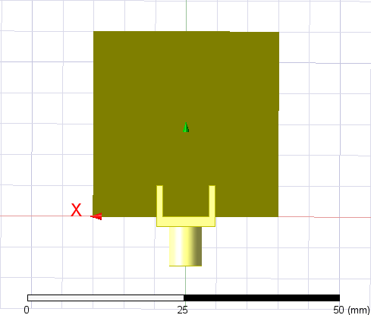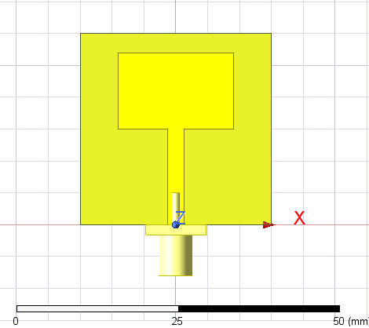

Figure ‎4.3. Bottom view of antenna No:1

Figure ‎4.4. Top view of antenna No:1

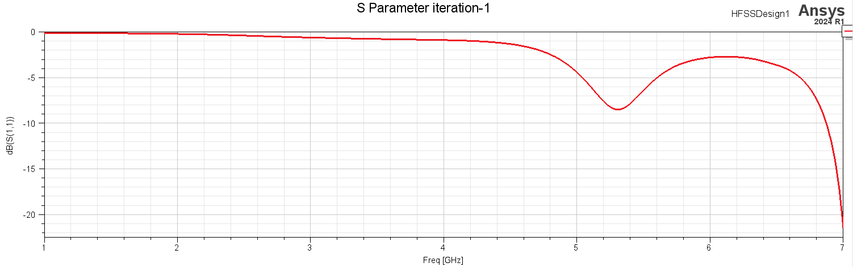

Figure ‎4.5. S11 of antenna No:1

**Iteration No:2**

**Top view Bottom view**

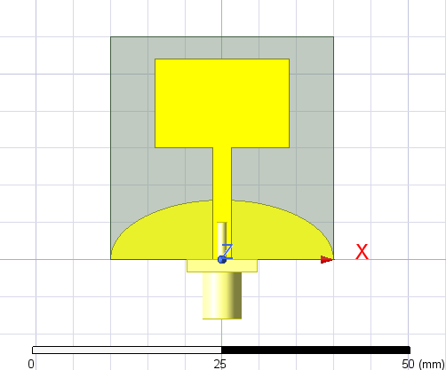

Figure ‎4.6. Top view of antenna No:2

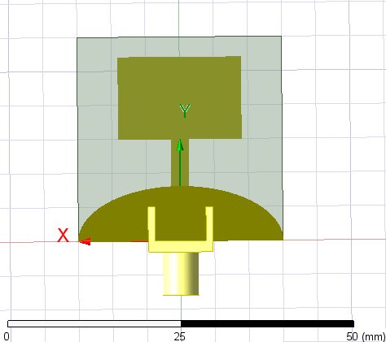

Figure ‎4.7. Bottom view of antenna No:2

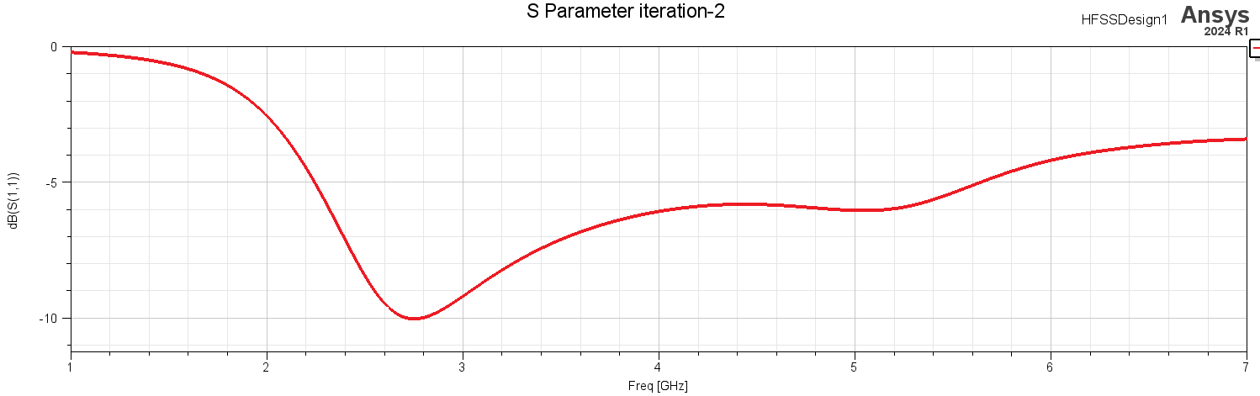

Figure ‎4.8. S11 of antenna No:2

**Iteration No:3**

**Top view Bottom view**

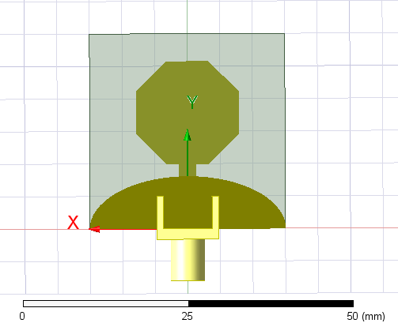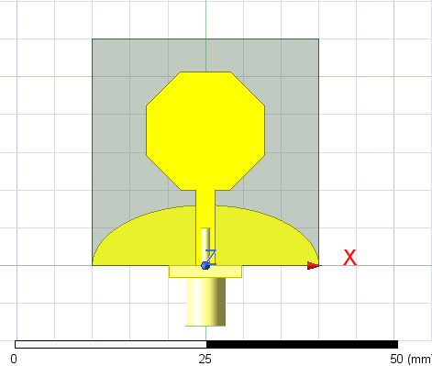

Figure ‎4.9. Bottom view of antenna No:3

Figure ‎4.10. Top view of antenna No:3

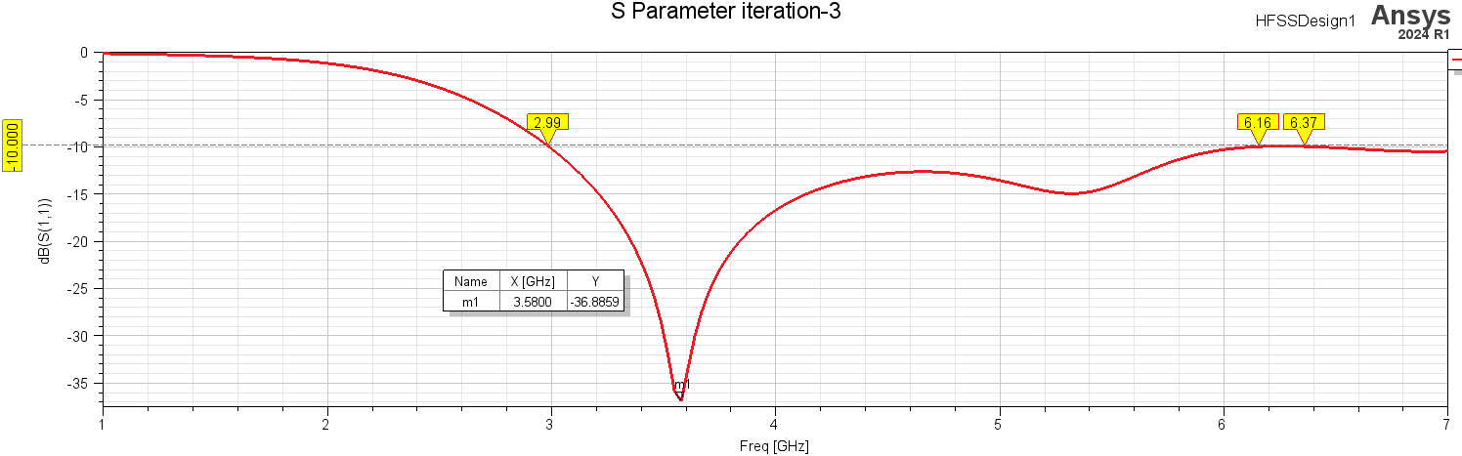

Figure ‎4.11. S11 of antenna No:3

**Iteration No:4**

**Top view Bottom view**

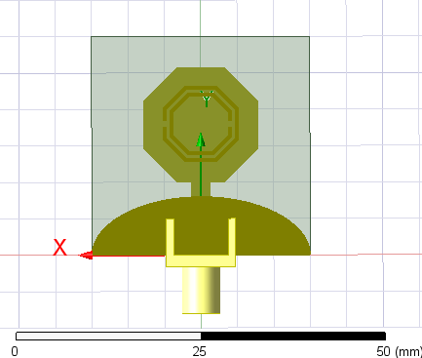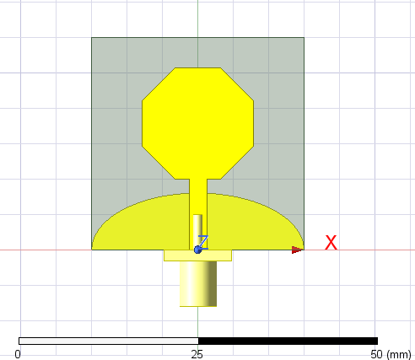

Figure ‎4.12. Top view of antenna No:4

Figure ‎4.13. Top view of antenna No:4

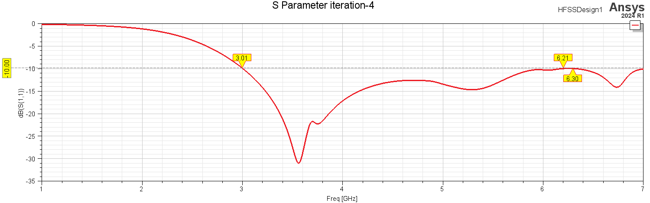

Figure ‎4.14. S11 of antenna No:4

**Iteration No:5**

**Top view Bottom view**

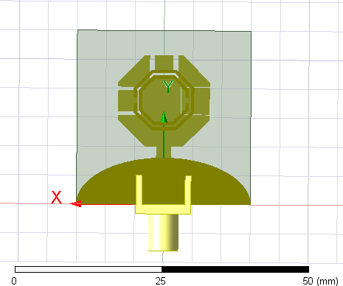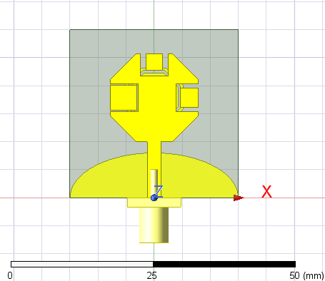

Figure ‎4.15. Top view of antenna No:5

Figure ‎4.16. Top view of antenna No:5

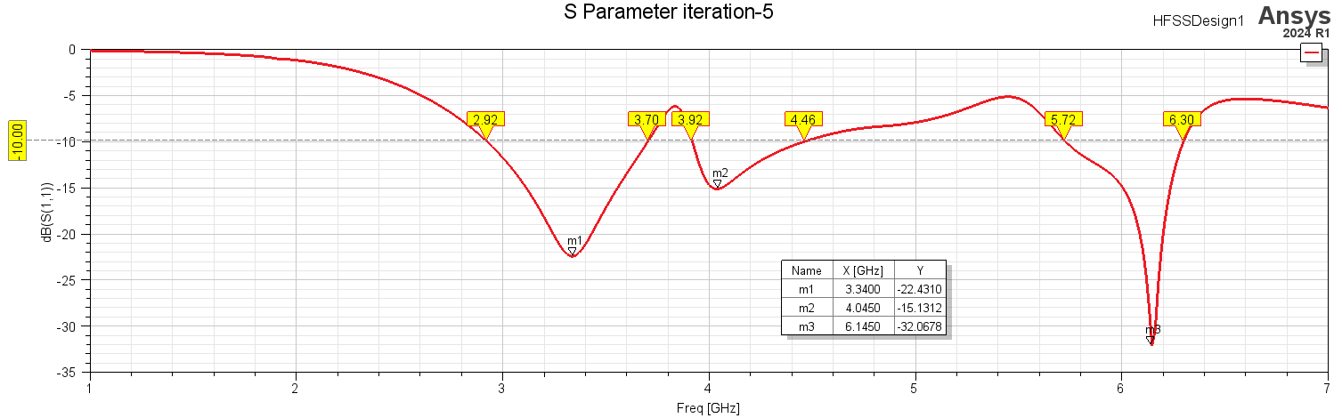

Figure ‎4.17. S11 of antenna No:5

**Starting parametric analyses**

**lg parameter**

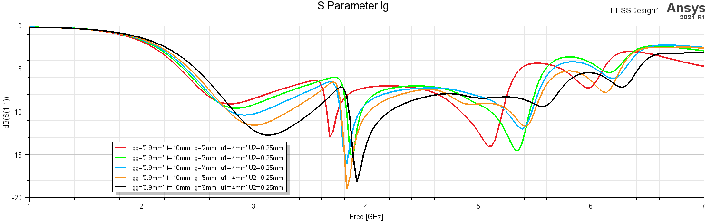

Figure ‎4.18. lg=2, lg=3, lg=4, lg=5, lg=6

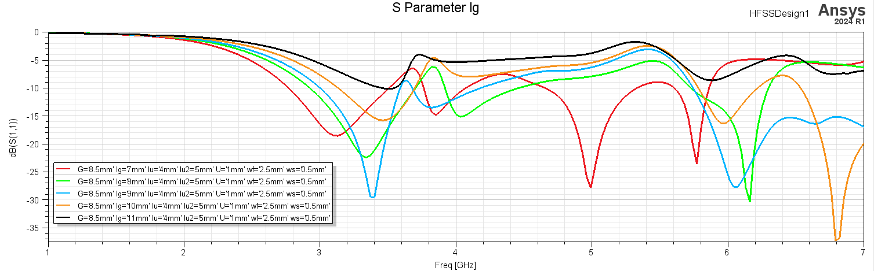

Figure ‎4.19. lg=7, lg=8, lg=9, lg=10, lg=11

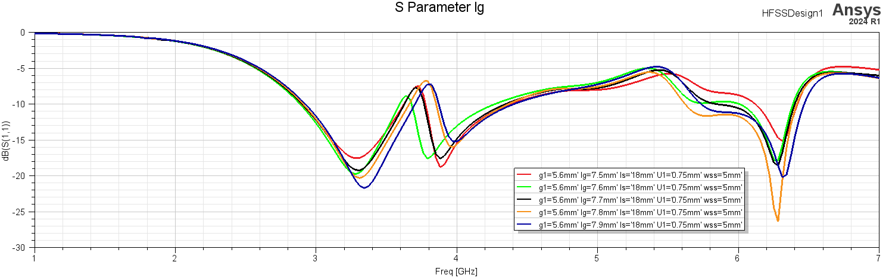

Figure ‎4.20. lg=7.5, lg=7.6, lg=7.7, lg=7.8, lg=7.9

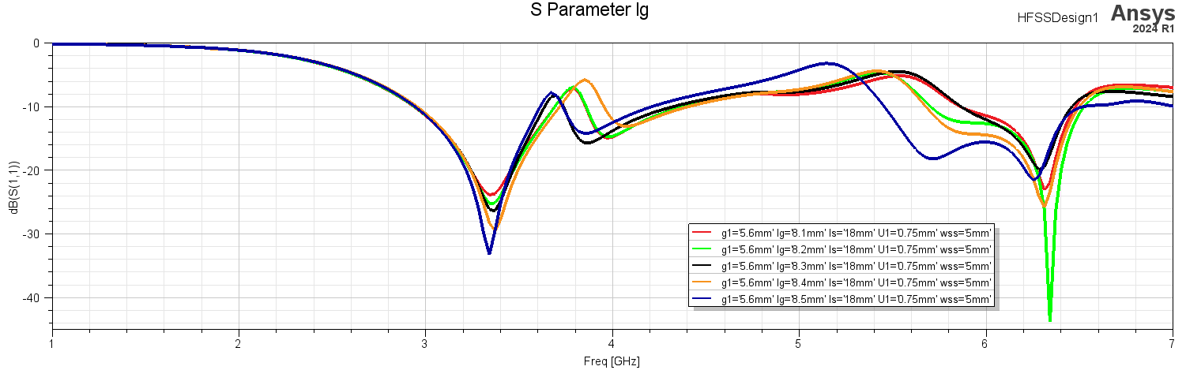

Figure ‎4.21. lg=8.1, lg=8.2, lg=8.3, lg=8.4, lg=8.5

lg the length of the ground elliptical shape over all control the power and some slit shift at 4GHz and 6GHz

**U parameter**

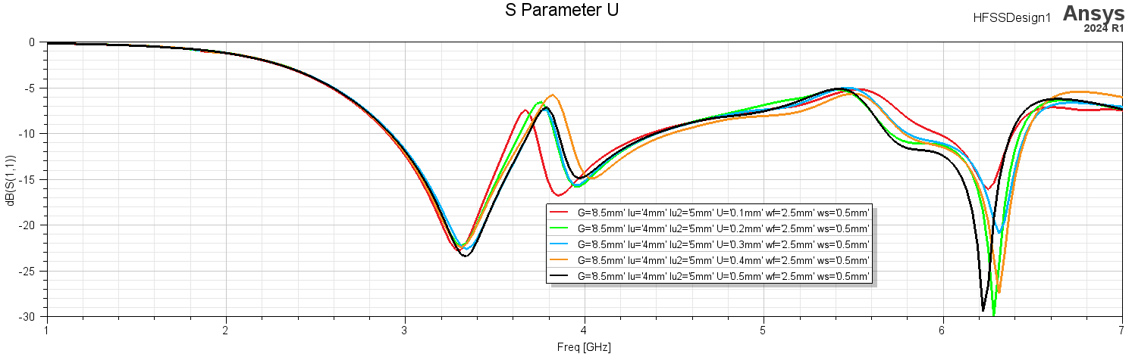

Figure ‎4.22. U=0.1, U=0.2, U=0.3, U=0.4, U=0.5

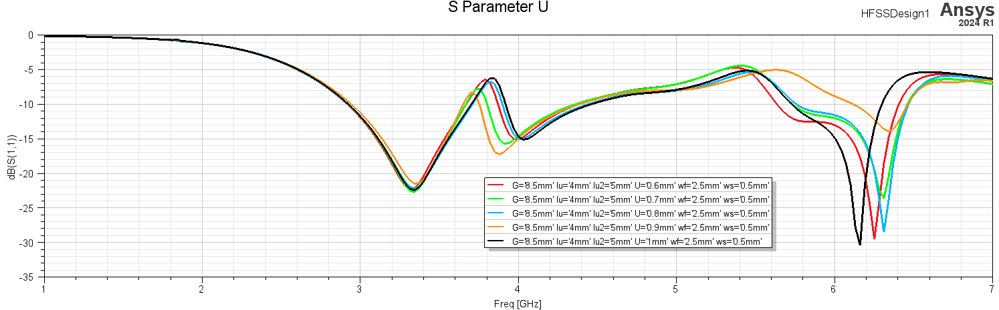

Figure ‎4.23. U=0.6, U=0.7, U=0.8, U=0.9, U=1

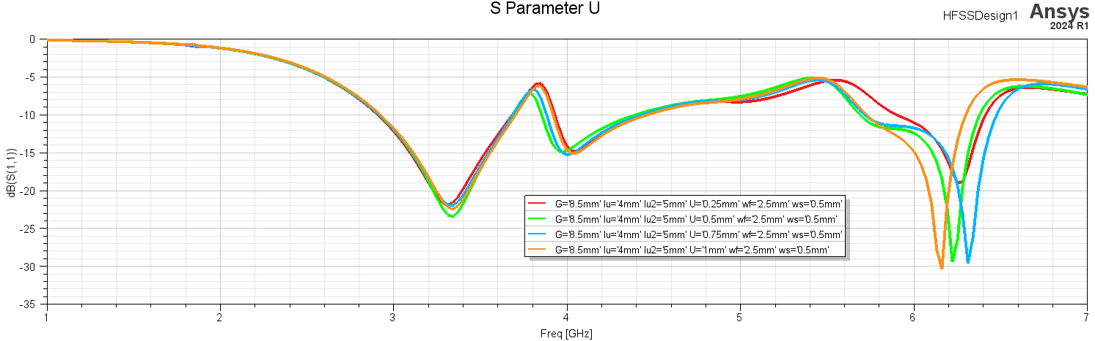

Figure ‎4.24. U=0.25, U=0.5, U=0.75, U=1

U1 the width of the centre U shape slot it shifts the 4GHz and 6GHz and Unnoticed shift at 3.3GHz and effect on the power at 6GHz

**U1parameter**

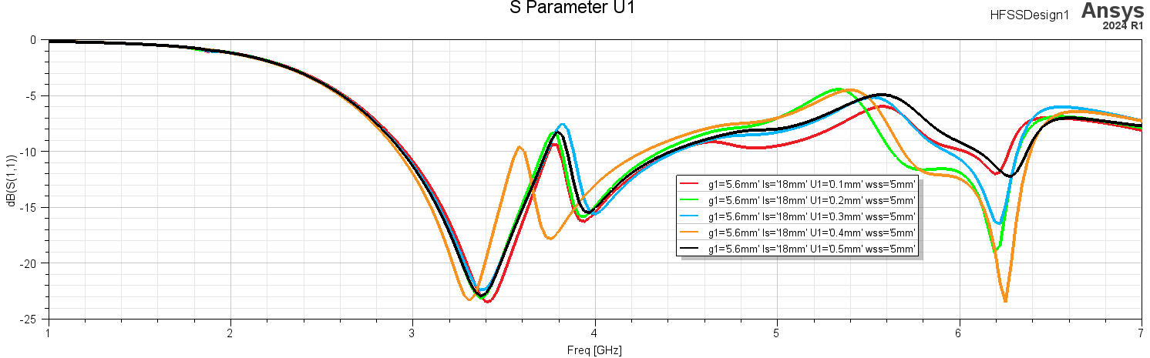

Figure ‎4.25. U1=0.1, U1=0.2, U1=0.3, U1=0.4, U1=0.5

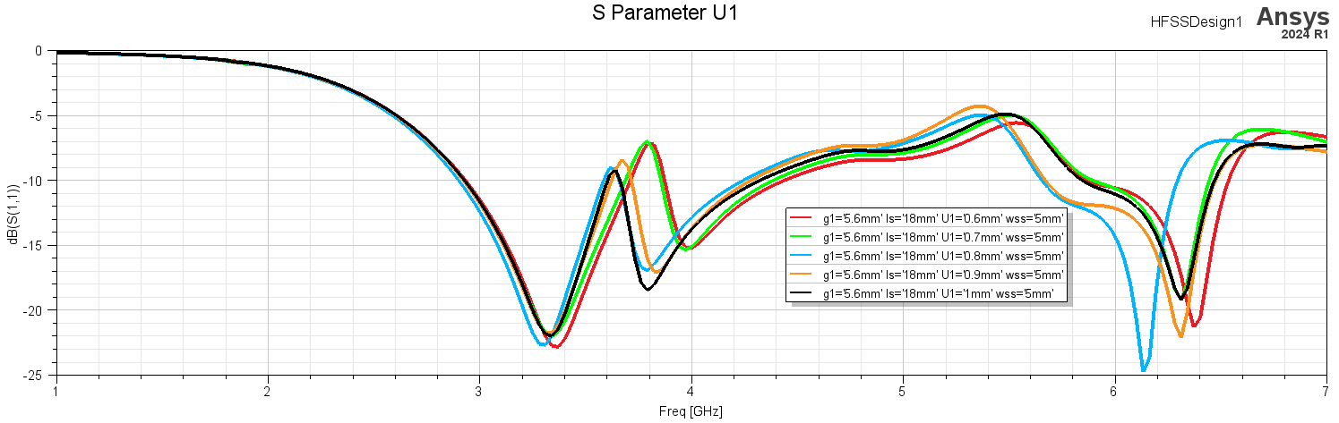

Figure ‎4.26. U1=0.6, U1=0.7, U1=0.8, U1=0.9, U1=1

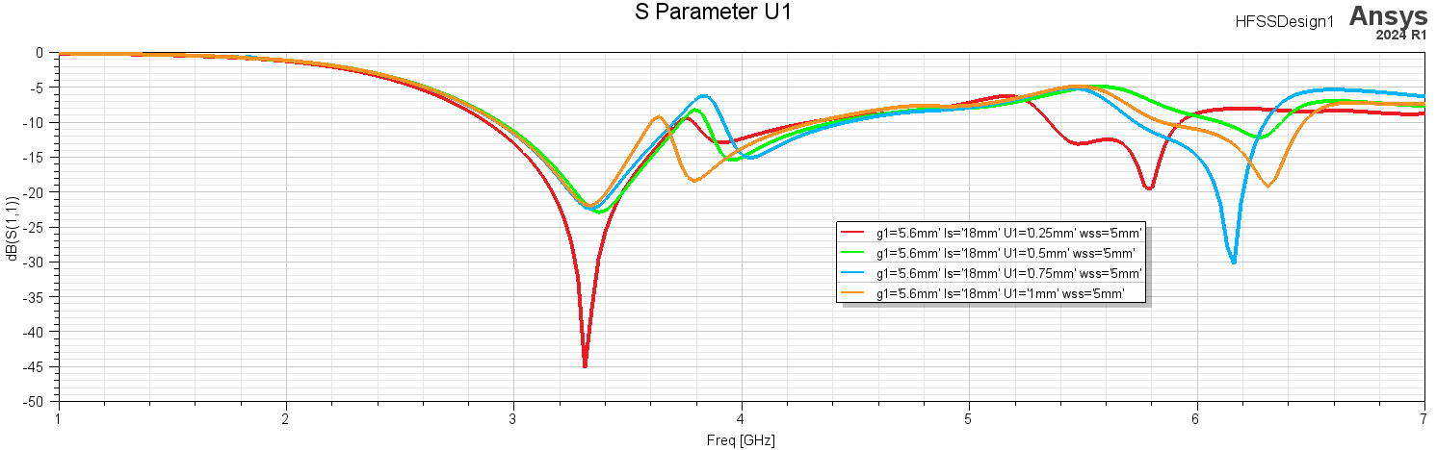

Figure ‎4.27. U1=0.25, U1=0.5, U1=0.75, U1=1

U1 the width of the right U shape slot it shifts the 4GHz and 6GHz and some shift at 3.3GHz and effect on the power at 4GHz & 6GHz.

**U2 parameter**

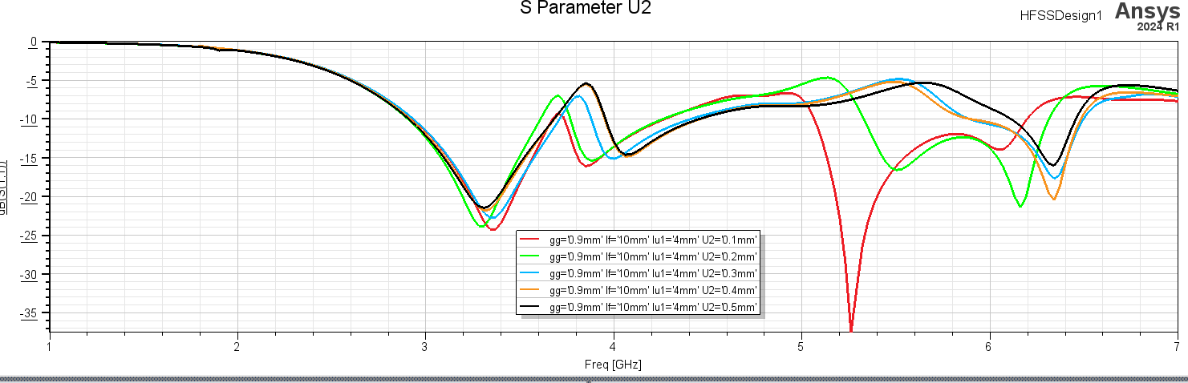

Figure ‎4.28. U2=0.1, U2=0.2, U2=0.3, U2=0.4, U2=0.5

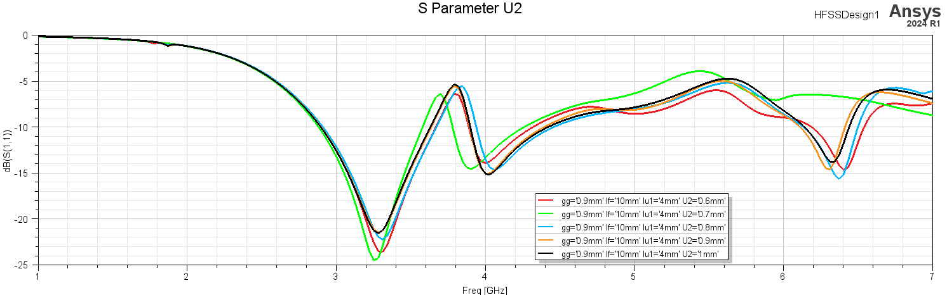

Figure ‎4.29. U2=0.6, U2=0.7, U2=0.8, U2=0.9, U2=1

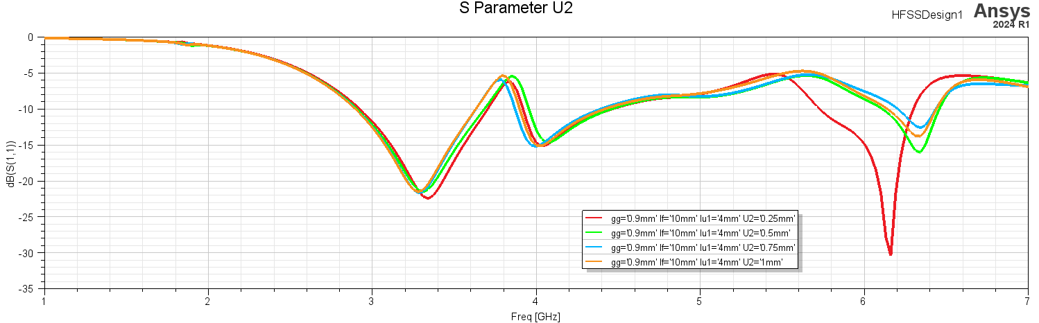

Figure ‎4.30. U1=0.25, U1=0.5, U1=0.75, U1=1

U2 the width of the left U2 shape slot it effects the resonant frequencies and the power at all frequencies

**lu parameter**

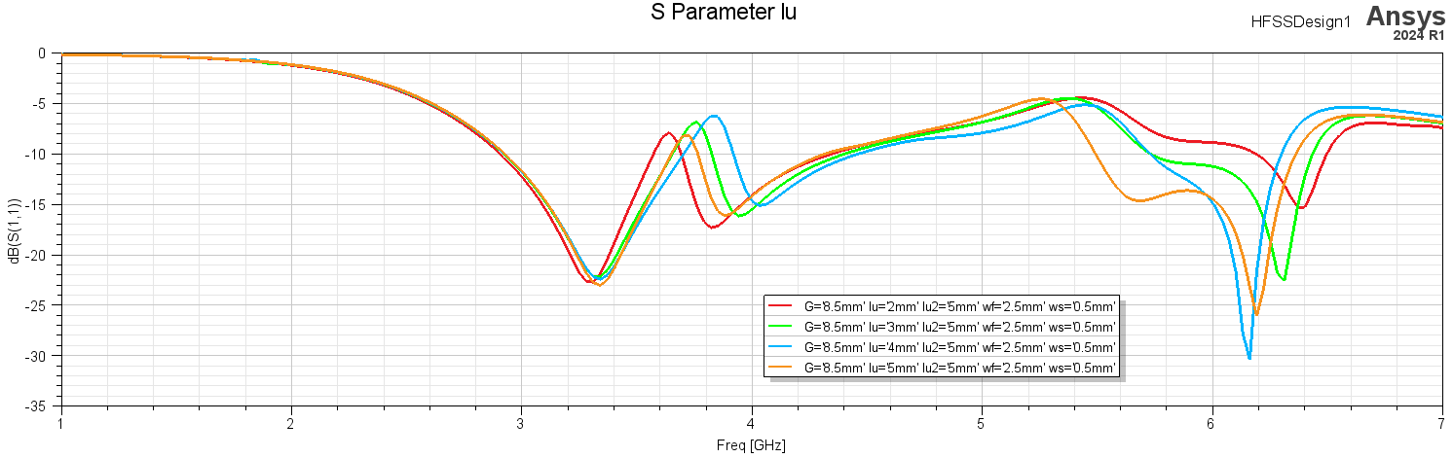

Figure ‎4.31. lu=2, lu=3, lu=4, lu=5

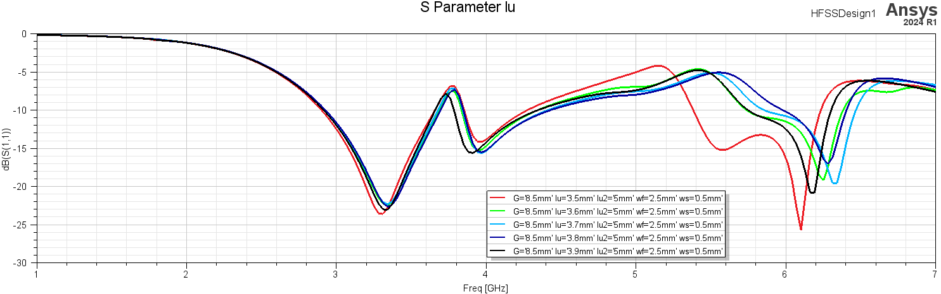

Figure ‎4.32. lu=3.5, lu=3.6, lu=3.7, lu=3.8, lu=3.9

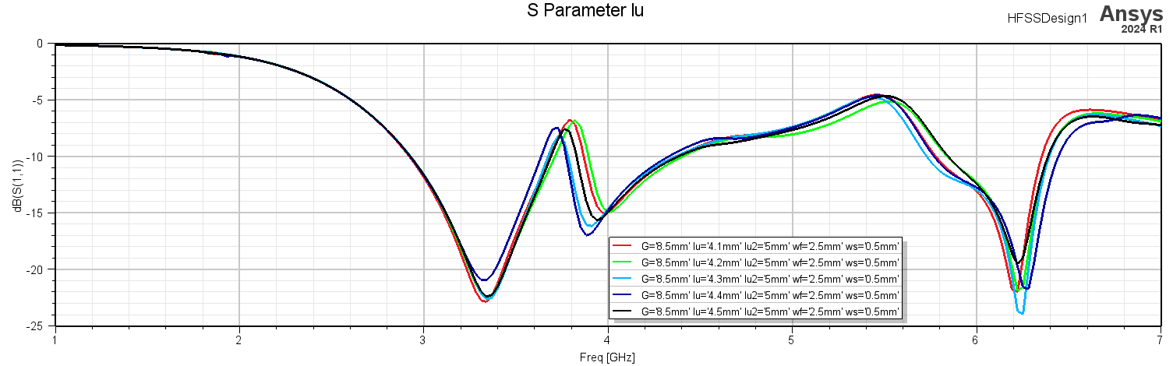

Figure ‎4.33. lu=4.1, lu=4.2, lu=4.3, lu=4.4, lu=4.5

lu the length of slot U it shifts the resonant frequencies and the power specially at 6GHz

**lu1 parameter**

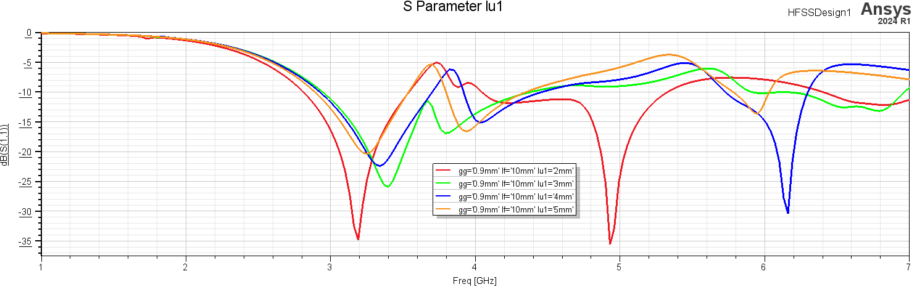

Figure ‎4.34. lu1=2, lu1=3, lu1=4, lu1=5

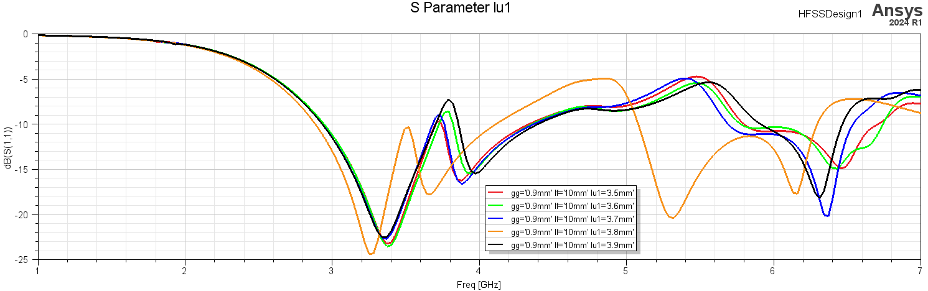

Figure ‎4.35. lu1=3.5, lu1=3.6, lu1=3.7, lu1=3.8, lu1=3.9

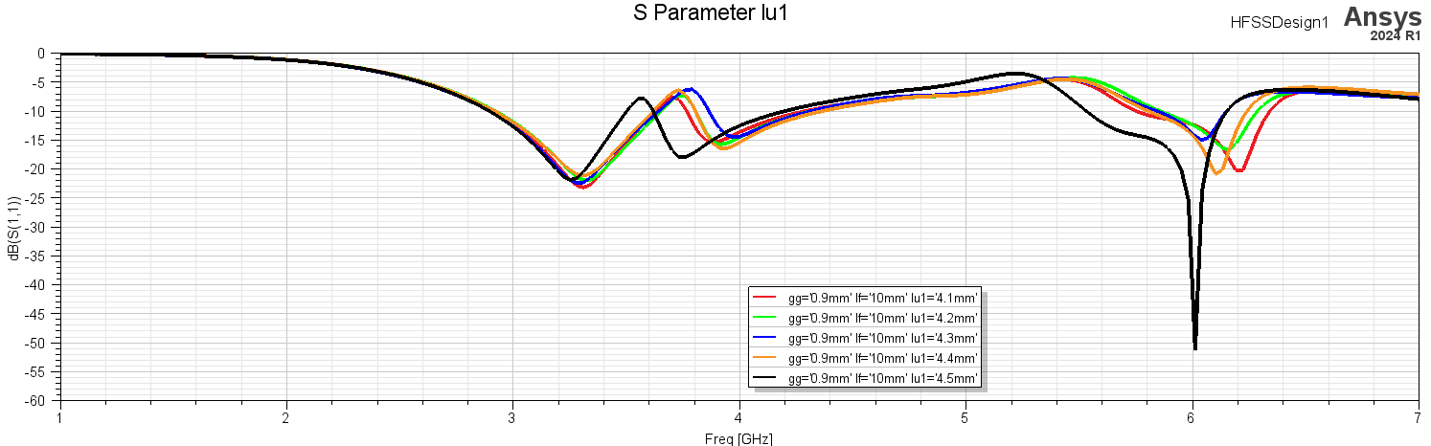

Figure ‎4.36. lu1=4.1, lu1=4.2, lu1=4.3, lu1=4.4, lu1=4.5

lu1 the length of slot U1 it effects the resonant frequencies and the power at all frequencies

**lu2 parameter**

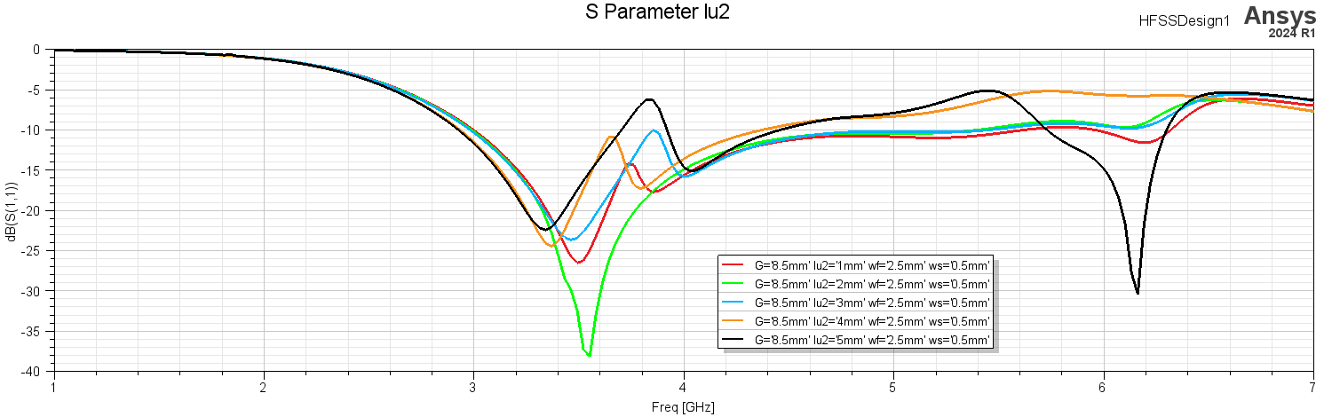

Figure ‎4.37. lu2=2, lu2=3, lu2=4, lu2=5

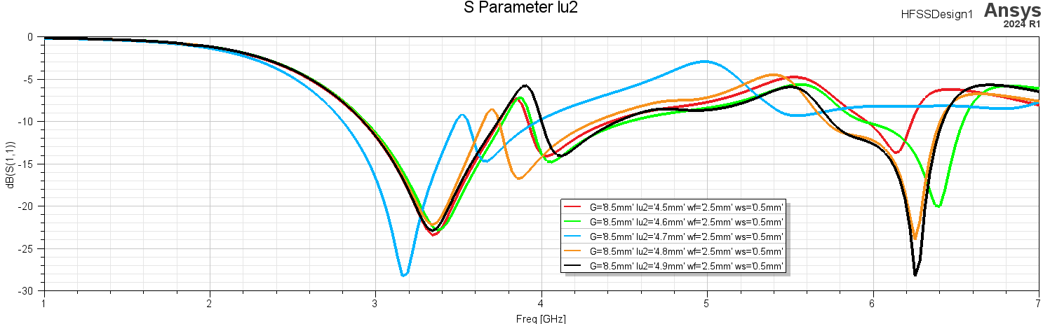

Figure ‎4.38. lu2=4.5, lu2=4.6, lu4.7=4, lu2=4.8, lu2=4.9

lu2 the length of slot U2 it effects the resonant frequencies and the power at all frequencies

**ls parameter**

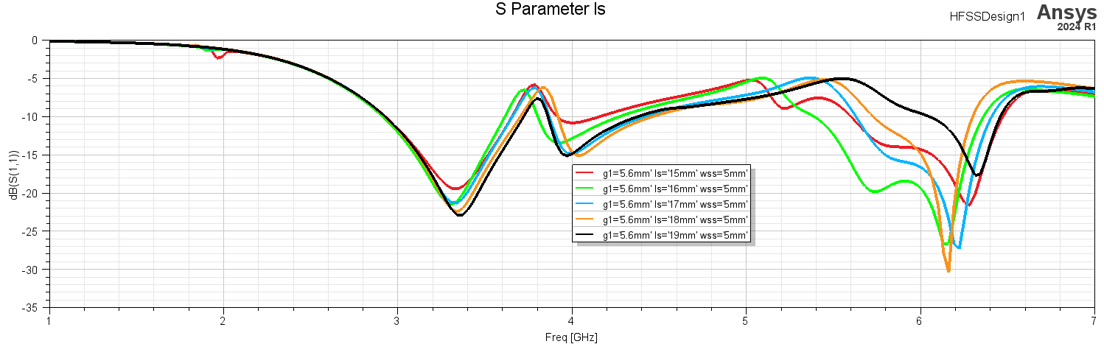

Figure ‎4.39. ls=15, ls=16, ls=17, ls=18, ls=19

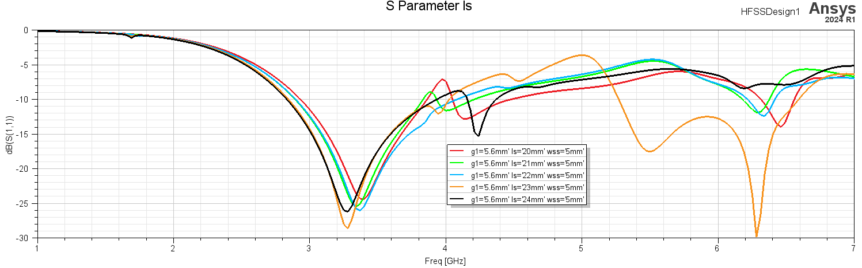

Figure ‎4.40. ls=20, ls=21, ls=22, ls=23, ls=24

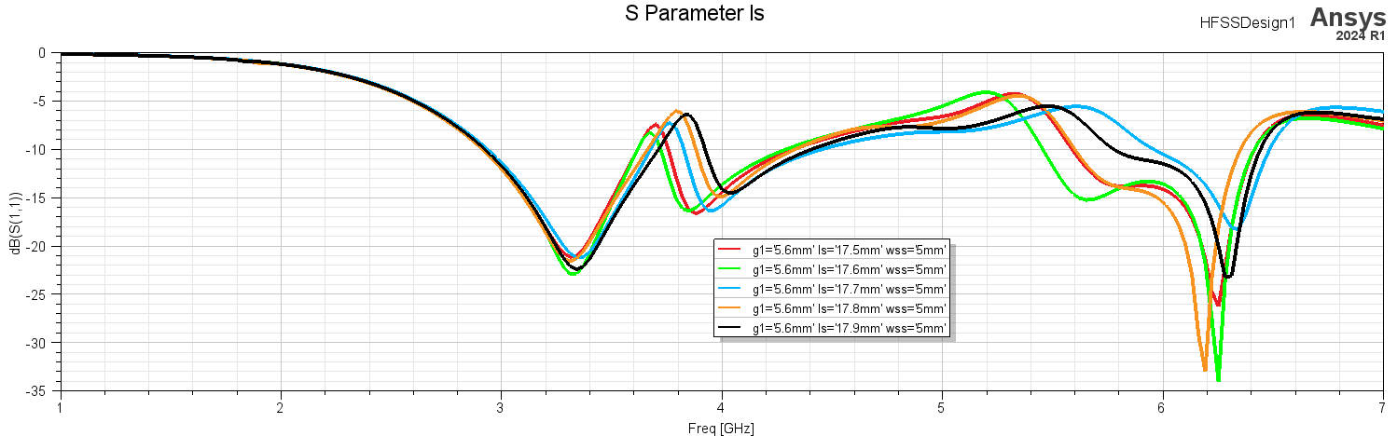

Figure ‎4.41. ls=17.5, ls=17.6, ls=17.7, ls=17.8, ls=17.9

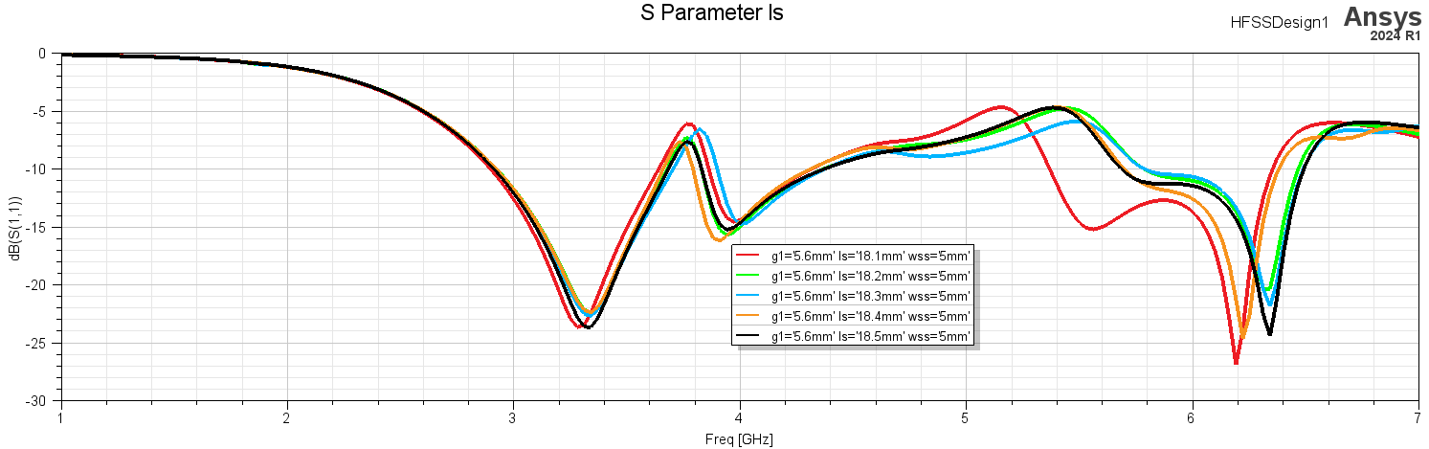

Figure ‎4.42. ls=18.1, ls=18.2, ls=18.3, ls=18.4, ls=18.5

ls the length from coordination center (0,0,0) to center of SRR it shift 4GHz and 6GHz and effect the power at all resonant frequencies special at 6GHz

**ws parameter**

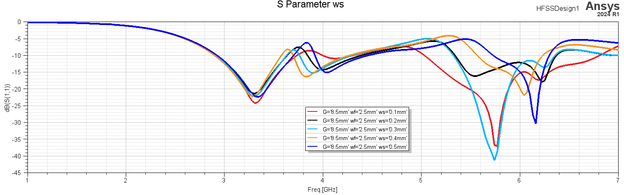

Figure ‎4.43. ws=0.1, ws=0.2, ws=0.3, ws=0.4, ws=0.5

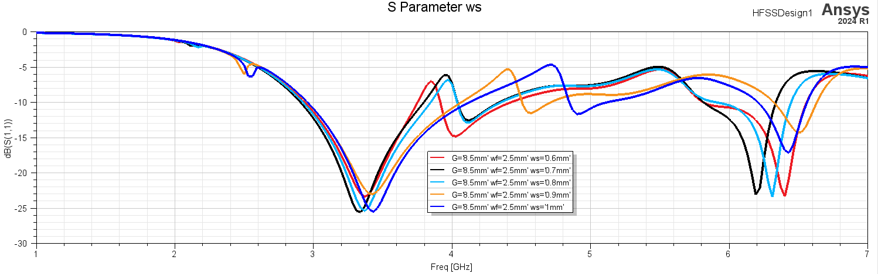

Figure ‎4.44. ws=0.6, ws=0.7, ws=0.8, ws=0.9, ws=1

ws the width of SRR effect mostly on the resonant frequencies and effects the power at 4GHz & 6GHz

**wf parameter**

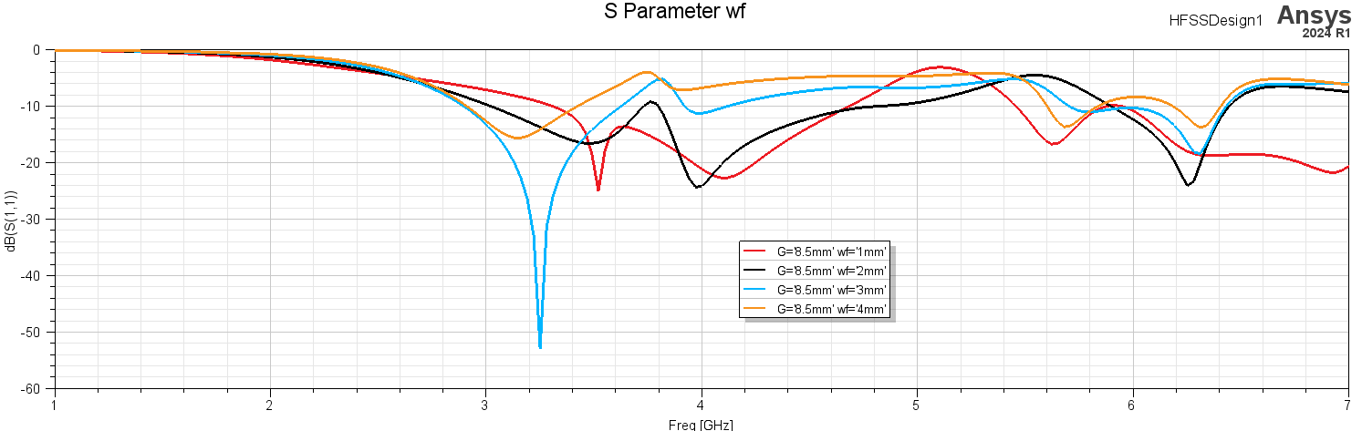

Figure ‎4.45. wf=1, wf=2, wf=3, wf=4

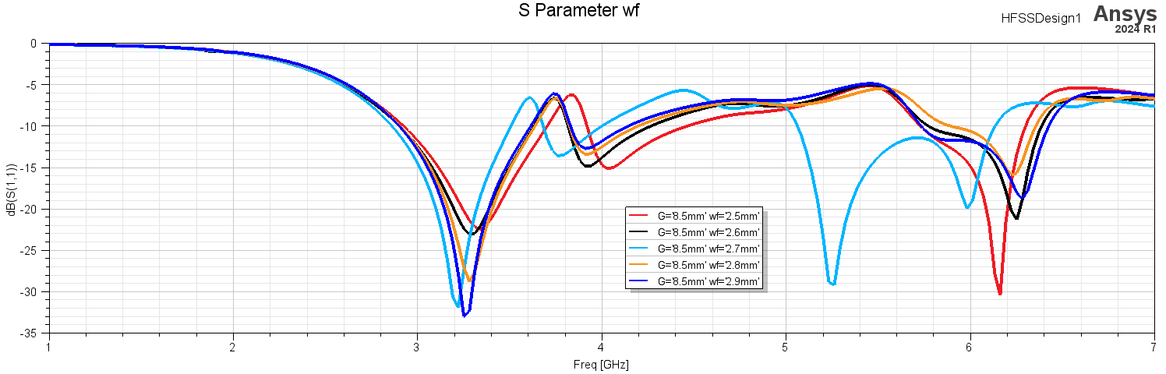

Figure ‎4.46. wf=2.5, wf=2.6, wf=2.7, wf=2.8, wf=2.9

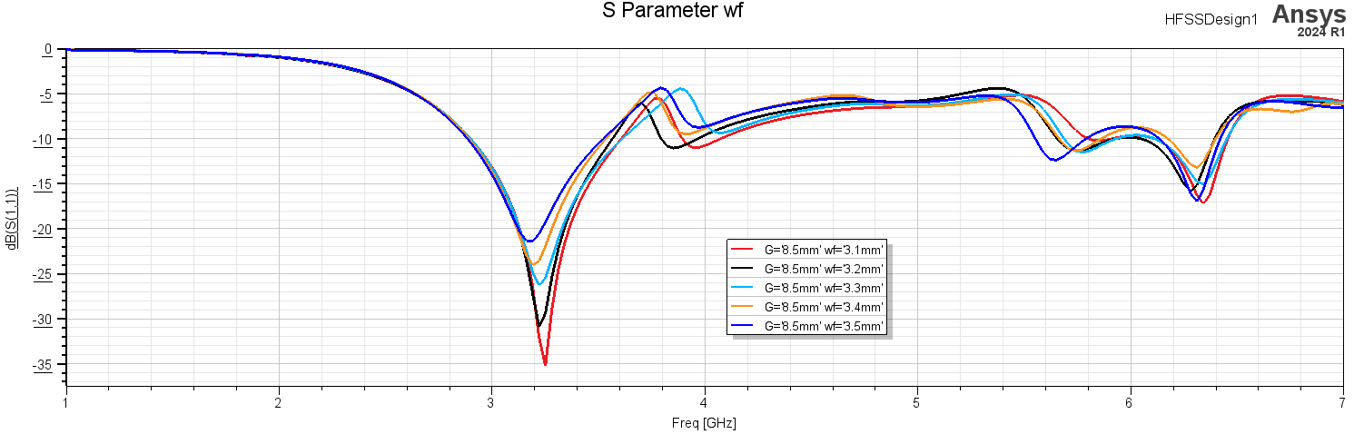

Figure ‎4.47. wf=3.1, wf=3.2, wf=3.3, wf=3.4, wf=3.5

wf the width of feed line effect mostly on the power at all resonant frequencies and some shift at 4GHz

**wss parameter**

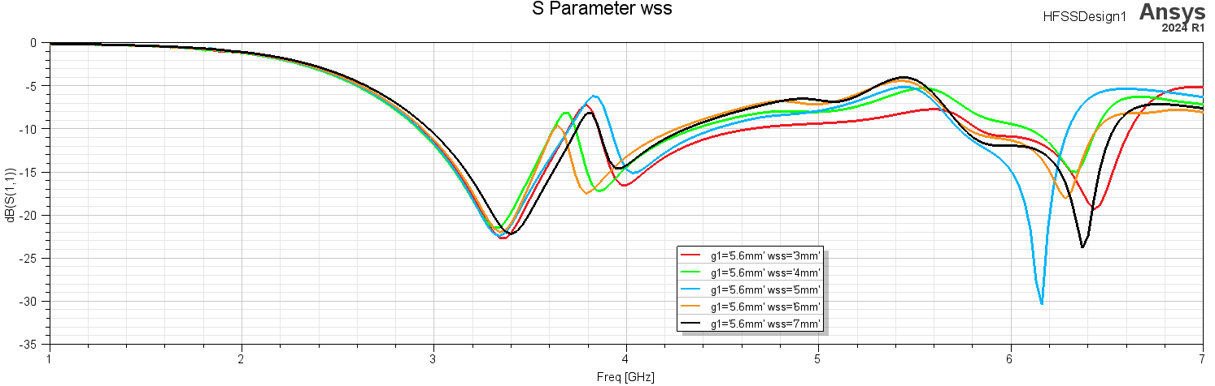

Figure ‎4.48. wss=3, wss=4, wss=5, wss=6, wss=7

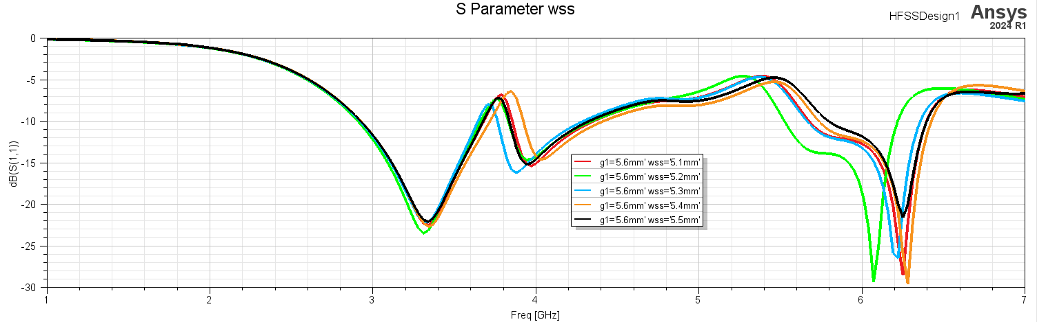

Figure ‎4.49. wss=5.1 wss=5.2, wss=5.3, wss=5.4, wss=5.5

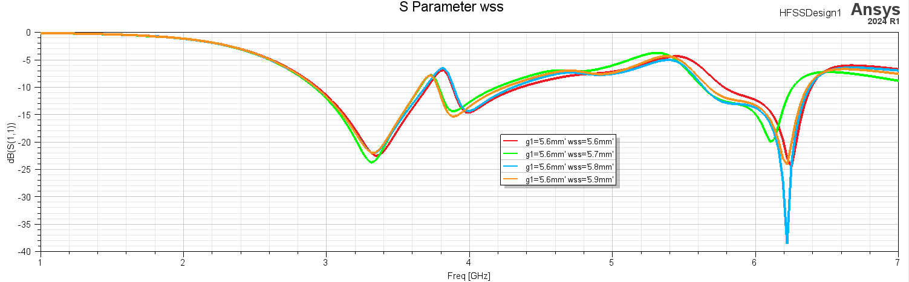

Figure ‎4.50. wss=5.6, wss=5.7, wss=5.8, wss=5.9

wss width of U shape it shifts resonant frequencies at 4GHz & 6GHz and small shift on 3.3GHz and effect the power mostly at 6GHz

**lf parameter**

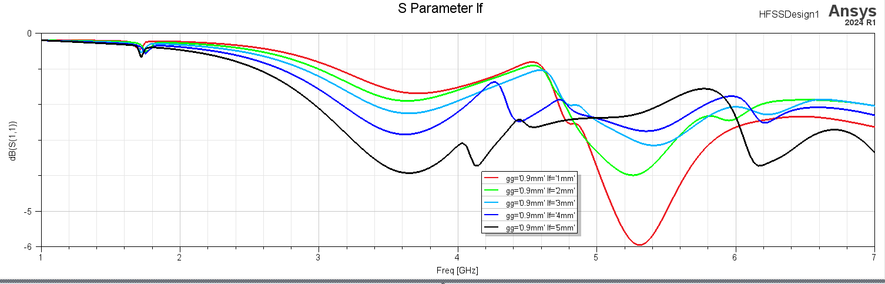

Figure ‎4.51. lf=1, lf=2, lf=3, lf=4, lf=5

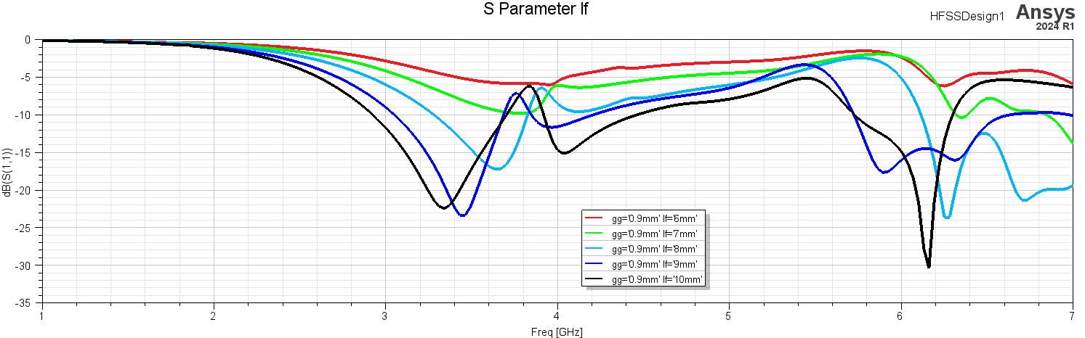

Figure ‎4.52. lf=6, lf=7, lf=8, lf=9, lf=10

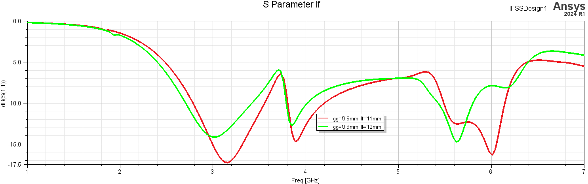

Figure ‎4.53. lf=11, lf=12

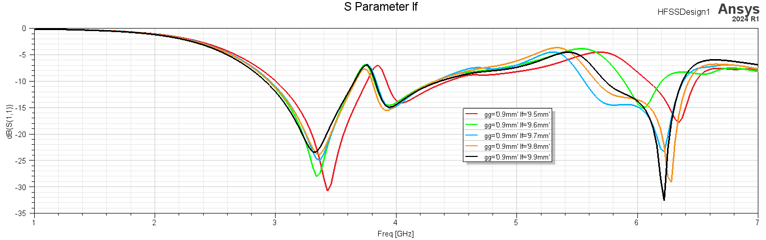

Figure ‎4.54. lf=9.5, lf=9.6, lf=9.7, lf=9.8, lf=9.9

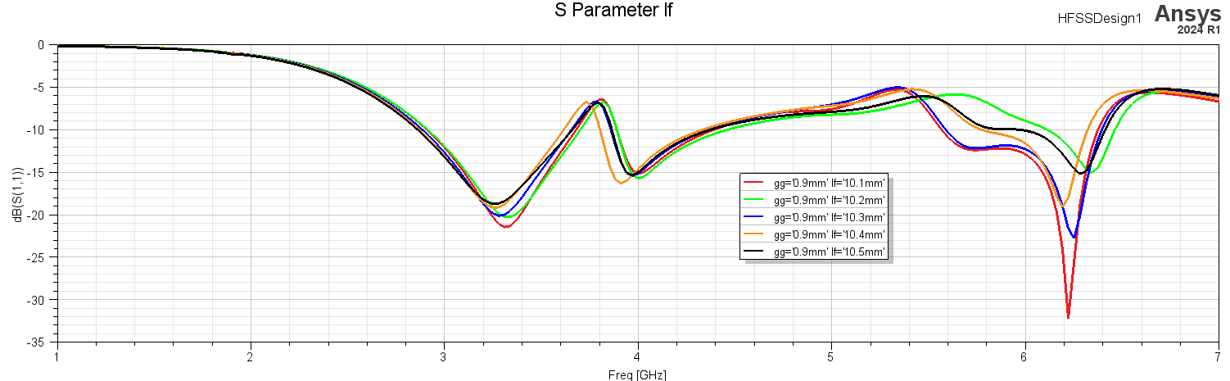

Figure ‎4.55. lf=10.1, lf=10.2, lf=10.3, lf=10.4, lf=10.5

lf length of feed line it shifts resonant frequencies at 3.3GHz & 6GHz and small shift at 4GHz and effects the power mostly at 3.3GHz & 6GHz

**gg parameter**

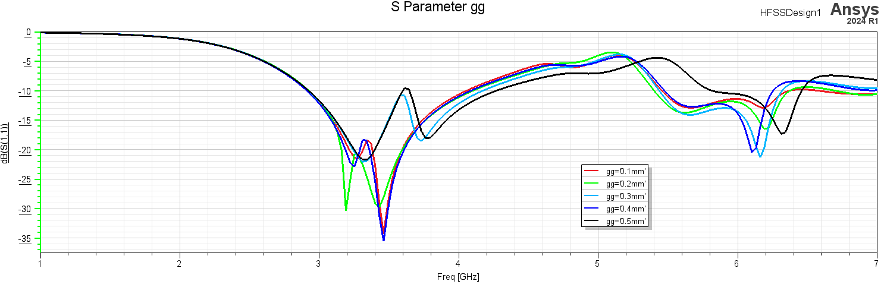

Figure ‎4.56. gg=0.1, gg=0.2, gg=0.3, gg=0.4, gg=0.5

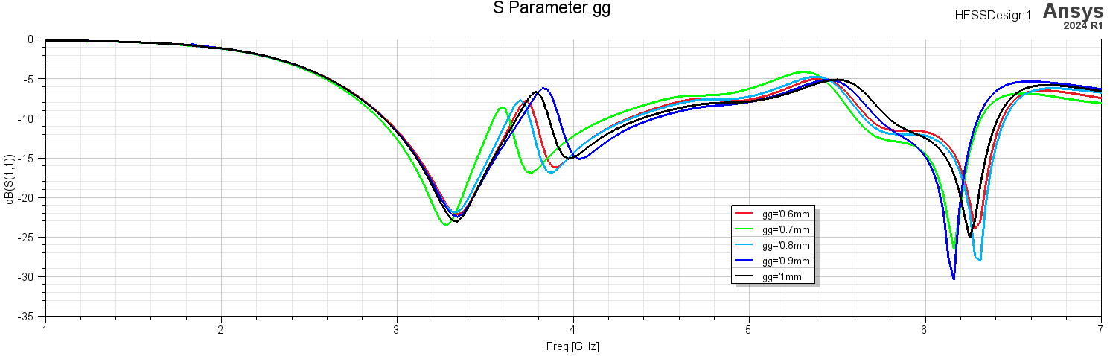

Figure ‎4.57. gg=0.6, gg=0.7, gg=0.8, gg=0.9, gg=1

gg the width of SRR gape it effect mostly the resonant frequencies at 4GHz & 6GHz

**G parameter**

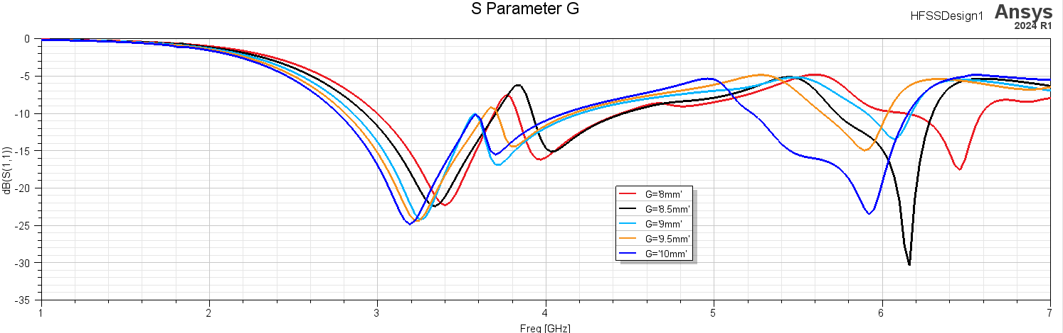

Figure ‎4.58. G=8, G=8.5, G=9, G=9.5, G=10

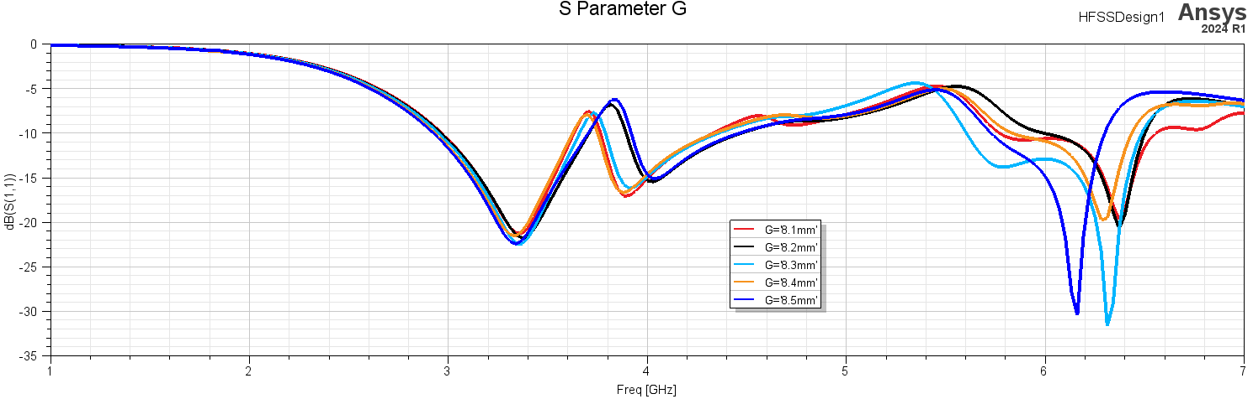

Figure ‎4.59. G=8.1, G=8.2, G=8.3, G=8.4, G=8.5

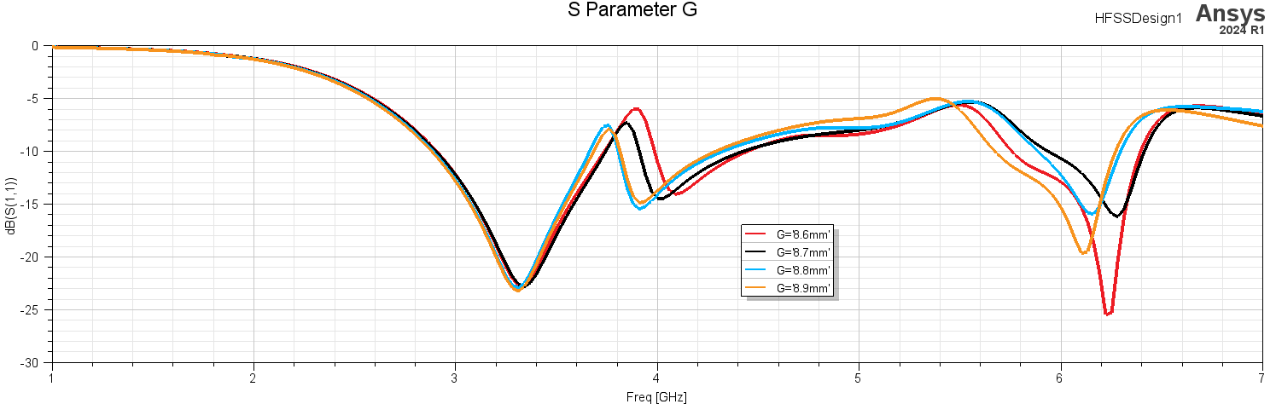

Figure ‎4.60. G=8.6, G=8.7, G=8.8, G=8.9

G the radius of patch hexagonal effects the power and shifts all resonant frequencies

**g1 parameter**

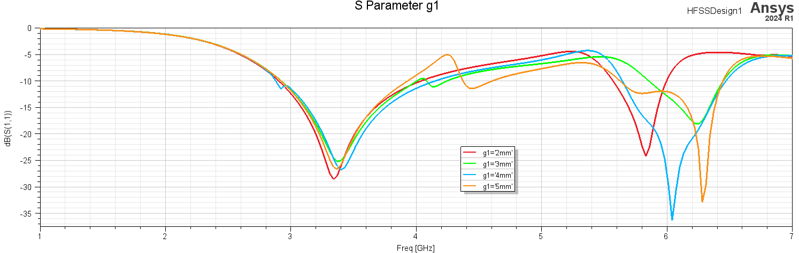

Figure ‎4.61. g1=2, g1=3, g1=4, g1=5

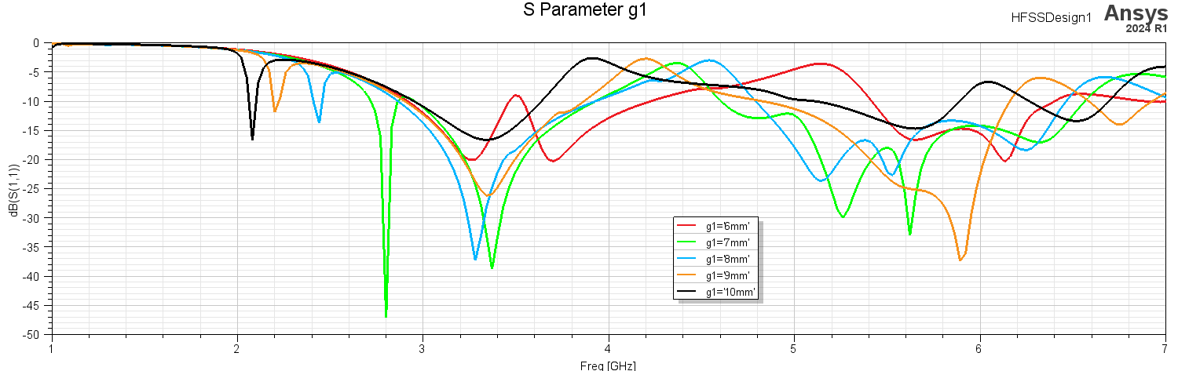

Figure ‎4.62. g1=6, g1=7, g1=8, g1=9, g1=10

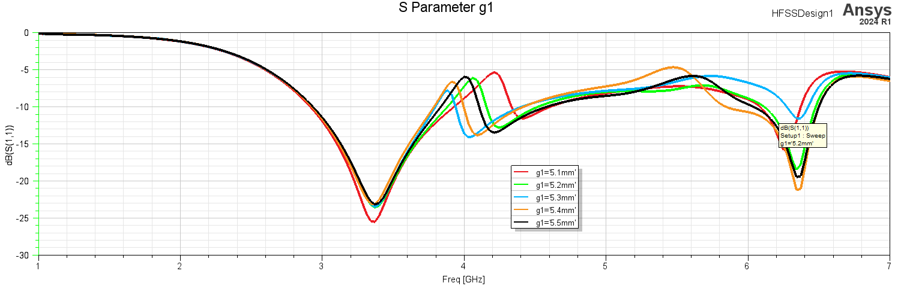

Figure ‎4.63. g1=5.1, g1=5.2, g1=5.3, g1=5.4, g1=5.5

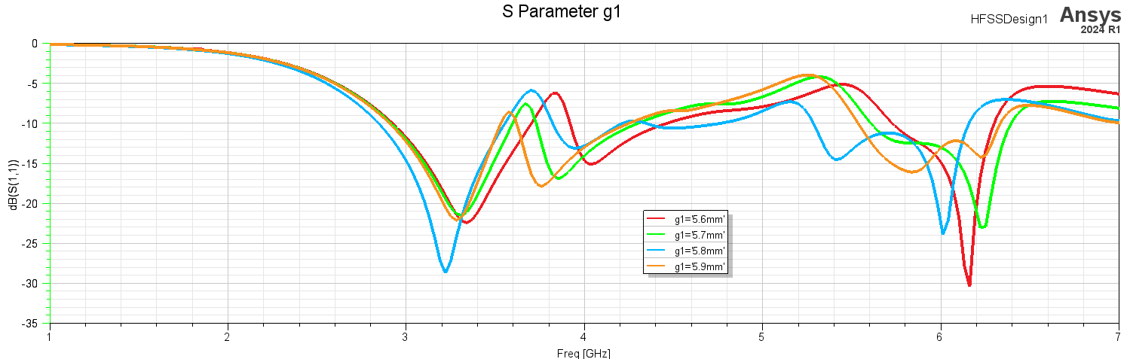

Figure ‎4.64. g1=5.6, g1=5.7, g1=5.8, g1=5.9

g1 the radius of SRR hexagonal effects the power and shifts all resonant frequencies and at specific value cane give a new band but it is narrow

**W parametric**

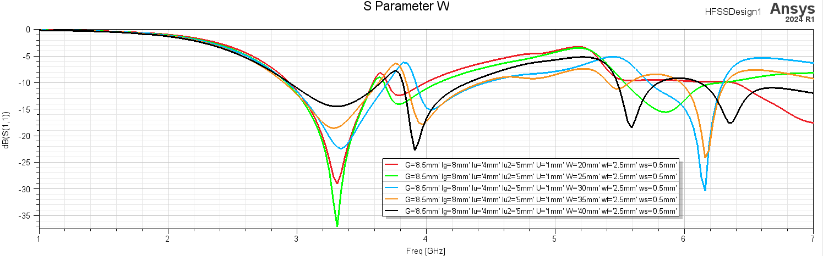

Figure ‎4.65. W=20, W=25, W=30, W=35, W=40

W width of substrate effects the power at all frequencies and shifts the resonant frequencies at 4GHz and 6GHz

**L parametric**

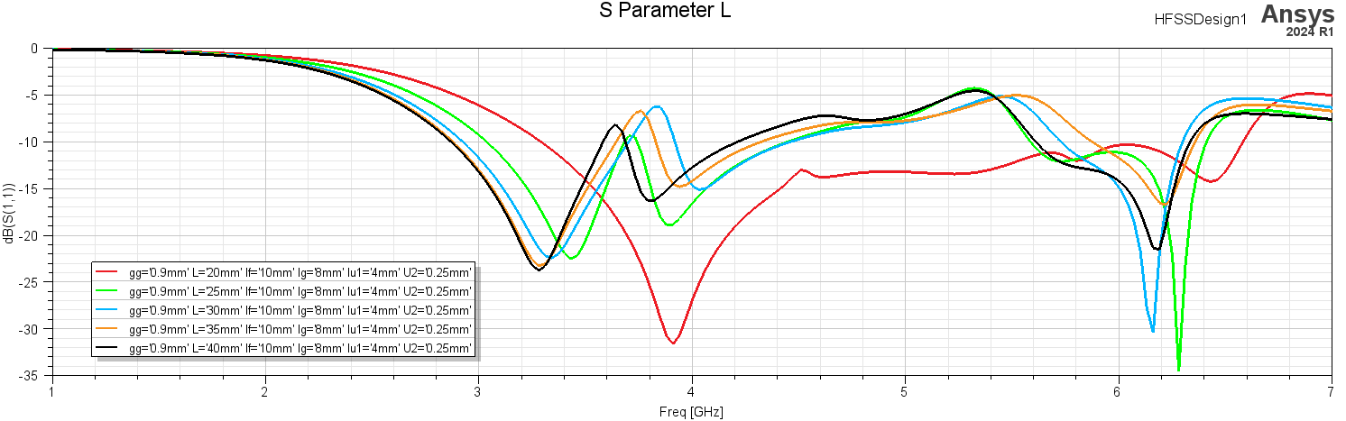

Figure ‎4.66. L=20, L=25, L=30, L=35, L=40

L the length of substrate effects the power and shift the all resonant frequencies

**Results**

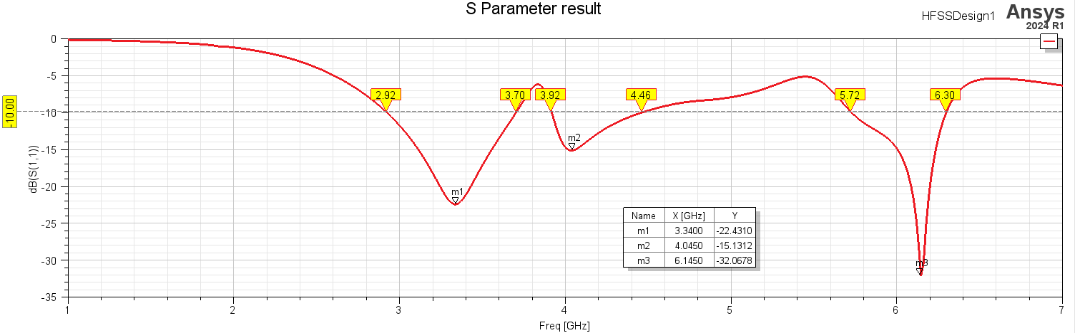

Figure ‎4.67. Final result of S11

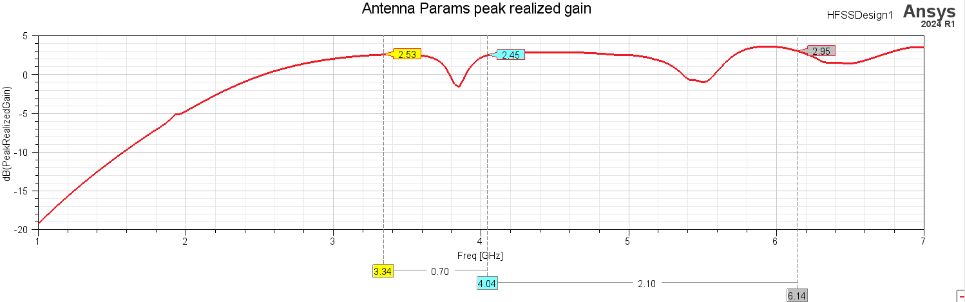

Figure ‎4.68. Final result of Peak Realized Gain

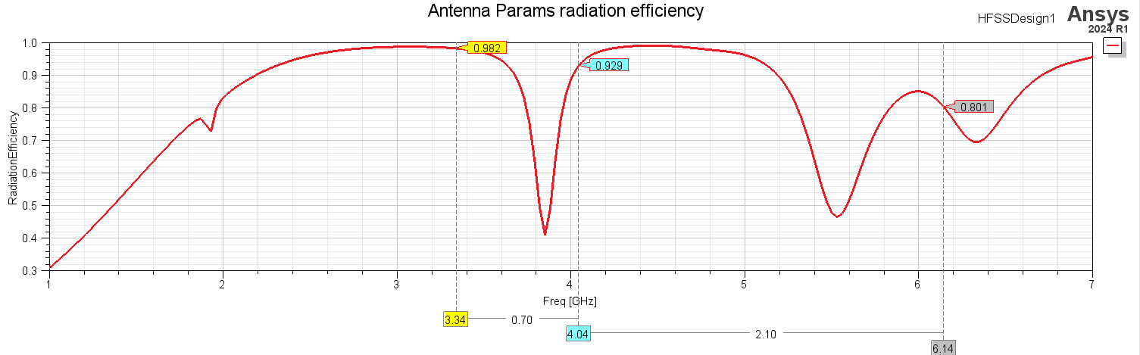

Figure ‎4.69. Final result of Radiation Efficiency

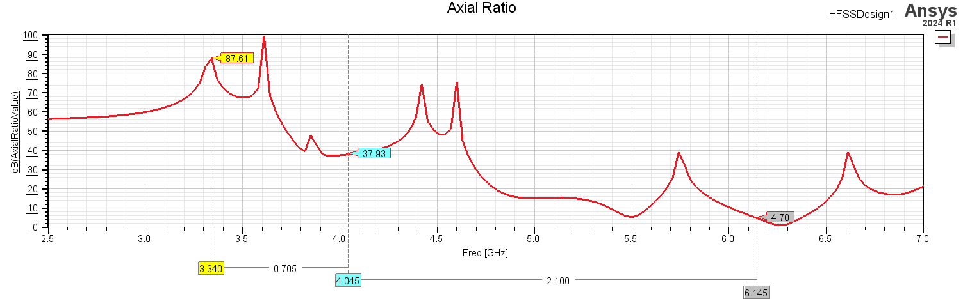

Figure ‎4.70. Final result of Axial Ratio

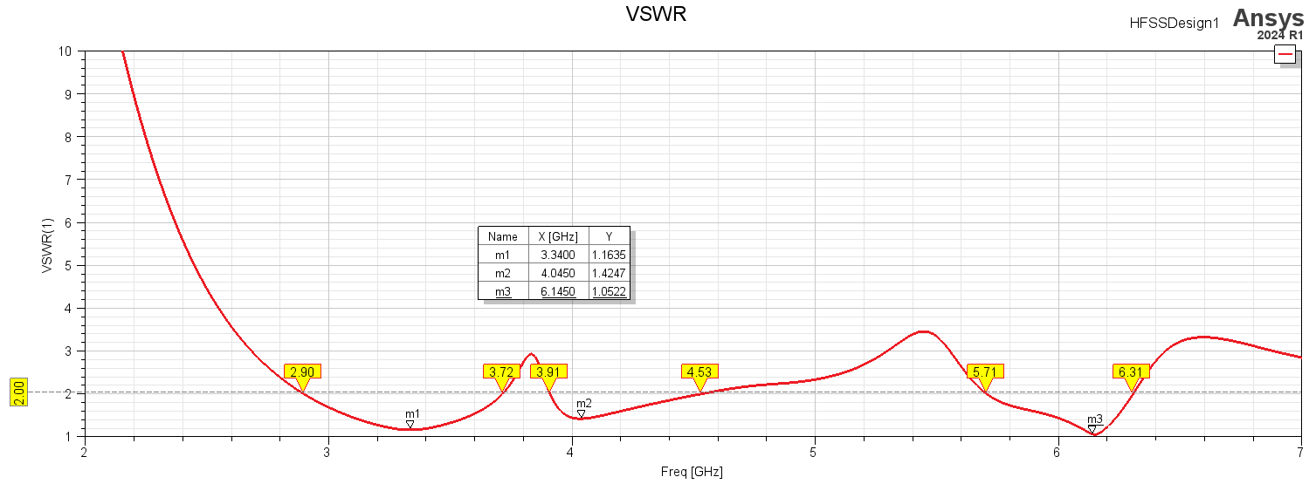

Figure ‎4.71. Final result of voltage standing wave ratio VSWR

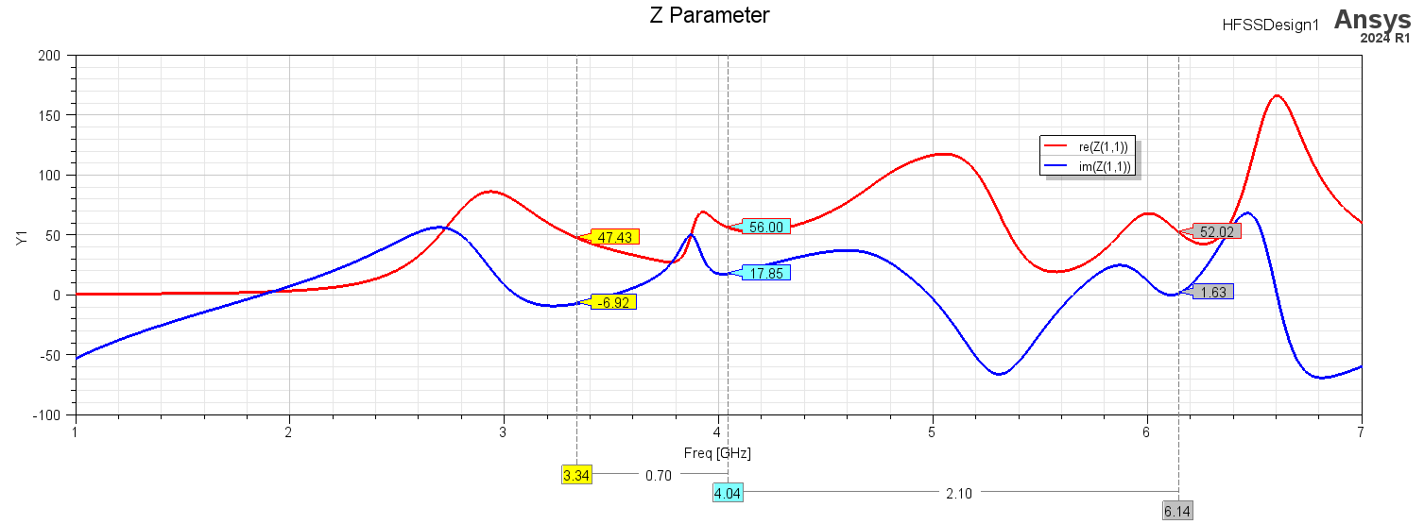

Figure ‎4.72. Final result of Z parameter

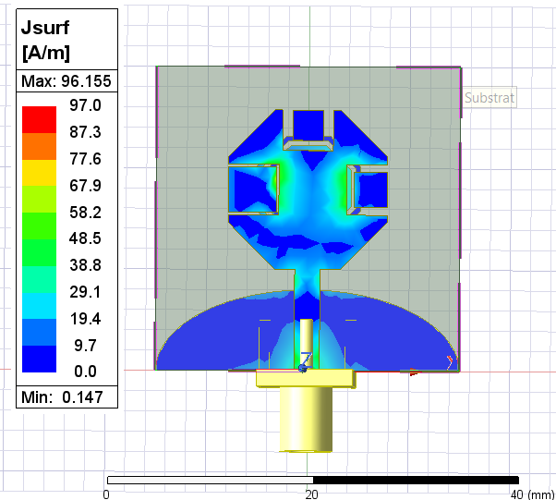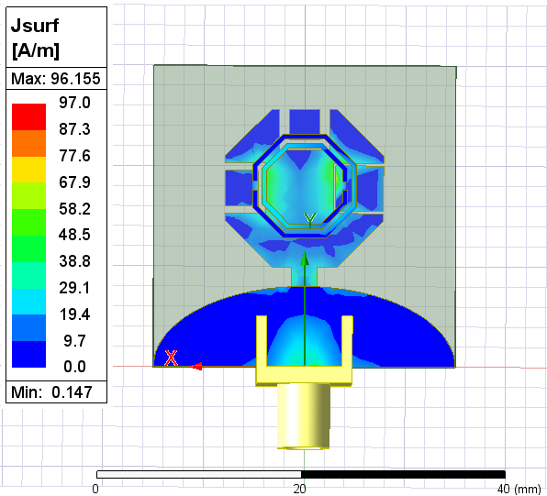

Figure ‎4.73Magnitude of current distribution Top view at 3.34GHz

Figure ‎4.74Magnitude of current distribution Bottom view at 3.34GHz

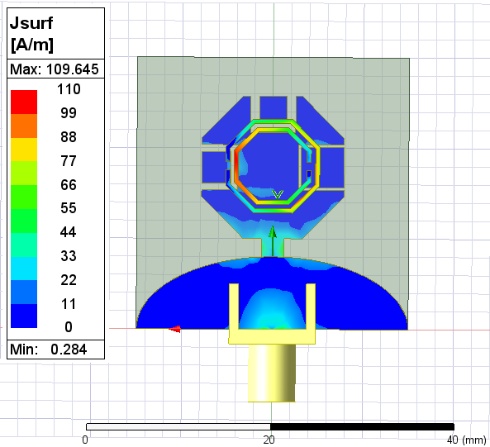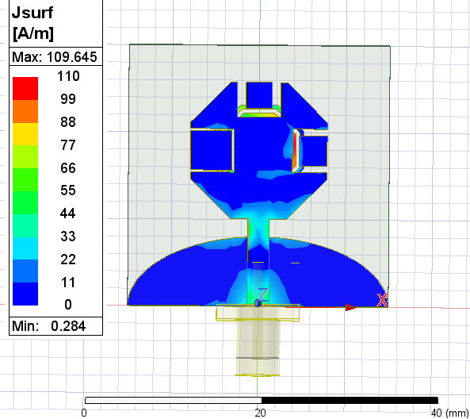

Figure ‎4.75Magnitude of current distribution Bottom view at 4.045GHz

Figure ‎4.76Magnitude of current distribution Top view at 4.045GHz

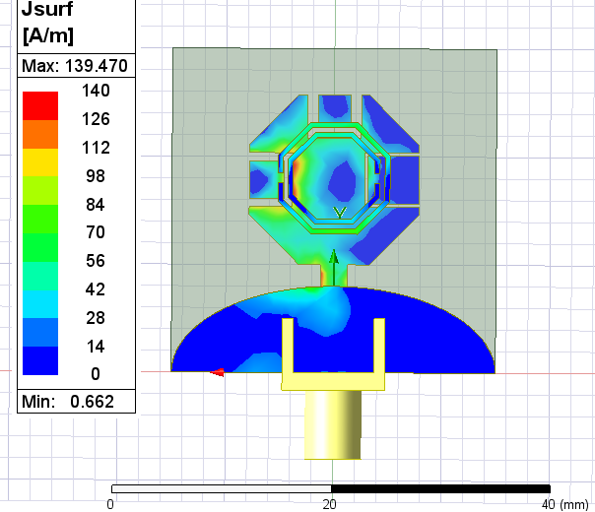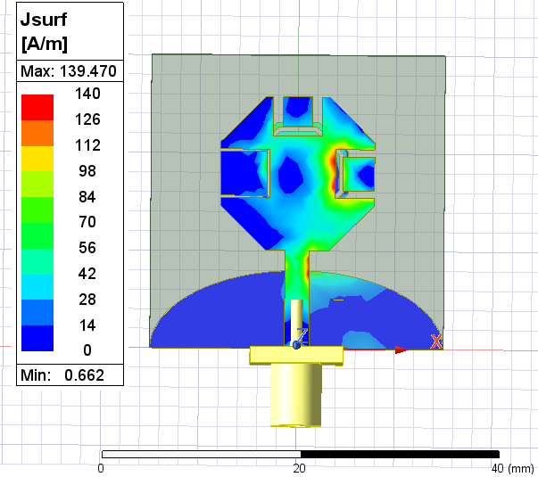

Figure ‎4.77. Magnitude of current distribution Bottom view at 6.145GHz

Figure ‎4.78Magnitude of current distribution Top view at 6.145GHz

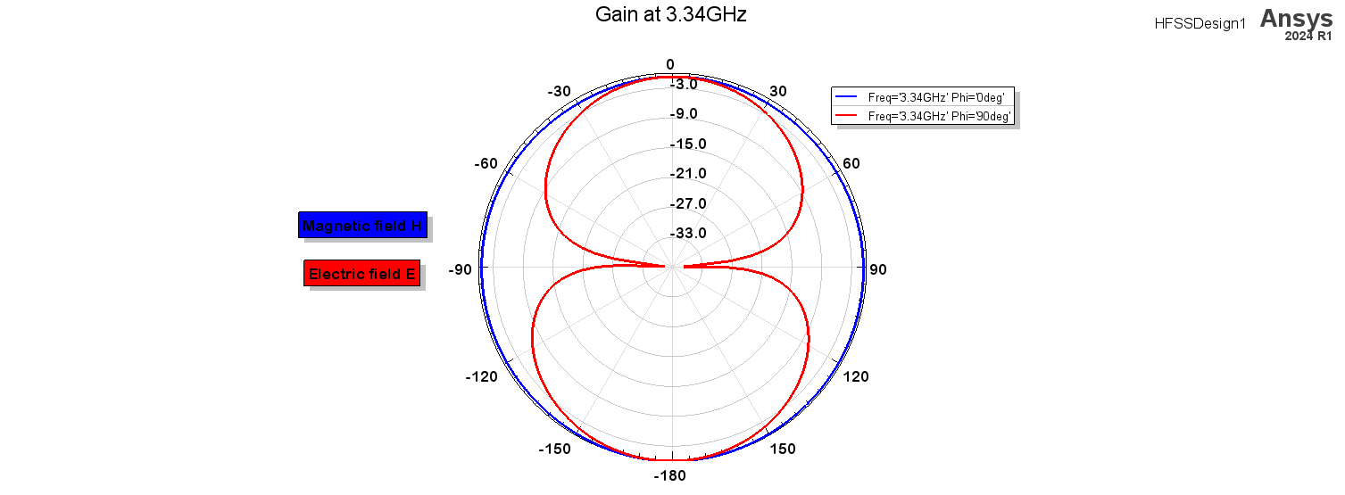

Figure ‎4.79. Final result of radiation patterned at frequency 3.34GHz

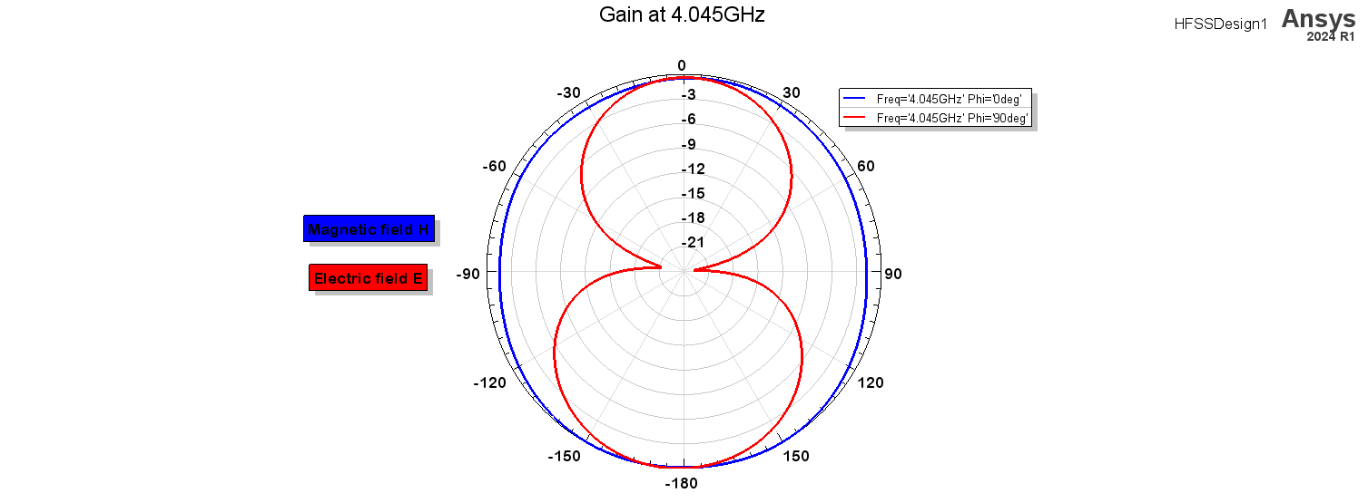

Figure ‎4.80. Final result of radiation patterned at frequency 4.045GHz

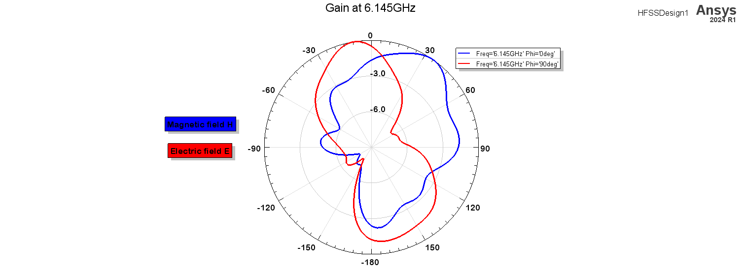

Figure ‎4.81. Final result of radiation patterned at frequency 6.145GHz

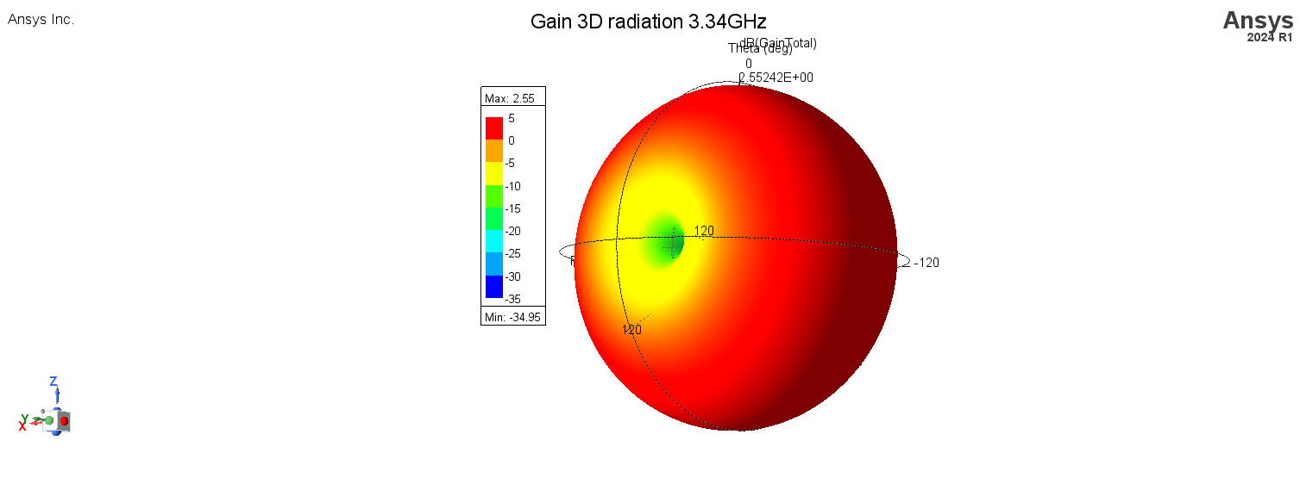

Figure ‎4.82. 3D radiation pattern at 3.34GHz

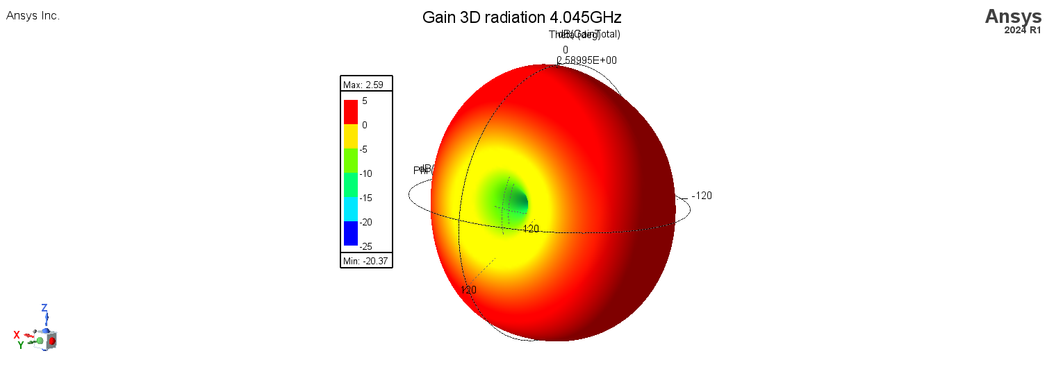

Figure ‎4.83. 3D radiation pattern at 4.045GHz

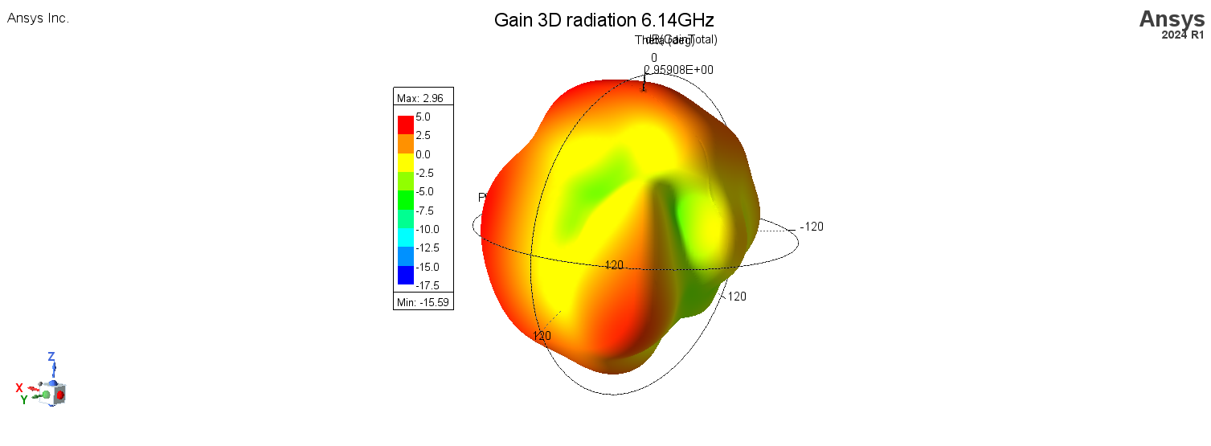

Figure ‎4.84. 3D radiation pattern at 6.14GHz

Table **Error! Use the Home tab to apply 0 to the text that you want to appear here.**‑5. Summary performance

|  |  |  |  |  |
| --- | --- | --- | --- | --- |
| Frequency (GHz) | Working bandwidth (GHZ) | Gain (dB) | Radiation Efficiency% | Axial ration (dB) |
| 3.34 | 2.92-3.70  Bandwidth (780MHz) | 2.53 | 98.2 | 87.61  Linear |
| 4.05 | 3.92-4.46  Bandwidth (540MHz) | 2.45 | 92.9 | 37.93  Linear |
| 6.145 | 5.72-6.3  Bandwidth (580MHz) | 2.95 | 80.1 | 4.7  Elliptical |

Table **Error! Use the Home tab to apply 0 to the text that you want to appear here.**‑6. The summary performance of the proposed monopole [1]

|  |  |  |  |  |
| --- | --- | --- | --- | --- |
| Monopole Antenna with Circular SRR | | | | |
| Frequency (GHz) | 2.09 | 3.5 | 4.90 | 5.58 |
| Working Bandwidth | (2.05-2.15) 100 MHz | (3.02-4.40) 1.380 GHz | (4.74 -6.27) 1.530 GHz | |
| Gain (dB) | 1.76 | 2.33 | 2.90 | 1.96 |
| Radiation Efficiency % | 73.29 | 80.34 | 26.94 | 56.74 |

**Compare to reproduce paper I achieved Multiband-Wideband with more efficiency and more gain**

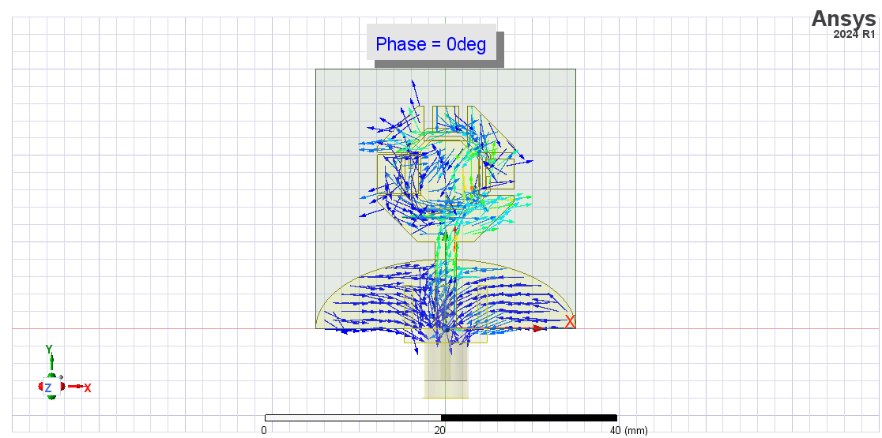

Figure ‎4.85. vector current distribution at 6.145GHz at angel 0 deg.

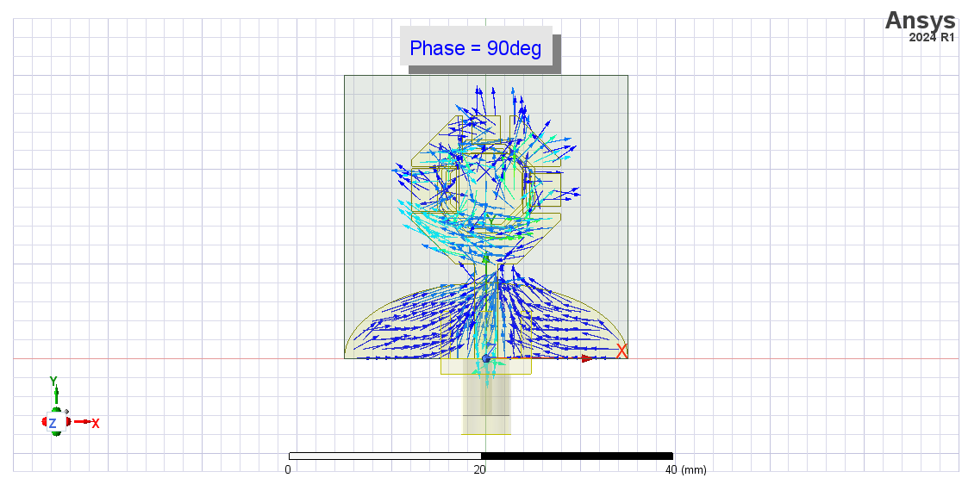

Figure ‎4.86. vector current distribution at 6.145GHz at angel 90 deg.

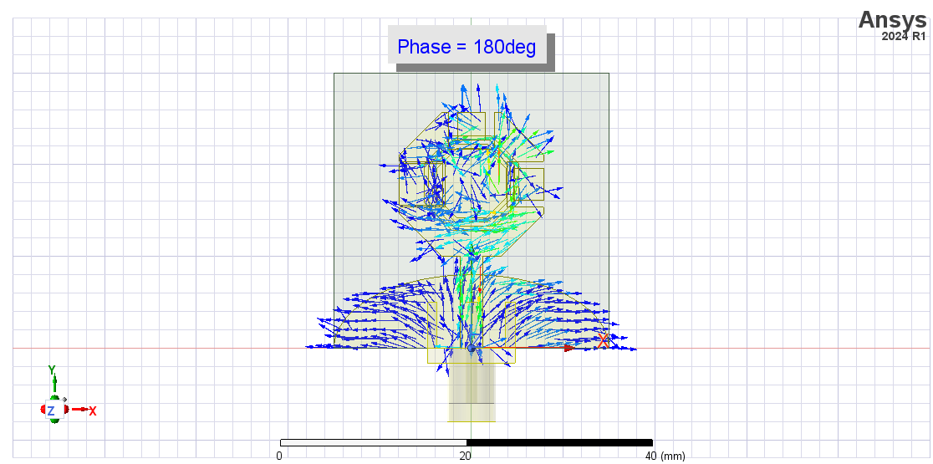

Figure ‎4.87. vector current distribution at 6.145GHz at angel 180 deg.

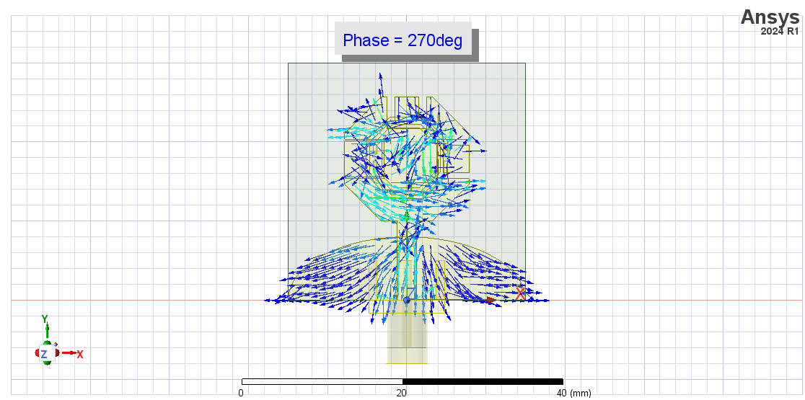

Figure ‎4.88. vector current distribution at 6.145GHz at angel 270 deg.

**Furthermore**

Some improvement cane made on the final design by replace U chape slot with L chape slot hers the comparison between them and the final design

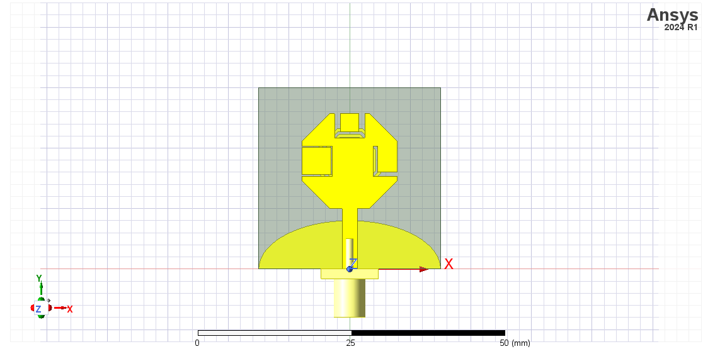1 Right Up L slot

Figure ‎4.89. Top view of right Up L slot antenna

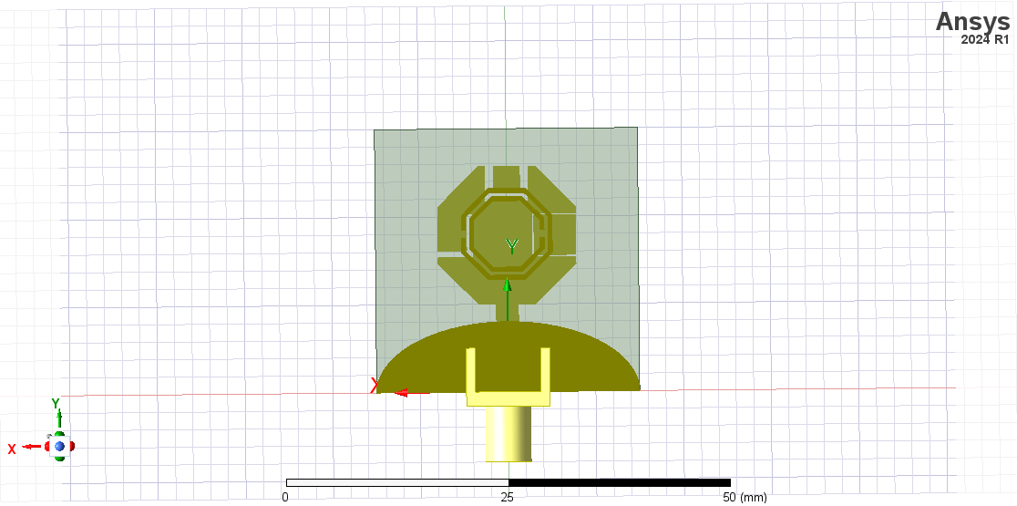

Figure ‎4.90. Bottom view of right Up L slot antenna

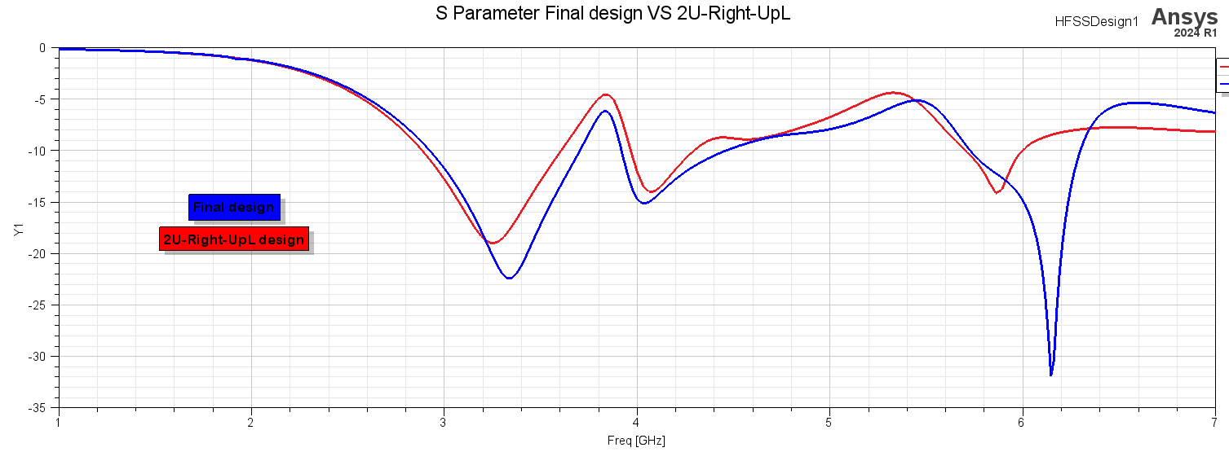

Figure ‎4.91. S11 parameter Final design VS Right Up L slot design

2 Left Up L slot

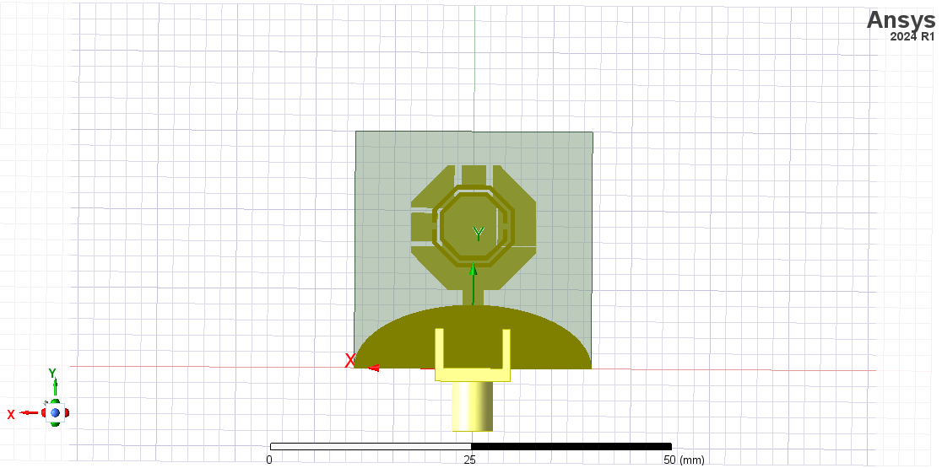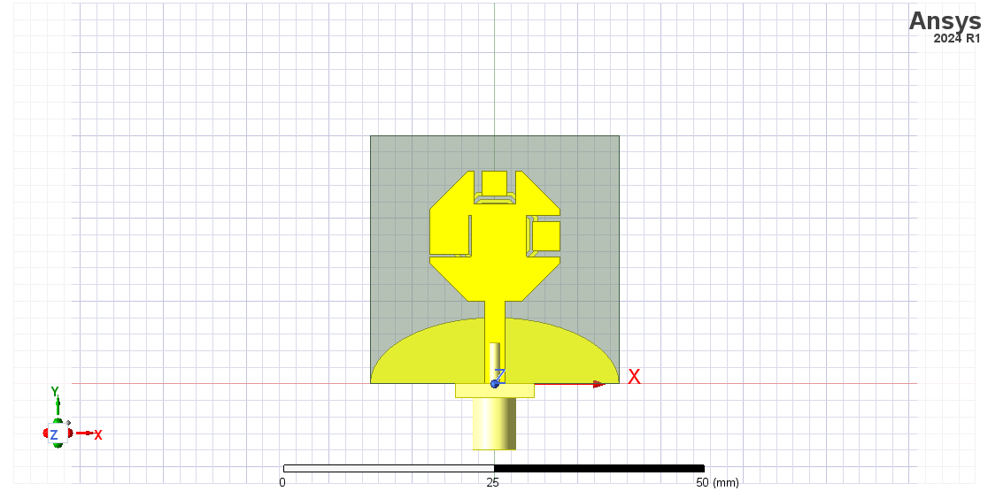

Figure ‎4.92. Bottom view of Left Up L slot antenna

Figure ‎4.93. Top view of right Up L slot antenna

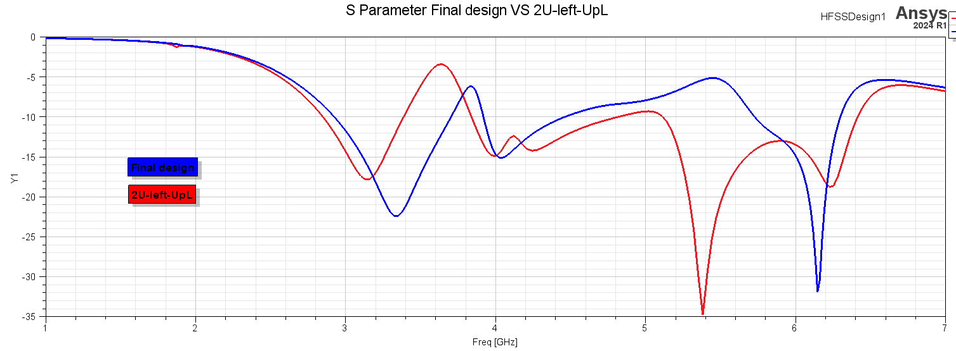

Figure ‎4.94. S11 parameter Final design VS Left Up L slot design

3 Center U slot Right & Left Up L slot

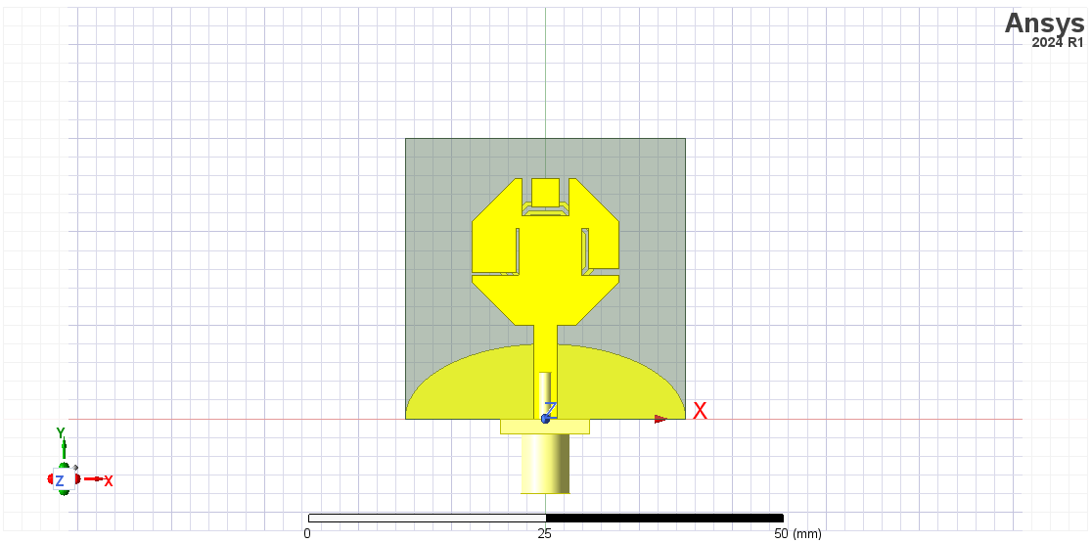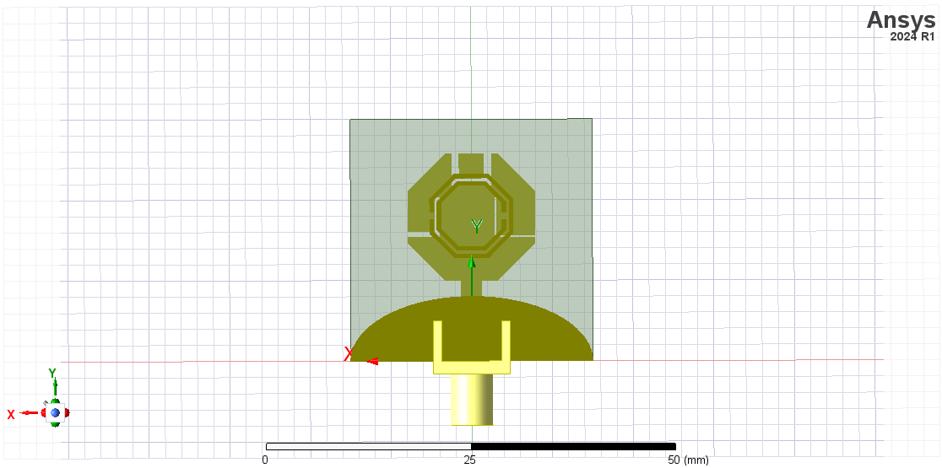

Figure ‎4.95. Top view of centre U slot right & left Up L slot antenna

Figure ‎4.96. Bottom view of centre U slot right & left Up L slot antenna

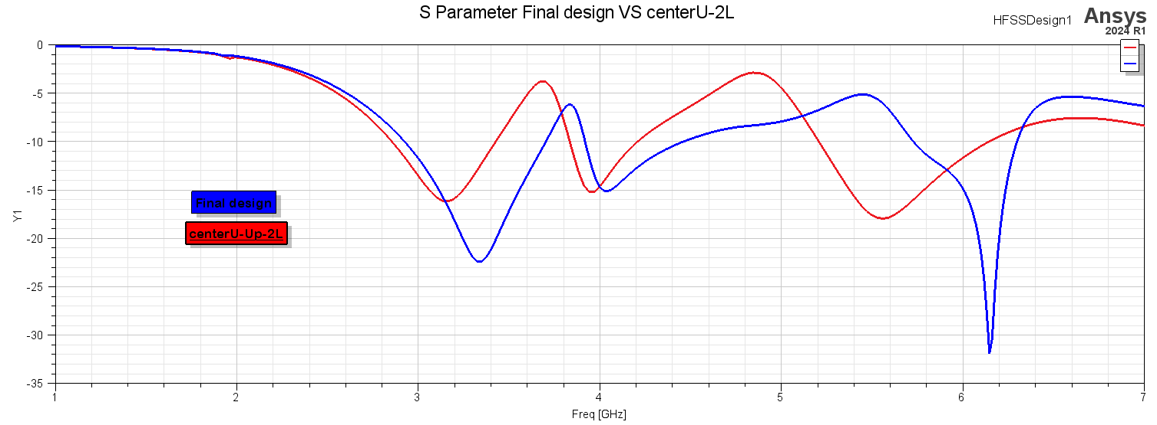

Figure ‎4.97. S11 parameter Final design VS centre U slot Right & Left Up L slot design

4 Right Down L slot

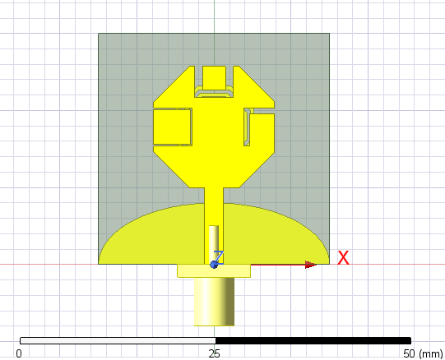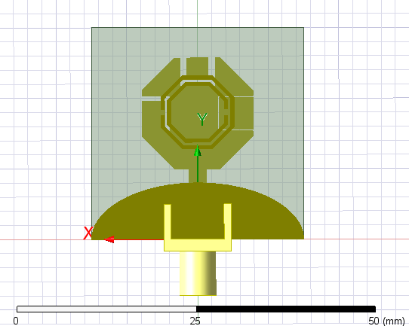

Figure ‎4.98. Top view of Right Down L slot antenna

Figure ‎4.99. Bottom view of Right Down L slot antenna

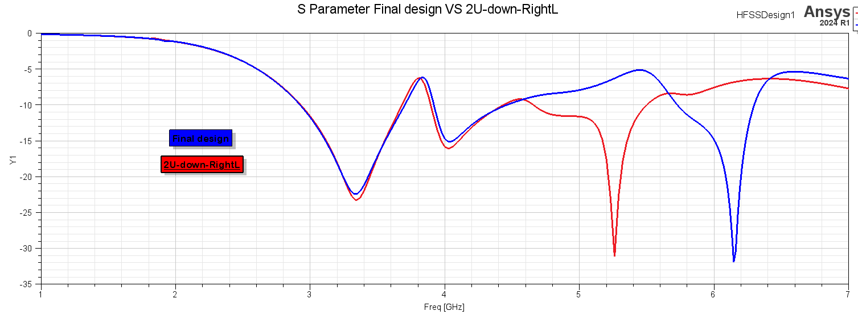

Figure ‎4.100. S11 parameter Final design VS Right Down L slot design

5 Left Down L slot

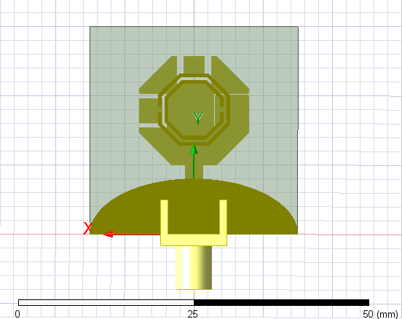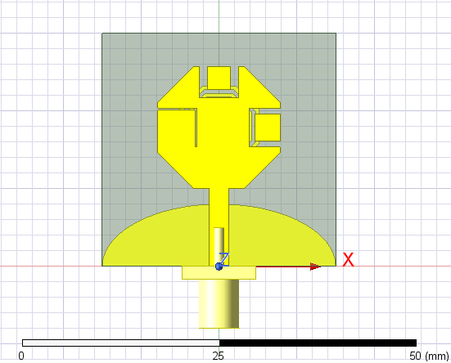

Figure ‎4.101. Bottom view of Left Down L slot antenna

Figure ‎4.102. Top view of Left Down L slot antenna

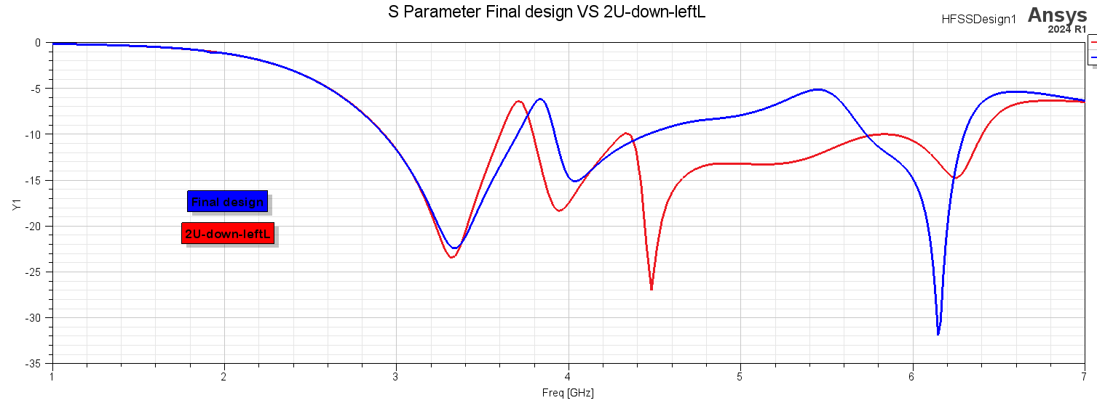

Figure ‎4.103. S11 parameter Final design VS Left Down L slot design

6 Center U slot right & left Down L slot

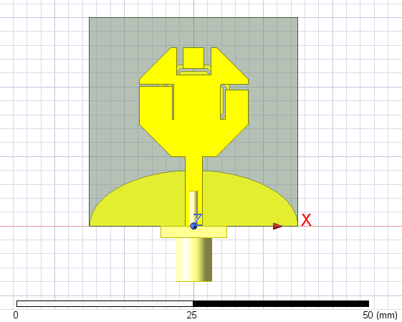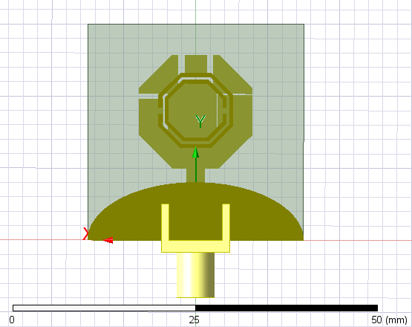

Figure ‎4.104. Top view of centre U slot right & left Down L slot antenna

Figure ‎4.105. Bottom view of centre U slot right & left Down L slot antenna

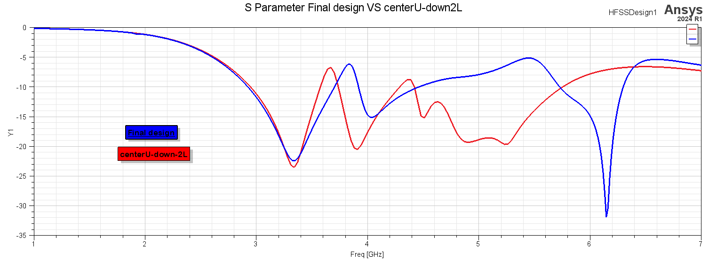

Figure ‎4.106. S11 parameter Final design VS center U slot Right & Left Down L slot design

7 Center U slot Right Up L slot Left Down L slot

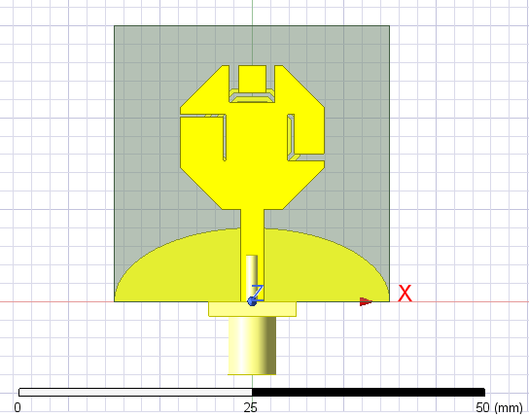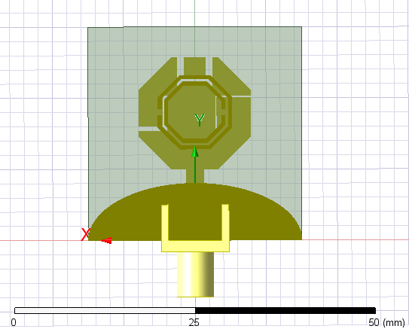

Figure ‎4.107. Top view of centre U slot right Up L slot left Down L slot antenna

Figure ‎4.108. Bottom view of centre U slot right Up L slot left Down L slot antenna

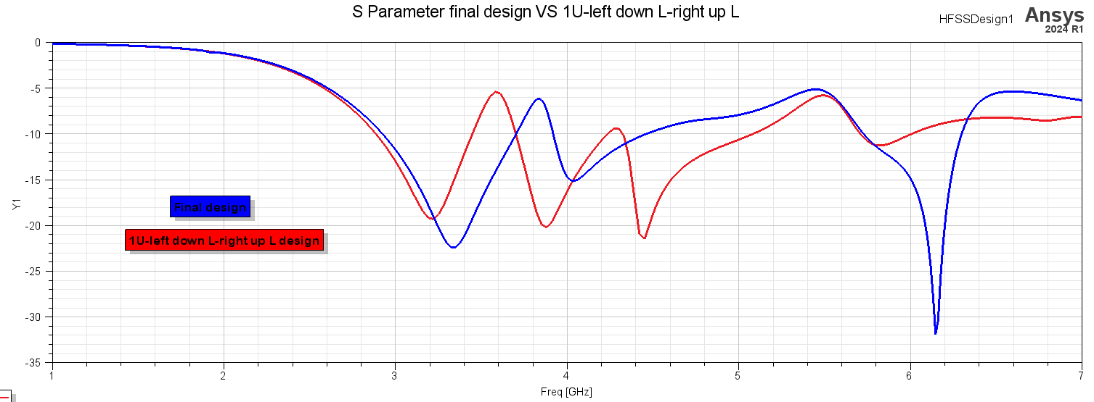

Figure ‎4.109. S11 parameter Final design VS centre U slot Right Up L slot Left Down L slot design

8 Center U slot Right Down L slot Left UP L slot

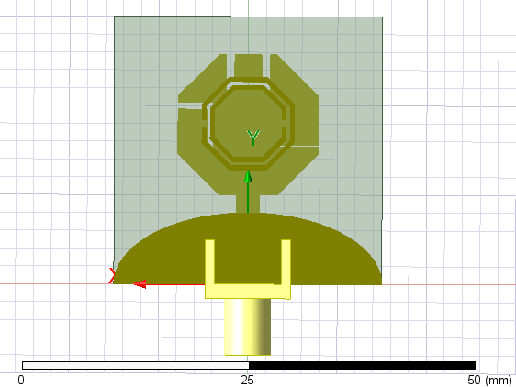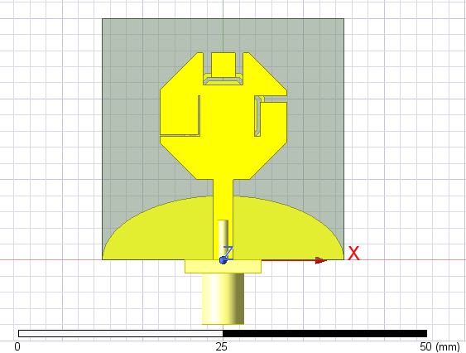

Figure ‎4.110. Bottom view of centre U slot right Down L slot left Up L slot antenna

Figure ‎4.111. Top view of centre U slot right Down L slot left Up L slot antenna

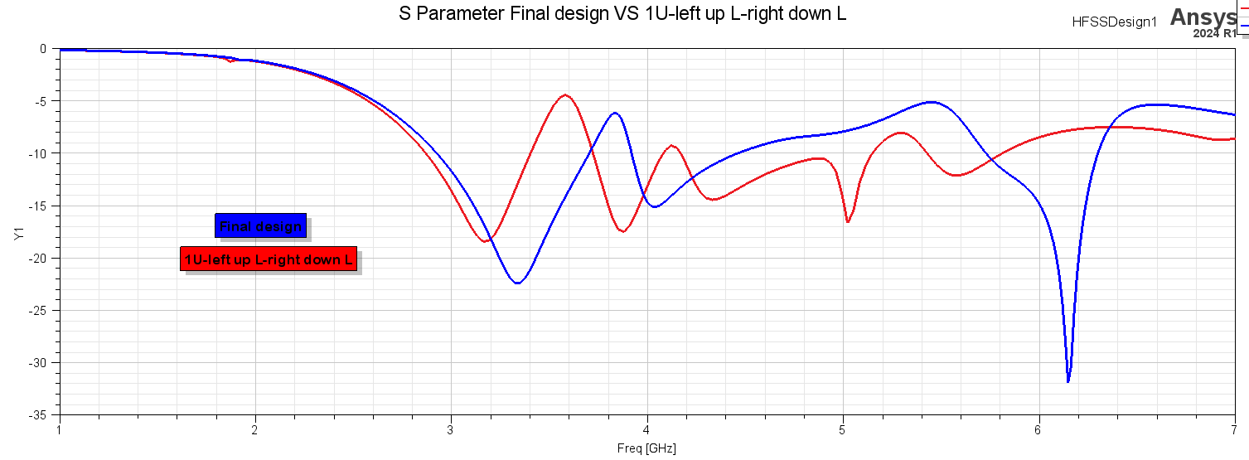

Figure ‎4.112. S11 parameter Final design VS center U slot Right Down L slot Left Up L slot design

**Second design**

* 1. **PIFA Design**

This design utilizes two PIFAs that are tuned for two frequencies 4.7GHz and 2.4GHz. In addition, we used DGS (defected ground structures) in the ground to produce another resonance at 3.7GHz and 5.8GHz. The proposed antenna has the following dimensions described in the figure 4.1 and detailed in the table 4.1 below using an FR-4 substrate of and height of 1.6mm.

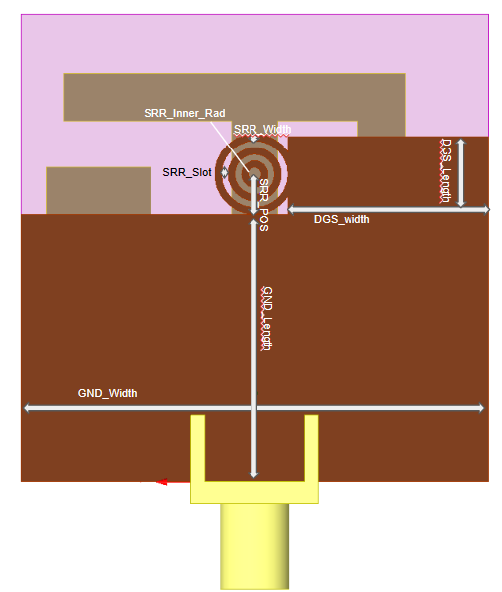

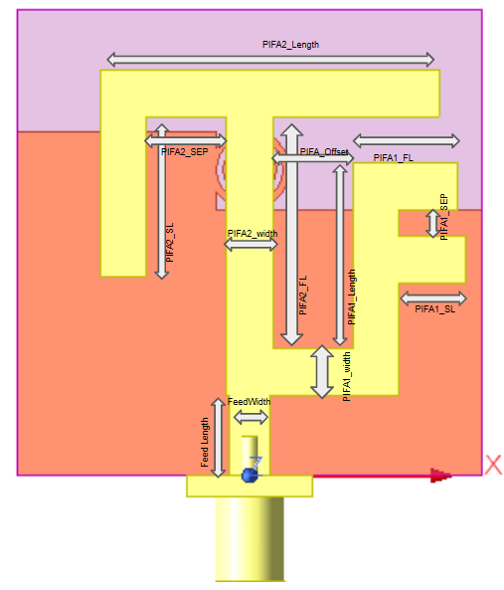

1. Back Side
2. Figure 3.‎4.113. Electric field & Magnetic field at 2.75GHzBack Side
3. Figure 3.‎4.114. Electric field & Magnetic field at 2.75GHzBack Side
4. Figure 3.‎4.115. Electric field & Magnetic field at 2.75GHzBack Side
5. Back Side
6. Figure 3.‎4.116. Electric field & Magnetic field at 2.75GHzBack Side
7. Figure 3.‎4.117. Electric field & Magnetic field at 2.75GHzBack Side
8. Figure 3.‎4.118. Electric field & Magnetic field at 2.75GHzBack Side

Figure ‎4.119. Front SideFiFigure

**Figure 4.105.** Proposed Antenna Structure

**Figure 4.105.** Proposed Antenna Structure

**Figure 4.105.** Proposed Antenna Structure

**Figure 4.105.** Proposed Antenna Structure

**Figure 4.105.** Proposed Antenna Structure

**Figure 4.105.** Proposed Antenna Structure

**Figure 4.105.** Proposed Antenna Structure

**Figure 4.105.** Proposed Antenna Structure

Table **Error! Use the Home tab to apply 0 to the text that you want to appear here.**‑7. PIFA proposed Dimensions.

|  |  |
| --- | --- |
| Parameter | Value (mm) |
| Substrate width | **35** |
| Substrate Length | **35** |
| Feed Length | **6** |
| Feed Width | **3** |
| PIFA1_width | **3.5** |
| PIFA1_Offset | **6** |
| PIFA1_FL | **4.37** |
| PIFA1_SL | **5** |
| PIFA1_Length | **14** |
| PIFA1_SEP | **2** |
| PIFA2_width | **3.5** |
| PIFA2_FL | **21** |
| PIFA2_SL | **12** |
| PIFA2_Length | **16** |
| PIFA2_SEP | **6** |
| DGS_Length | **5.8** |
| DGS_width | **15** |
| GND_Length | **20** |
| GND_width | **35** |
| SRR_slot | **0.5** |
| SRR_Thickness | **0.5** |
| SRR_Inner_Radius | **0.5** |
| SRR_POS | **3** |

**PIFA Design**

**Feed Width.** Adjusting the feed's width alters its characteristic impedance across the frequency domain, enabling impedance matching with the 50-ohm coaxial feeder at different frequency bands. It is important to note that increasing the feed width shifts the frequency bands to Lower frequencies at the 2.4GHz and 3.7GHz bands and vice versa at the other bands.

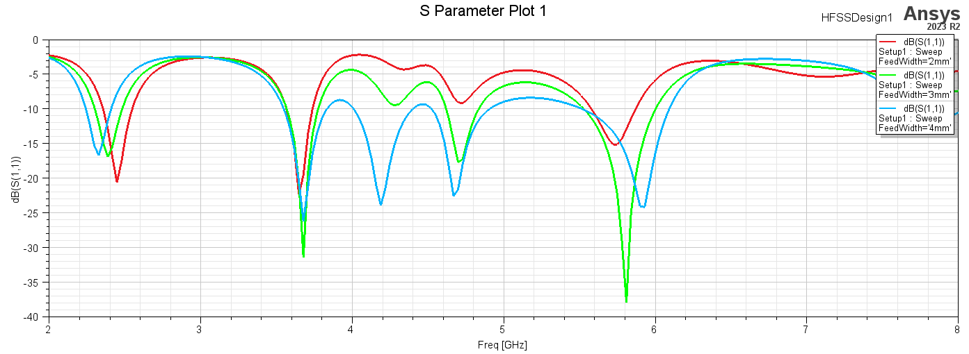

Figure ‎4.120. Feed Width effect

**PIFA1 Width.** This parameter primarily affects the lowest frequency resonance around the 2.4GHz band. As the width increases, the resonance frequency of this band decreases. Additionally, this parameter influences the reflected power at other bands, with reflection decreasing as the width increases up to 4mm, after which it begins to increase again.

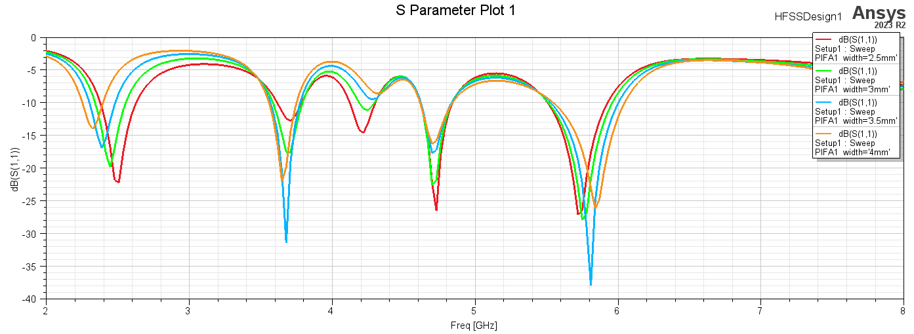

Figure ‎4.121. PIFA1 Width

**PIFA2 Width.** Increasing this parameter causes the PIFA1 resonance at 2.4GHz to become more prominent because the 2.4GHz signal sees the PIFA1 tuned impedance more clearly when PIFA2 presents a high impedance at this frequency. For higher frequencies, the impedance seen by the signal increases as the width increases. The frequency around 4.7GHz increases with increasing width until it reaches 4mm, at which point it begins to decrease. The frequency around 3.7GHz also increases as the PIFA2 width increases.

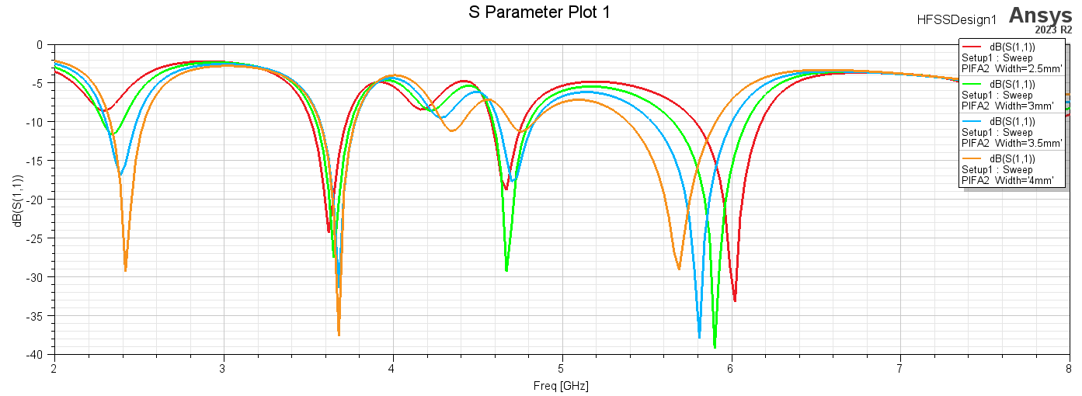

Figure ‎4.122. PIFA2 Width effect.

**PIFA2_Radiator and PIFA1 Length.** The PIFA (Planar Inverted-F Antenna) functions similarly to a monopole antenna, where increasing the radiator length results in a decrease in the resonance frequency. This relationship is clearly demonstrated by the shifting of the frequency bands in the figures below. As the length of the radiator increases, the resonance frequency moves to lower values.

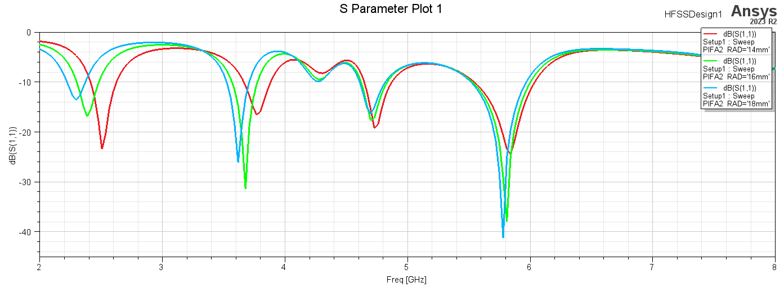

Figure ‎4.123. PIFA2 Length effect.

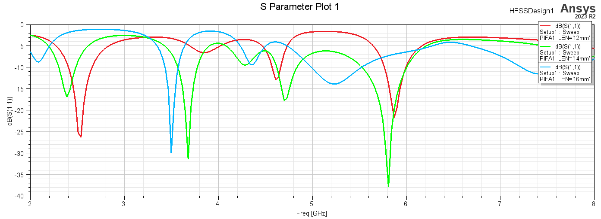

Figure ‎4.124. PIFA1 Length effect.

**PIFA2_FL and PIFA1_FL.** The effect of the two planner Inverted Antennas feed lengths is shown in the figures below where in the case of the PIFA1 the increase in the feed length will make tunning about 5.8GHz possible. While the PIFA2 shifts high frequencies toward the lower ones and vice versa.

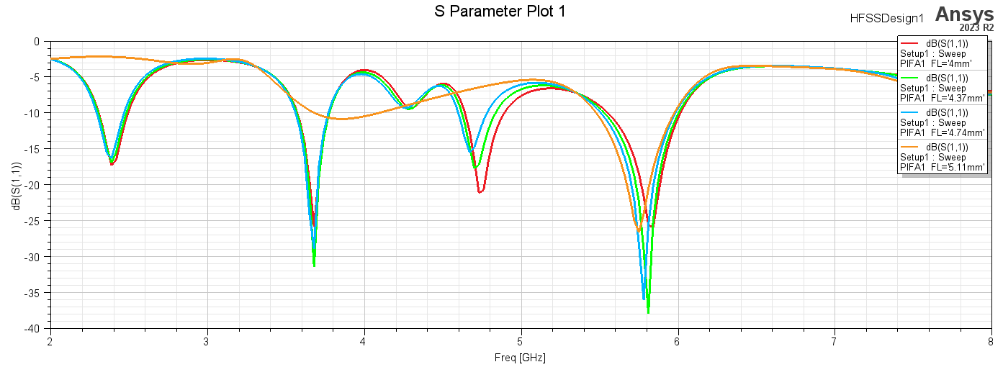

Figure ‎4.125. PIFA1 Feed Length effect.

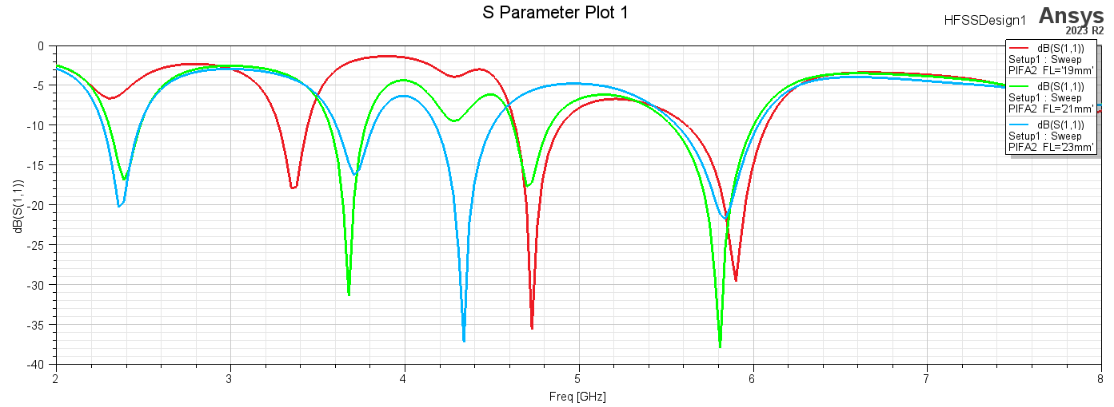

Figure ‎4.126. PIFA2 Feed Length effect

PIFA Stub separation. These two parameters PIFA1_SEP and PIFA2_SEP will shift the high resonance frequencies as described in the figures below.

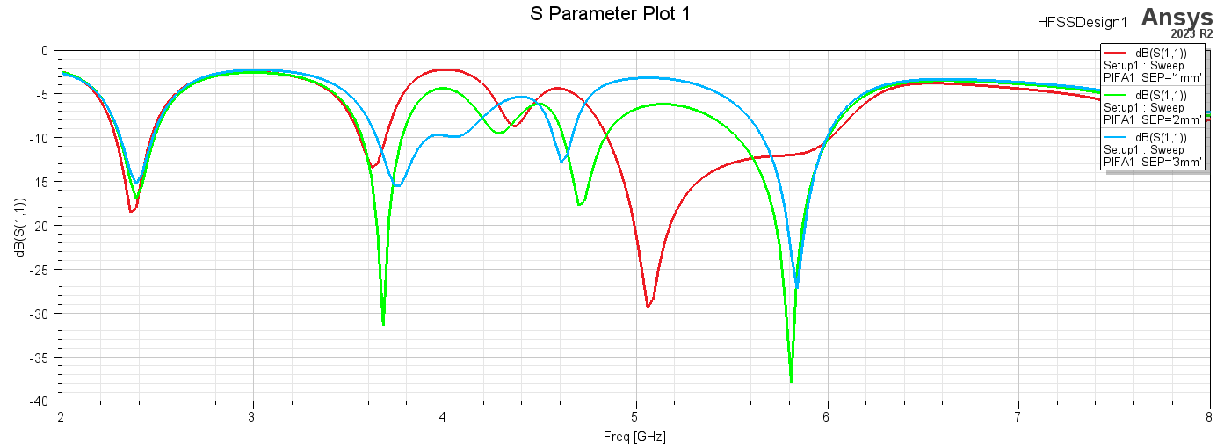

Figure ‎4.127. PIFA1 Feed - Short Separation increases resonance frequencies as its increase.

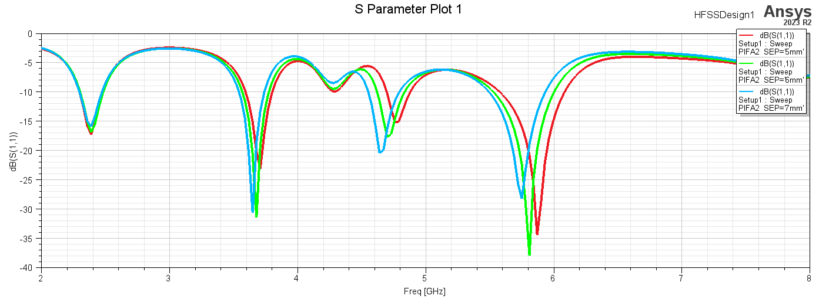

Figure ‎4.128. PIFA2 Feed - Short Separation increases resonance frequencies as its decrease.

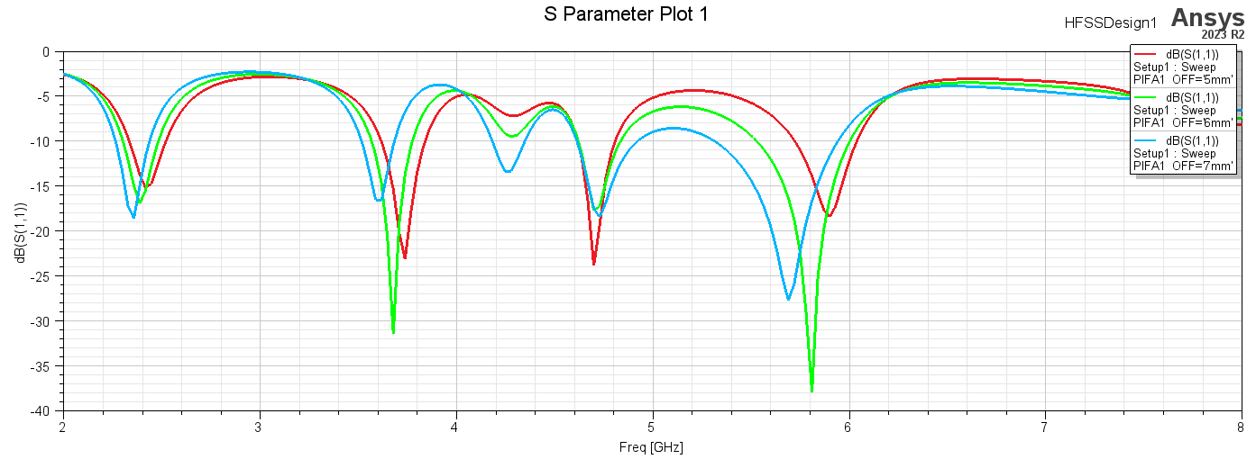**PIFA1_OFF.** The increase in the offset between the PIFA1 and the PIFA2 feed will shift the frequency to the left as described in the figure below.

Figure ‎4.129. PIFA1 offset from PIFA2 feed

**The Defected Ground Structure parameters.** DGS parameters play a crucial role in tuning the resonance frequencies of antennas. Adjusting the length of the DGS rectangular slot shifts the resonance frequency to higher values until the length reaches approximately 6mm, after which it begins to shift back to lower frequencies. Similarly, increasing the width of the DGS rectangular slot affects the resonances around 5.8GHz and 4.7GHz, moving them slightly as the width increases.

The Split Ring Resonator (SRR) introduces a new resonance at around 5.8GHz and expands the bandwidth of the 4.7GHz resonance. Specifically, the 4.7GHz resonance initially shifts to lower frequencies after the width reaches 0.5mm. For the 3.7GHz resonance, the frequency shifts higher initially and then to lower frequencies after 0.5mm. The SRR radius has a minor effect on the 2.4GHz resonance, while the distance between the rings influences the bandwidth at 2.4GHz, 4.7GHz, and 5.8GHz, also controlling the 3.7GHz resonance frequency. Increasing the SRR thickness generally shifts the resonances to lower frequencies, except for the 2.4GHz resonance, which shifts to higher frequencies as the SRR thickness increases.

These adjustments enable precise tuning of the antenna's resonance characteristics, which is essential for optimizing performance across different frequency bands. Understanding these parameters aidsa in designing antennas for specific applications, ensuring they meet the desired operational requirements.

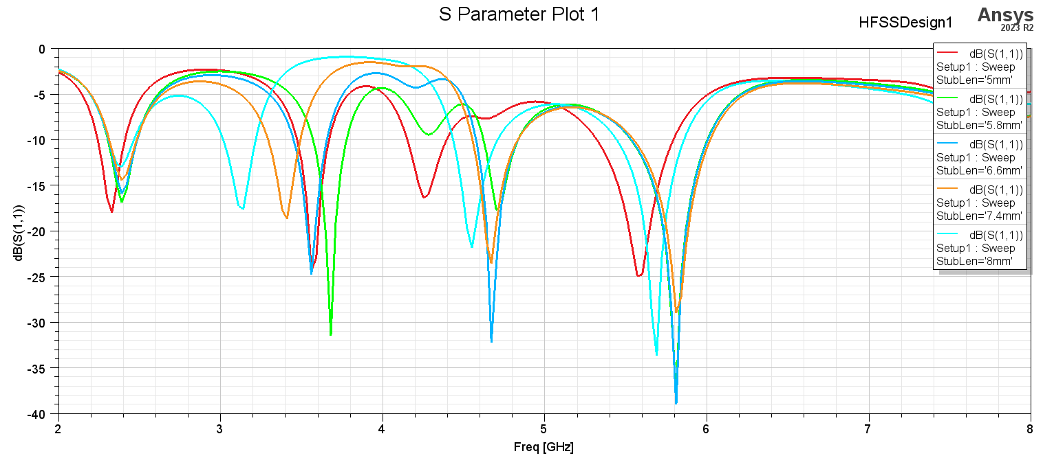

Figure ‎4.130. Rectangular DGS length effect

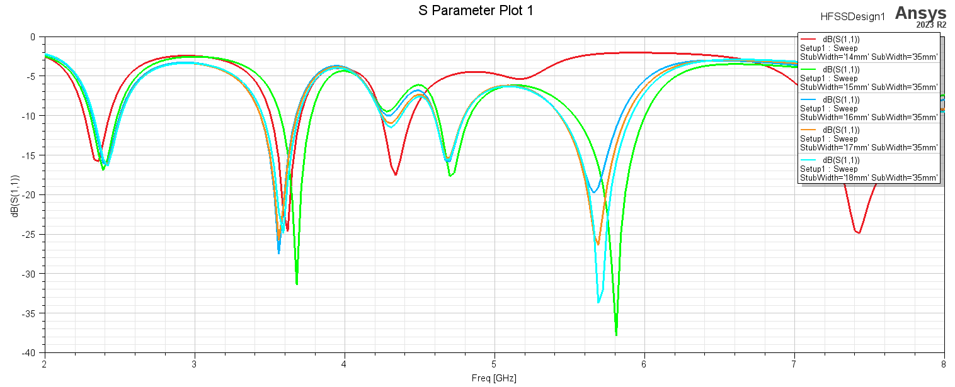

Figure ‎4.131. Rectangular DGS width effect

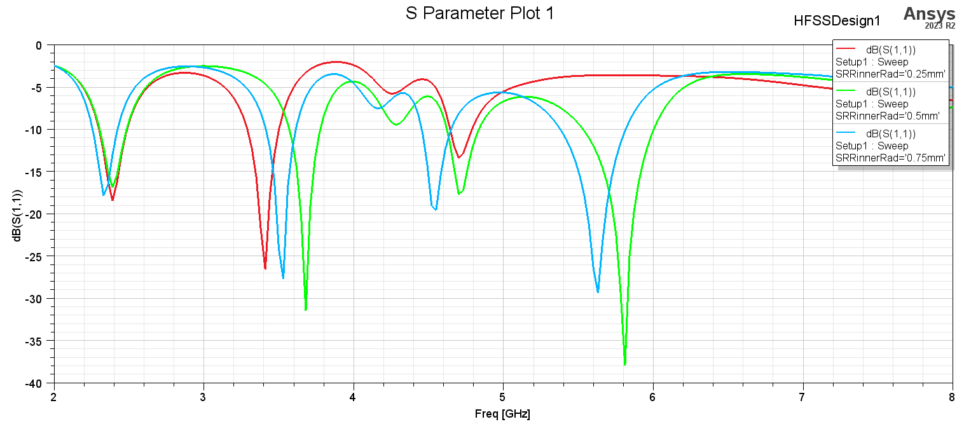

Figure ‎4.132. SRR radius Effect.

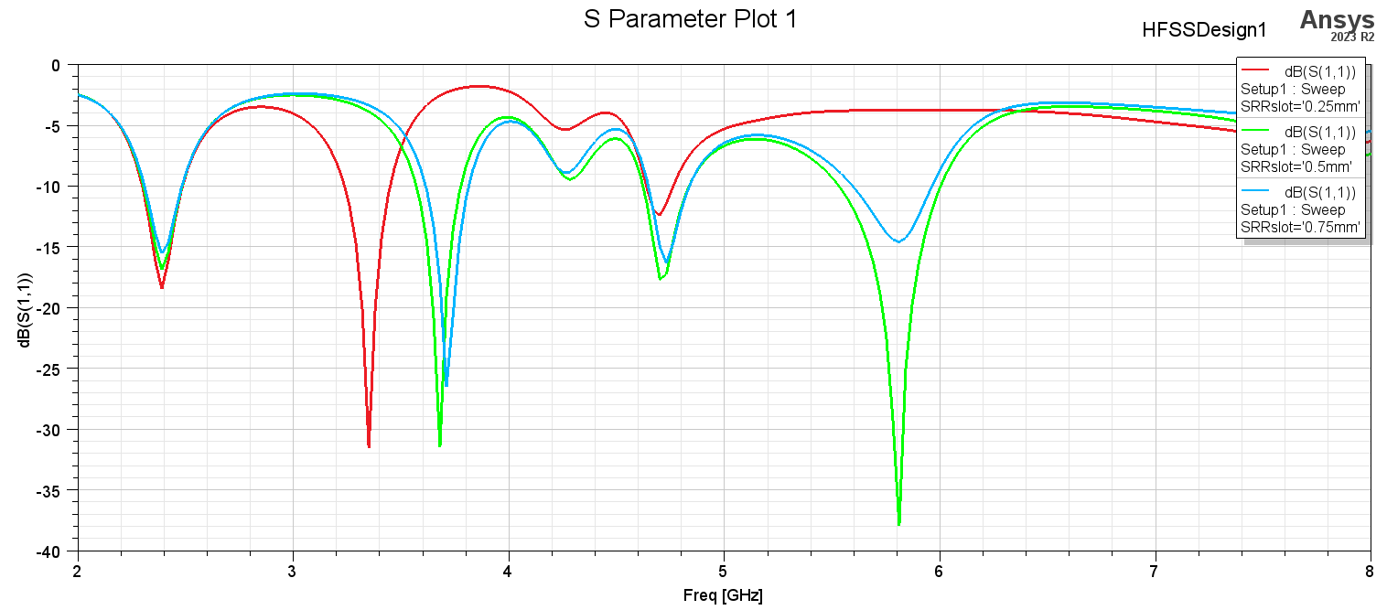

Figure ‎4.133. SRR separation slot Effect.

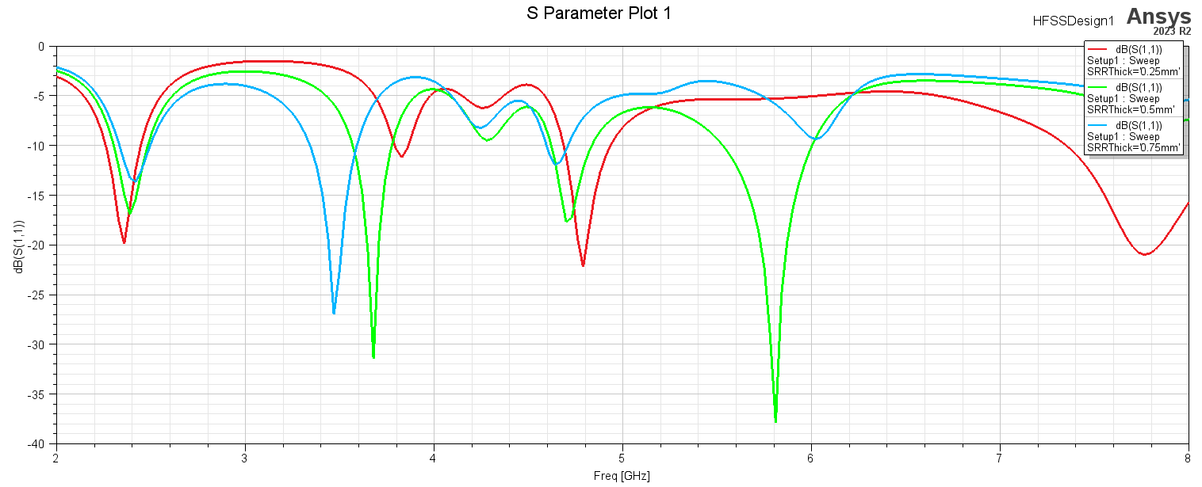

Figure ‎4.134. SRR thickness Effect.

**Design Iteration**

**PIFA Design**

Figure 6.1 Shows the proposed antenna structure which can provide 4 bands at 2.4GHz, 3.7GHz, 4.7GHz, and 5.8GHz in the 5G cellular communication and Wi-Fi applications of the following bandwidths respectively {190MHz, 210MHz,220MHz, and 470MHz}.

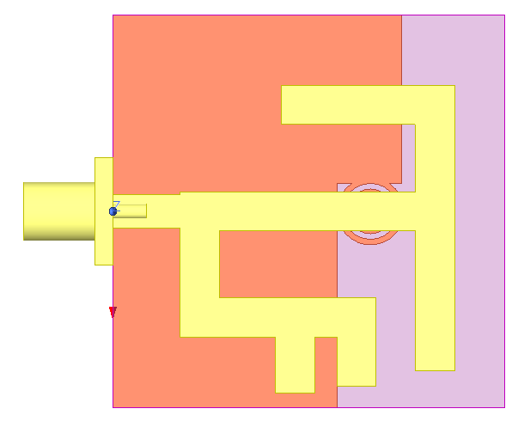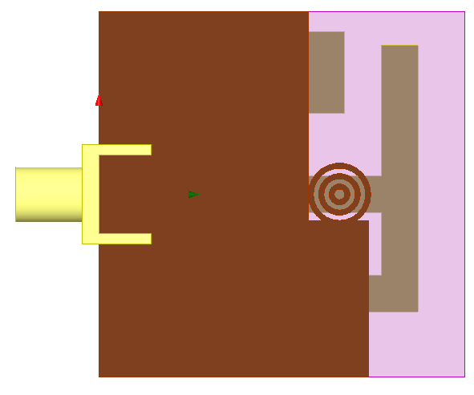

1. Back View
2. Back View
3. Back View
4. Back View
5. Back View
6. Back View
7. Back View
8. Back View
9. Front View
10. Front View
11. Front View
12. Front View
13. Front View
14. Front View
15. Front View
16. Front View

Figure ‎4.135. Proposed Antenna Structure

The design process begins with Figure 6.2.a, which establishes a resonance at 4.13GHz. The Planar Inverted-F Antenna (PIFA) length is estimated for 4.7GHz based on the analogy to a monopole antenna's most optimal length, which is approximately a quarter wavelength. This estimation is calculated using Equation 1 below.

$$PIFA1_{Estimated Length}= \frac{⋋}{4}=\frac{c}{4f\sqrt{∈_{r}} }$$

The width of the microstrip line is initially calculated to match a 50 Ohm input impedance, starting with an estimate of 3.5mm for a 4.7GHz line. Adding another PIFA resonator, as illustrated in Figure 6.3.a, introduces another resonance at a lower band, around 2.4GHz, as shown in Figure 6.3.b. The lengths of the PIFA resonators are initially assumed based on the optimal lengths of monopole antennas, which are calculated using Equation 6.1 to be approximately 8mm and 25mm, respectively.

In the next iteration, a rectangular defected ground structure (DGS) is added. A DGS in a microstrip antenna introduces a resonance by creating a localized perturbation in the ground plane, which affects the electromagnetic field distribution around the antenna, thereby altering the antenna's resonant frequency or bandwidth. Based on the electric field distribution around 3.7GHz. a DGS is added in that region, as suggested by Figure 6.4.a. This adjustment results in another resonance at around 8GHz and 3.7GHz, as seen in Figure 6.4.b.

By identifying the 3.7GHz current distribution, a DGS is placed to interact with the areas of highest density. After the initial simulation, the electric field distribution on the antenna structure is visualized by selecting "Fields" -> "E-Field" in the results section. This visualization helps identify areas with strong electric fields (hotspots) and weak fields (nulls), indicating where the antenna is resonating and where adjustments might be needed. To adjust the resonance frequency, the antenna dimensions are modified: shortening the elements increases the resonant frequency, while lengthening them decreases it. Additionally, altering the width of the elements can affect the resonance, with wider elements generally lowering the frequency. For antennas with gaps, such as patch antennas, adjusting the gap size between elements fine-tunes the resonance. To achieve the desired tuning, three rings are added at areas close to high electric field density spots, with the three slots interacting with the dual element resonators to shift the resonance frequencies of both high and low bands.

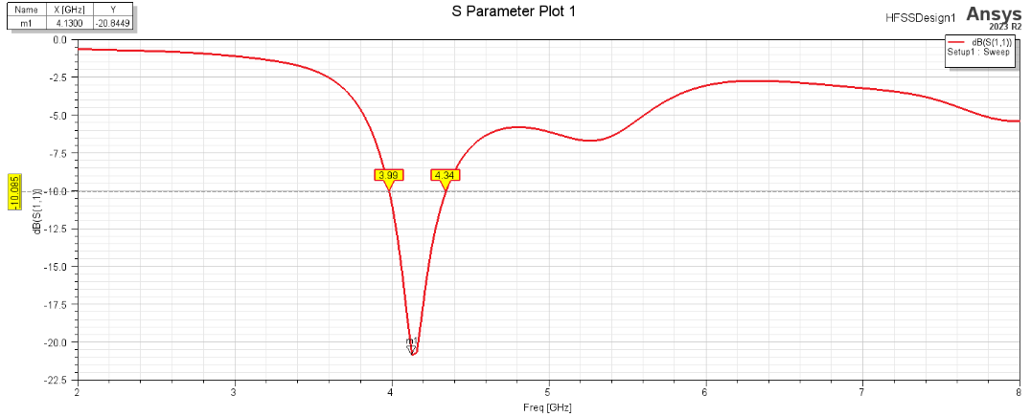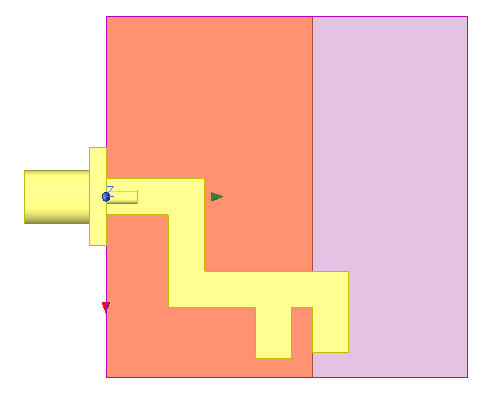

1. Iteration 1 – S11
2. Iteration 1 – S11
3. Iteration 1 – S11
4. Iteration 1 – S11
5. Iteration 1 – S11
6. Iteration 1 – S11
7. Iteration 1 – S11
8. Iteration 1 – S11
9. Iteration 1 - Structure

t

1. Iteration 1 - Structure

t

1. Iteration 1 - Structure

t

1. Iteration 1 - Structure

t

1. Iteration 1 - Structure

t

1. Iteration 1 - Structure

t

1. Iteration 1 - Structure

t

1. Iteration 1 - Structure

t

Figure ‎4.136. Iteration

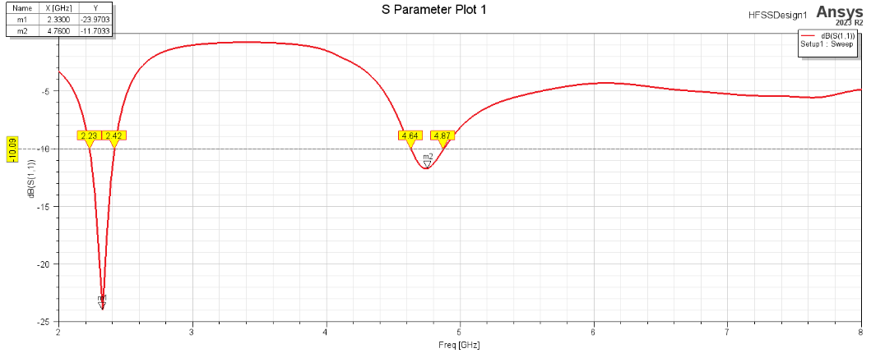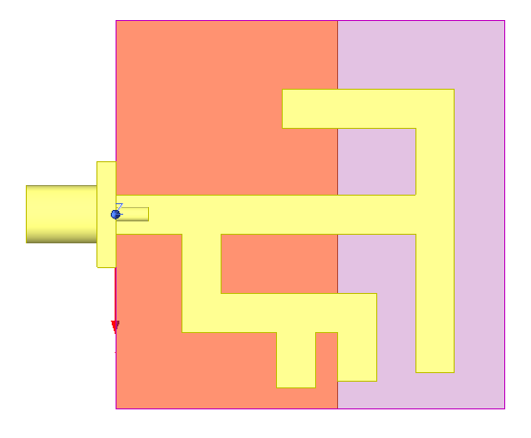

1. Iteration 2 - Structure

t

1. Iteration 2 - Structure

t

1. Iteration 2 - Structure

t

1. Iteration 2 - Structure

t

1. Iteration 2 - Structure

t

1. Iteration 2 - Structure

t

1. Iteration 2 - Structure

t

1. Iteration 2 - Structure

t

1. Iteration 2 – S11

t

1. Iteration 2 – S11

t

1. Iteration 2 – S11

t

1. Iteration 2 – S11

t

1. Iteration 2 – S11

t

1. Iteration 2 – S11

t

1. Iteration 2 – S11

t

1. Iteration 2 – S11

t

Figure ‎4.137. Iteration 2

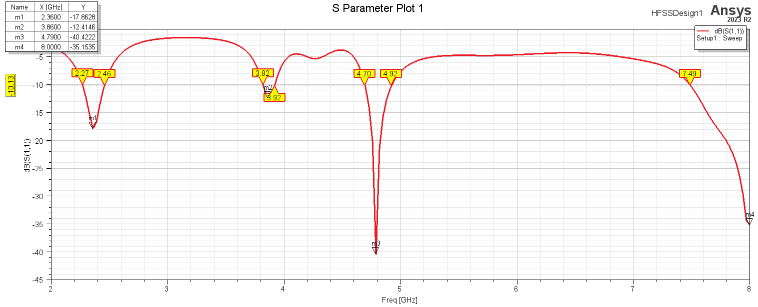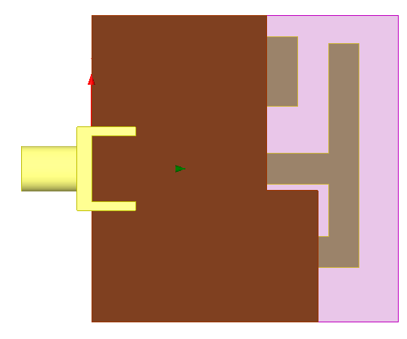

1. Iteration 2 – S11

t

1. Iteration 2 – S11

t

1. Iteration 2 – S11

t

1. Iteration 2 – S11

t

1. Iteration 2 – S11

t

1. Iteration 2 – S11

t

1. Iteration 2 – S11

t

1. Iteration 2 – S11

t

1. Iteration 3 - Structure

t

1. Iteration 3 - Structure

t

1. Iteration 3 - Structure

t

1. Iteration 3 - Structure

t

1. Iteration 3 - Structure

t

1. Iteration 3 - Structure

t

1. Iteration 3 - Structure

t

1. Iteration 3 - Structure

t

Figure ‎4.138. Iteration 3

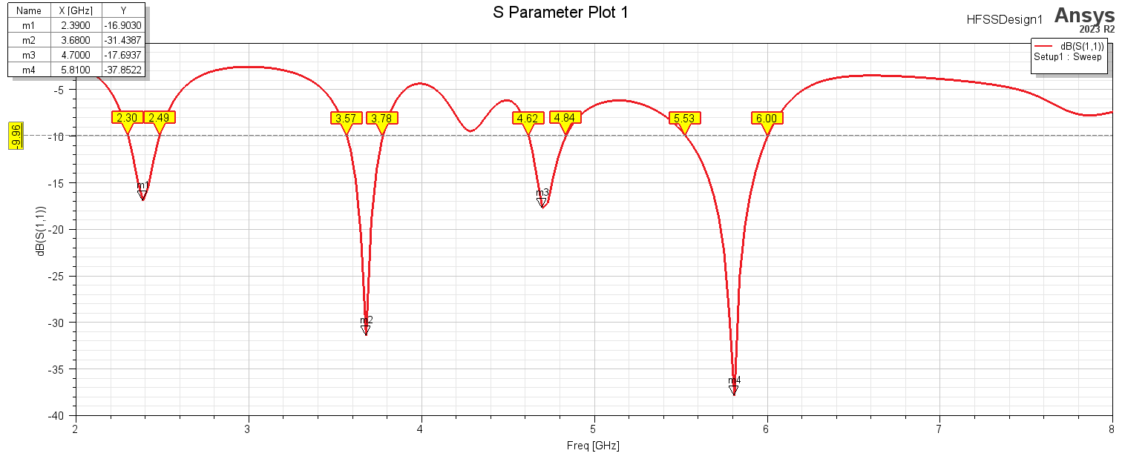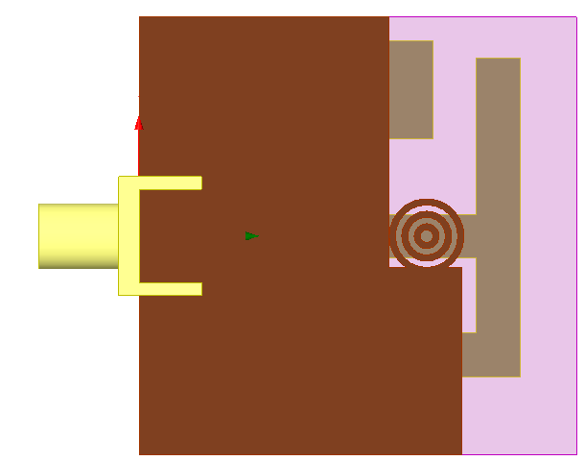

1. Iteration 4 - Structure

t

1. Iteration 4 - Structure

t

1. Iteration 4 - Structure

t

1. Iteration 4 - Structure

t

1. Iteration 4 - Structure

t

1. Iteration 4 - Structure

t

1. Iteration 4 - Structure

t

1. Iteration 4 - Structure

t

1. Iteration 4 – S11

t

1. Iteration 4 – S11

t

1. Iteration 4 – S11

t

1. Iteration 4 – S11

t

1. Iteration 4 – S11

t

1. Iteration 4 – S11

t

1. Iteration 4 – S11

t

1. Iteration 4 – S11

t

Figure ‎4.139. Iteration 4

**Results**

**PIFA Design**

**Antenna Geometry.** The proposed antenna, with a substrate size of 35 mm x 35 mm, is ideal for compact devices such as mobile phones, tablets, laptops, IoT devices, microcontrollers, and sensors. Notably, this antenna supports 5G and WiFi bands at 2.4GHz, 3.7GHz, 4.7GHz, and 5.8GHz. The substrate used is FR-4, with a relative permittivity of 4.4 and a height of 1.6mm. [Refer to Chapter 2 for complete dimensions.]

**Reflection Coefficient (S11).** The reflection coefficient measures the reflection loss relative to a 50-ohm line feeder, indicating the power returned to the source rather than propagated power. The S11 parameter for the proposed antenna is shown in the figure below. The S11 represents the antenna's frequency response, which can determine the antenna's spectrum specifications and its applications concerning the system's resonance frequency (tuned at -15dB or below) and bandwidth, typically measured from the -10dB point. [Note that some papers use the -6dB bandwidth instead.]

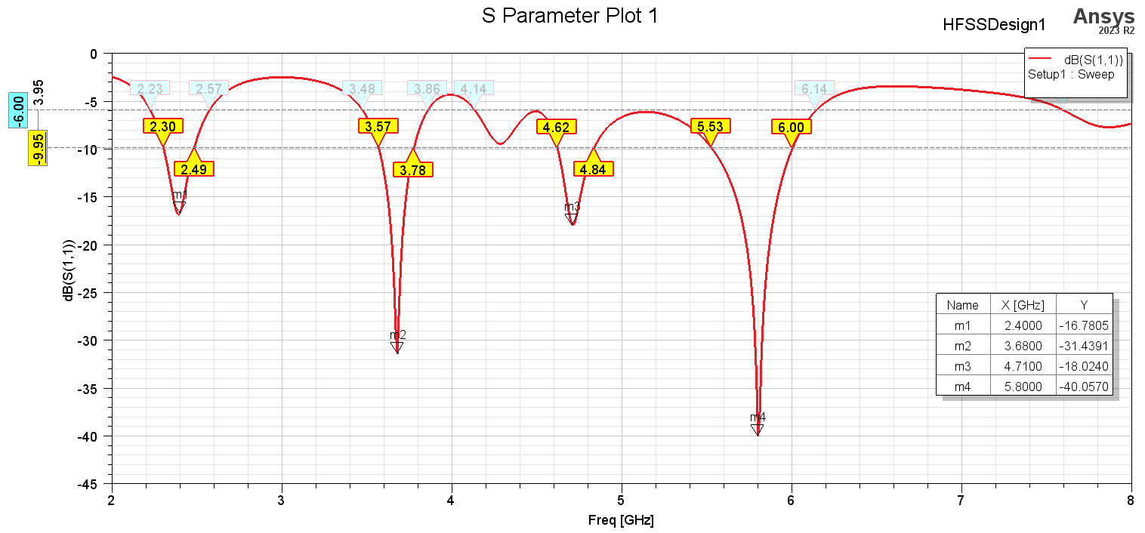

Figure ‎4.140. The S11 plot shows the antenna resonating at 2.4GHz, 3.68GHz, 4.71GHz, and 5.8GHz, with respective 10dB bandwidths of 190MHz, 210MHz, 220MHz, and 470MHz. The 6dB bandwidths are 340MHz, 380MHz, and 2GHz (covering both the 4.7GHz and 5.8GHz resonances below -15dB).

**Voltage Standing Wave Ratio (VSWR).** VSWR measures how well the antenna is impedance-matched to the transmission line, typically 50 ohms. A perfect match ensures that all the power is transmitted to the antenna with minimal reflections, and a lower VSWR (close to 1:1) indicates good matching, which is essential for efficient power transfer. Secondly, a high VSWR means significant power is reflected back towards the source, reducing the power available for radiation. This inefficiency can lead to higher losses and reduced system performance. Maintaining a low VSWR ensures maximum power is radiated by the antenna. Additionally, reflected power due to poor matching can cause signal distortion and interference, degrading the quality of the transmitted or received signal. Low VSWR helps maintain signal integrity by minimizing reflections and ensuring a cleaner signal path. Furthermore, high VSWR can result in high voltage standing waves along the transmission line, potentially damaging the transmitter, amplifier, or other connected components due to excessive voltage or current. Keeping the VSWR low helps protect these components from damage. VSWR is also an indicator of the antenna's operational bandwidth. An antenna with a low and stable VSWR across a wide frequency range is considered broadband and can support multiple frequency bands, making it versatile for various applications. Moreover, many communication standards and regulations specify acceptable VSWR limits for antennas to ensure efficient and interference-free operation. Meeting these standards is necessary for certification and legal operation in certain frequency bands. The figure below shows the VSWR for the proposed antenna along the frequency domain.

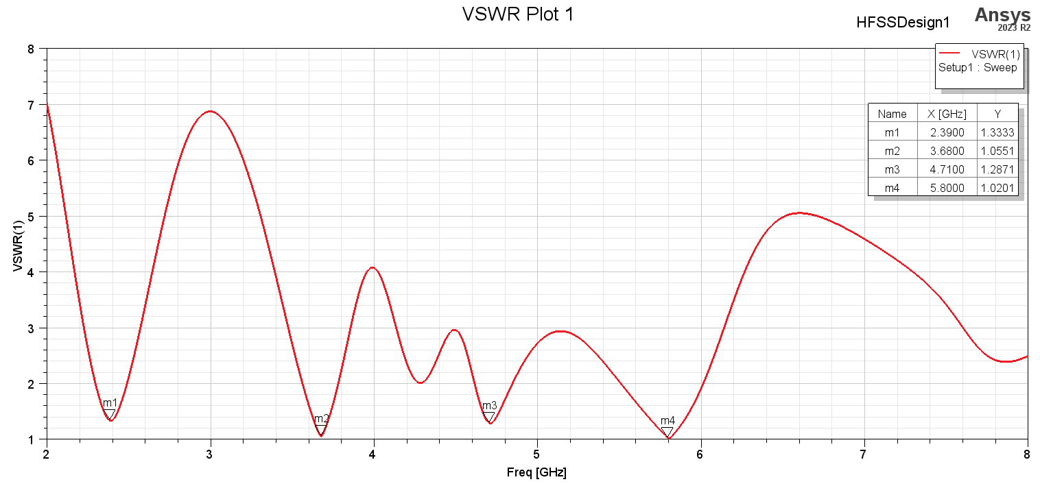

Figure ‎4.141. The VSWR vs Frequency where the minimal VSWR at 2.4GHz, 3.68GHz, 4.71GHz, and 5.8GHz. In general a good VSWR is below 2.

**Impedance.** The antenna impedance is crucial for designing matching networks to minimize reflections. Generally, antennas are designed with an impedance of 50 ohms, which is a common feeder impedance, making matching easier. The figure below shows the antenna impedance, including both the real and imaginary components.

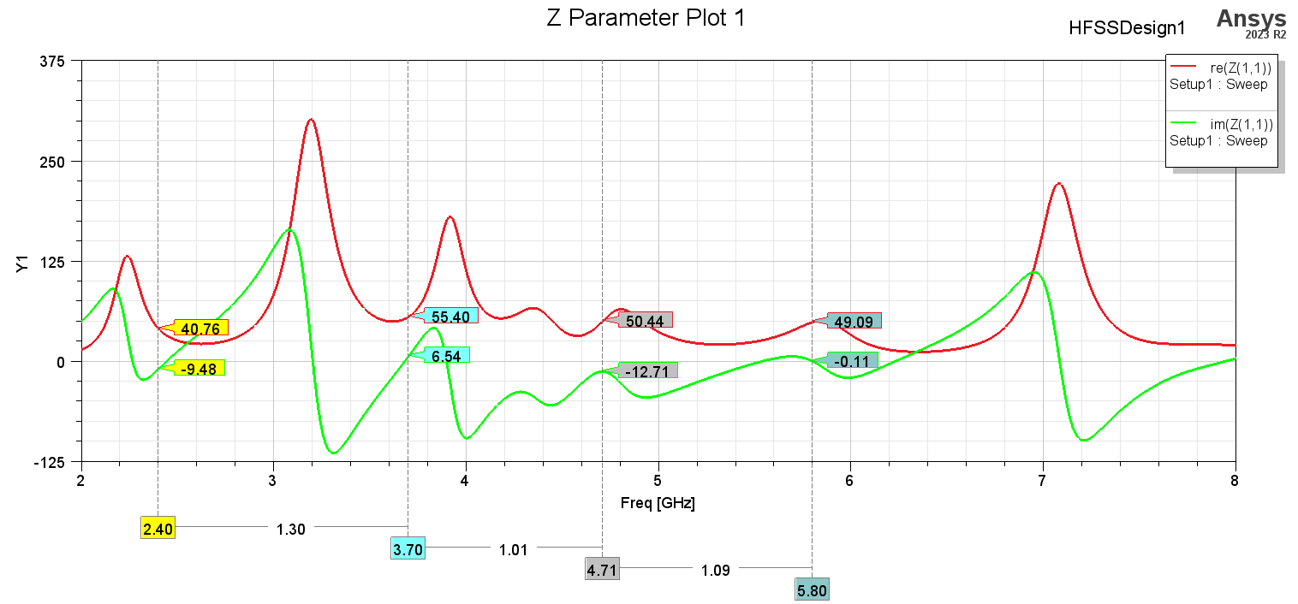

Figure ‎4.142. Antenna Impedance Vs. Frequency.

**The Antenna gains.** The Antenna Gain indicates the amount of power that propagates in each radial direction from the antenna relative to the input power applied at the antenna input terminal. It serves as a metric to assess the directional characteristics of the proposed antenna, whether it is directional or omnidirectional. The figures below provides a visualization of the antenna's gain in a 2D plot along the x-z axis and y-z axis. Antenna gain can also specify how power efficient the antenna is where it shall not attenuate the input power (negative dB gain).

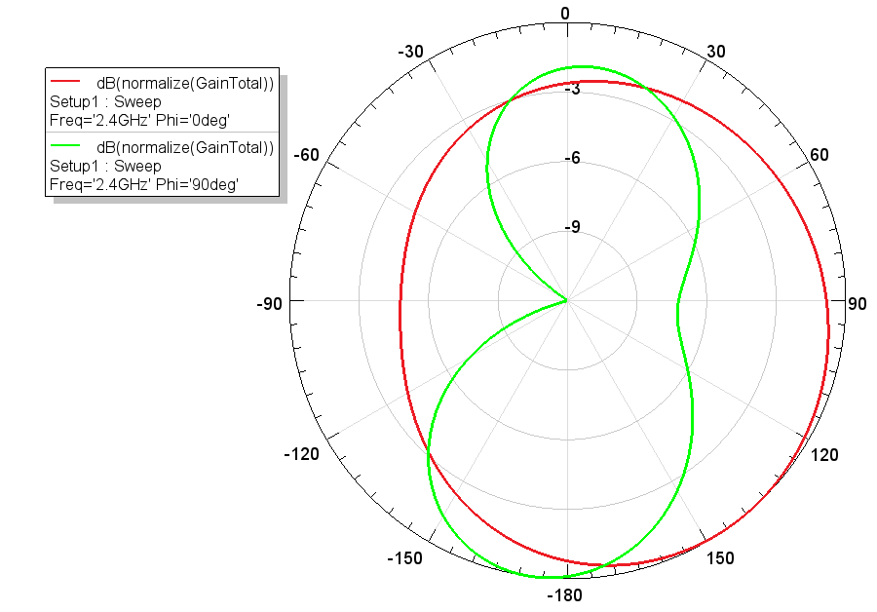

Figure ‎4.143. Antenna Gain at 2.4GHz.

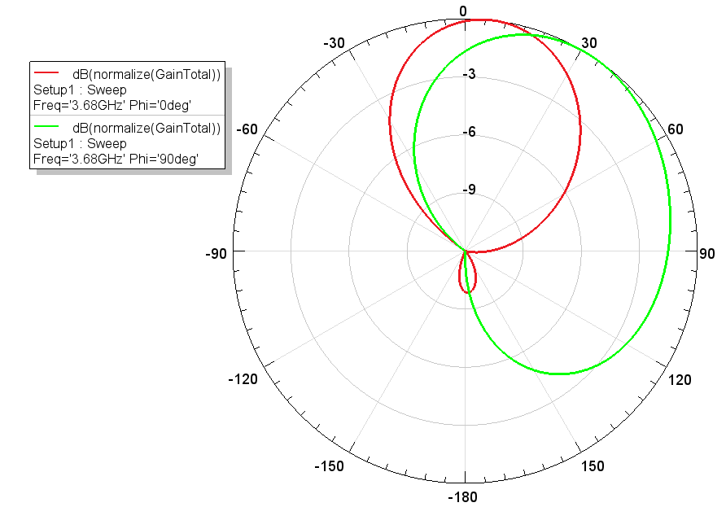

Figure ‎4.144. Antenna gain at 3.68GHz.

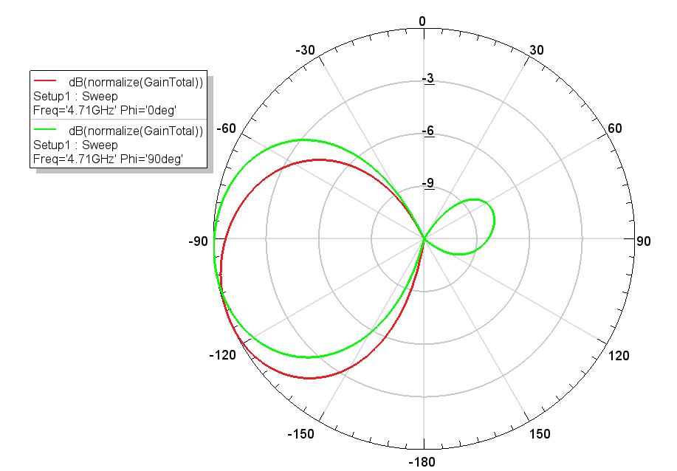

Figure ‎4.145. Antenna gain at 4.71GHz.

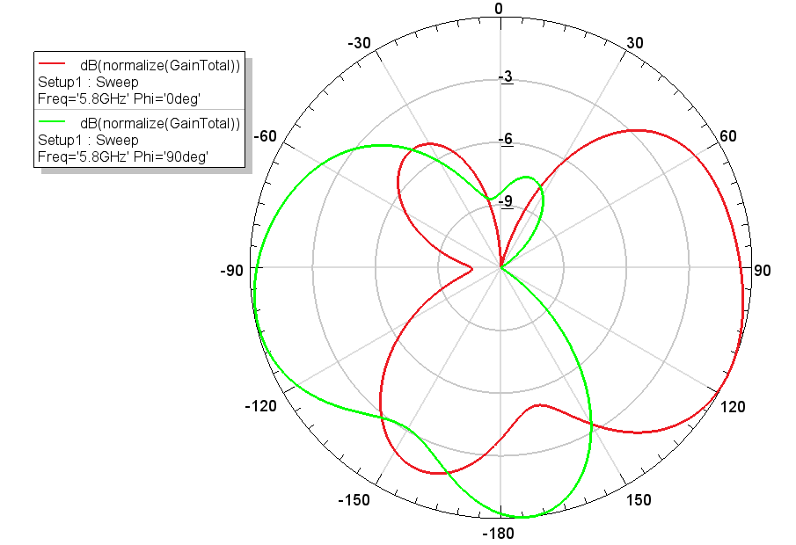

Figure ‎4.146. Antenna gain at 5.8GHz.

**The Directivity.** Plotting the directivity of an antenna in 3D provides a comprehensive visualization of its radiation pattern, offering several advantages for antenna engineers and designers. 3D directivity plots provide a complete spatial representation of the antenna's radiation pattern, allowing engineers to visualize how the antenna radiates electromagnetic energy in all three dimensions. This comprehensive view helps in understanding how the antenna performs in different directions around its structure. Antennas often exhibit directional characteristics, meaning they radiate more power in certain directions than others. By plotting directivity in 3D, engineers can accurately assess the antenna's directional behavior, including main lobes, side lobes, and nulls, across azimuth and elevation angles.

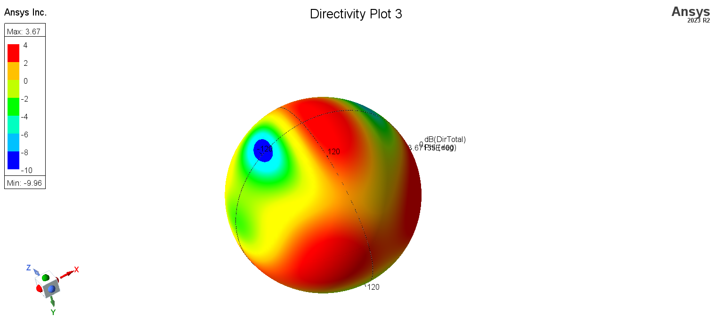

Figure ‎4.147. 3D Directivity plot at 5.8GHz

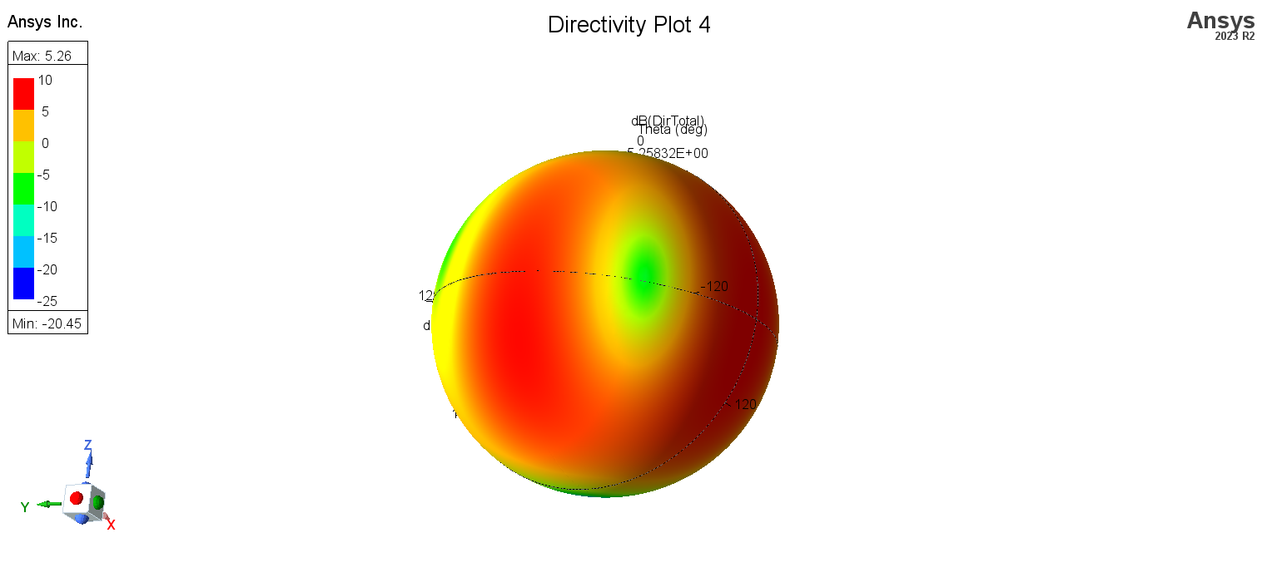

Figure ‎4.148. 3D – Directivity plot at 4.71GHz.

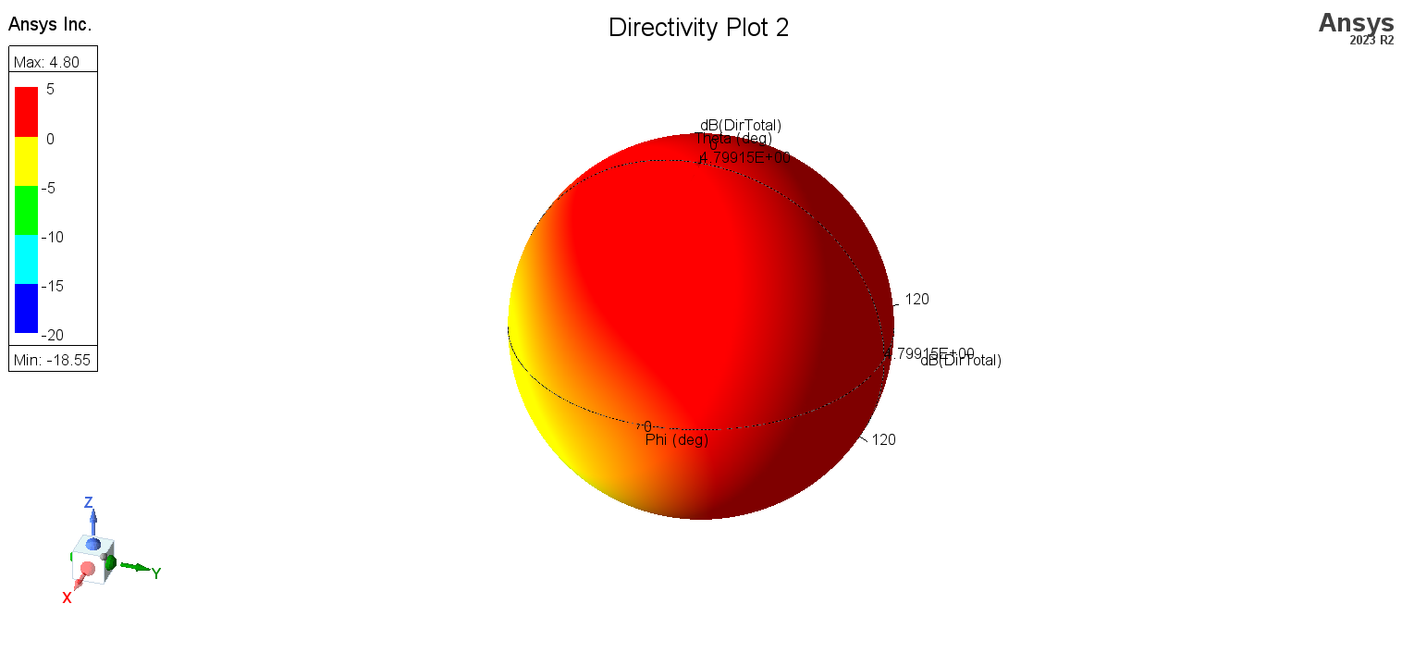

Figure ‎4.149. 3D – Directivity plot at 3.68GHz.

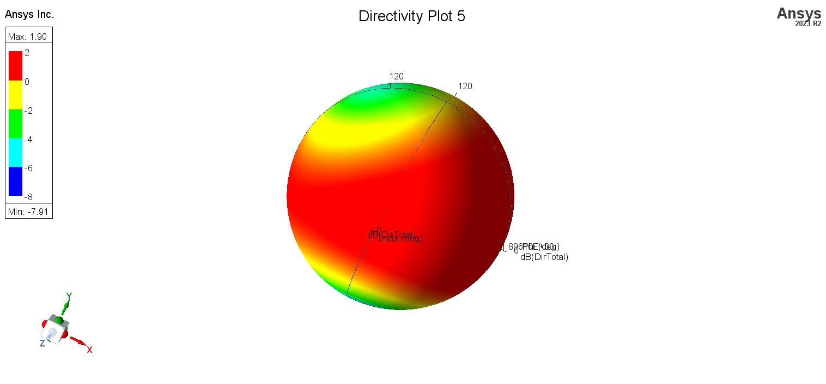

Figure ‎4.150. 3D – Directivity plot at 2.4GHz.

**Current Distribution.** Current distribution on antennas is a critical factor in antenna design and performance analysis for several reasons. The current distribution on the antenna elements directly determines the radiation pattern. Different current distributions can lead to different radiation characteristics such as directionality, beam width, and side lobe levels. Understanding the current distribution helps engineers design antennas with desired radiation patterns for specific applications. The current distribution affects the input impedance of the antenna. Proper impedance matching is essential to ensure maximum power transfer from the transmitter to the antenna and minimize reflections. By analyzing the current distribution, engineers can optimize the antenna geometry to achieve better impedance matching with the transmission line, typically 50 ohms. The current distribution indicates the resonant modes of the antenna. Resonance occurs when the current distribution forms standing waves at specific frequencies. By analyzing the current distribution, engineers can identify the resonant frequencies and adjust the antenna design to achieve the desired operating frequency and bandwidth.

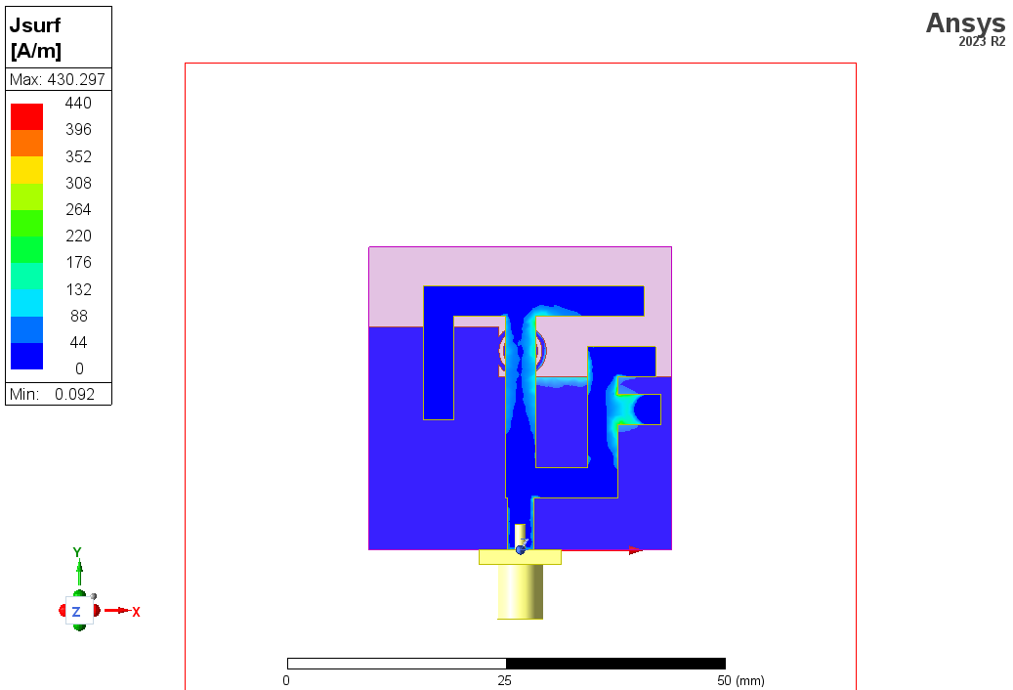

Figure ‎4.151. Current Distribution at 2.4GHz.

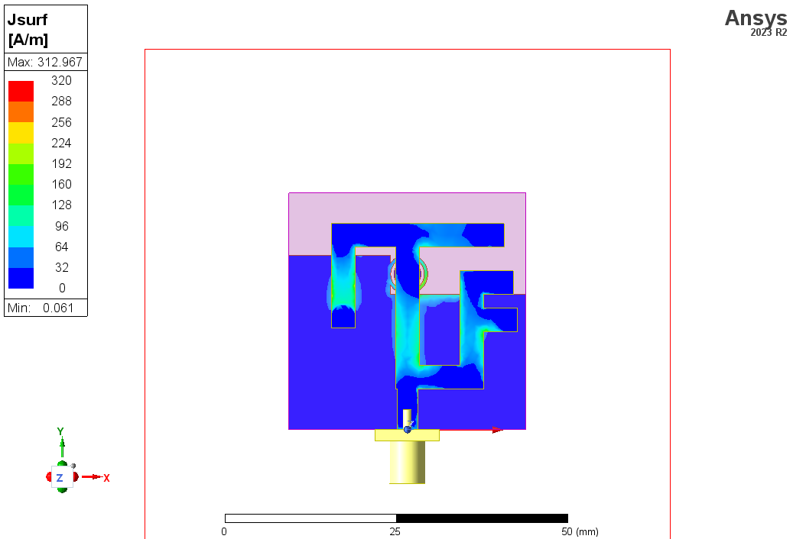

Figure ‎4.152. Current Distribution at 3.68GHz.

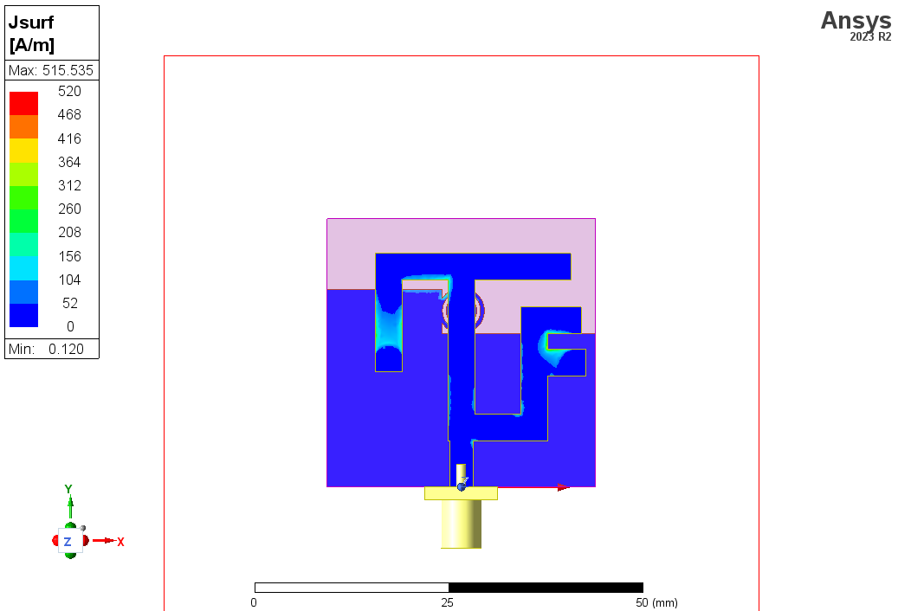

Figure ‎4.153. Current Distribution at 4.71GHz.

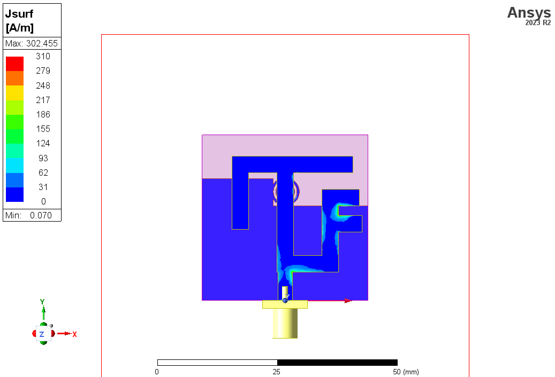

Figure ‎4.154. Current Distribution at 5.8GHz.

**Axial ratio vs. Frequency.** plotting the axial ratio vs. frequency is crucial for evaluating and ensuring the circular polarization performance of an antenna across its operating frequency range. It helps in optimizing the antenna design, assessing bandwidth performance, maintaining polarization purity, and comparing different designs to select the best option for specific applications. This analysis is essential for applications where reliable circular polarization is necessary, such as satellite communication, GPS, and certain radar systems.

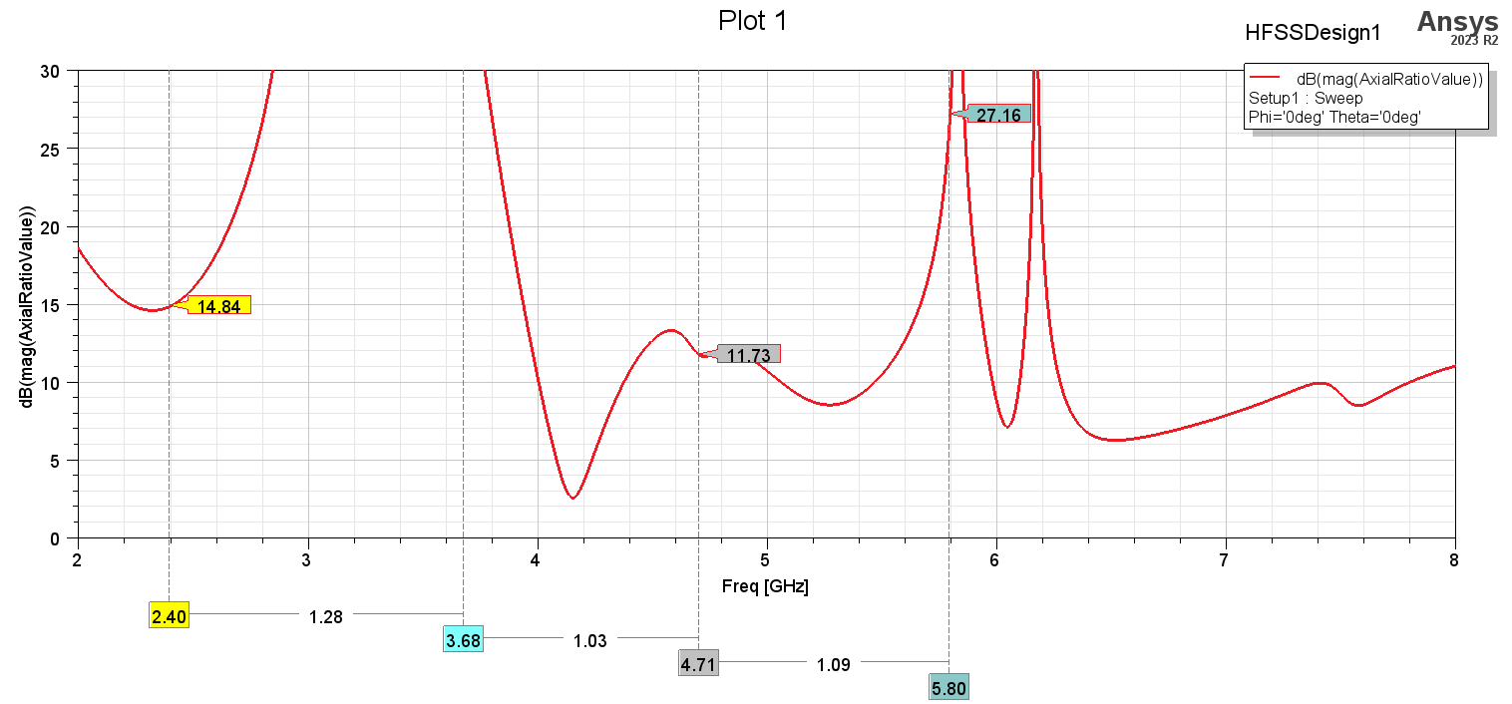

Figure ‎4.155. The figure clearly shows that all frequencies are linearly polarized as they all have axial ratio above 10dB.

**Peak Realized gain.** This shows the best peak gain that each frequency can achieve as the figure below shows all resonant frequencies we are interested in shows positive dB gain.

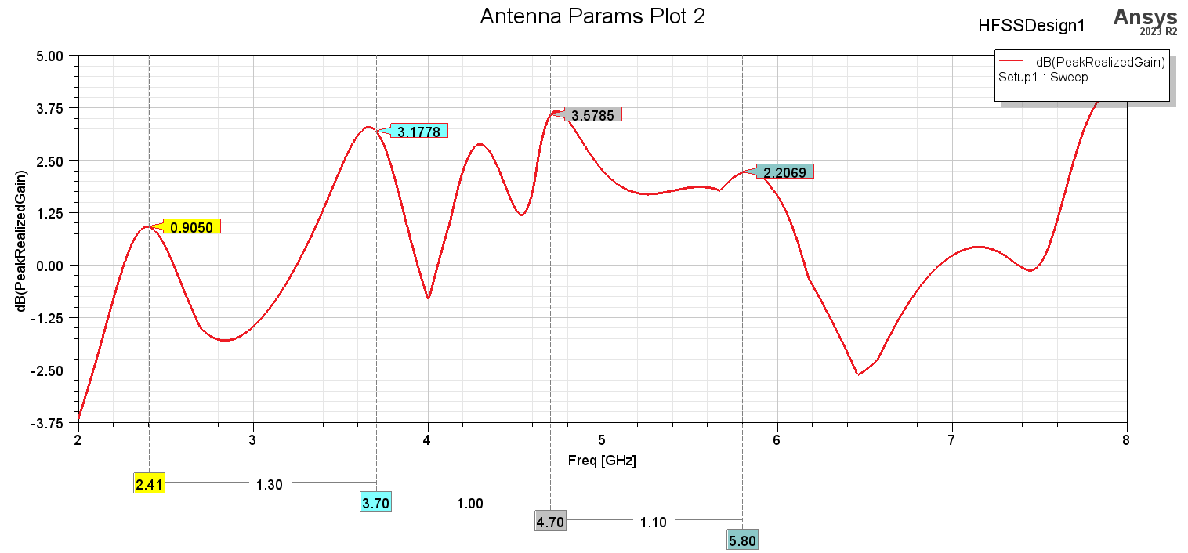

**Radiation efficiency.** This measures the amount of losses due the antenna conduction and dielectric losses. The figure below shows the efficiency for all frequencies.

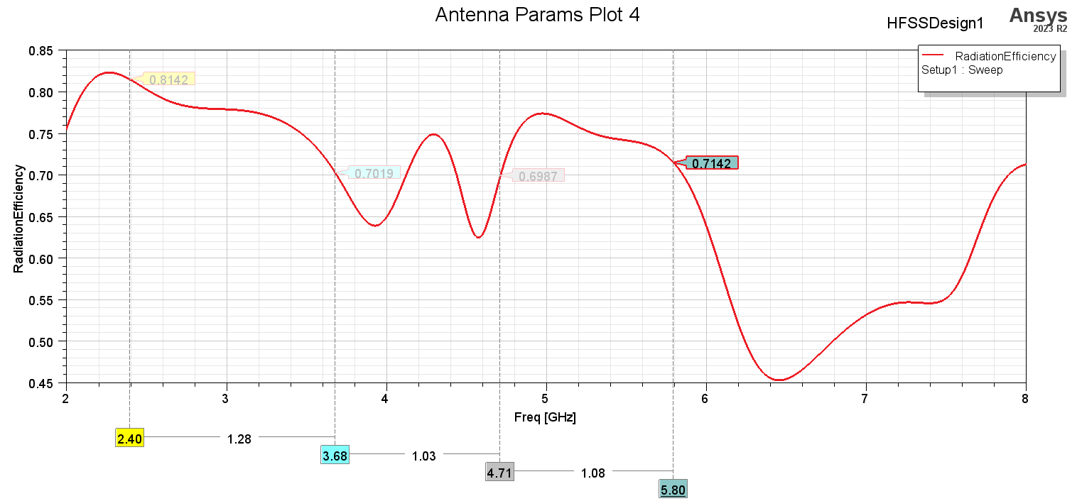

Figure ‎4.156

|  |  |  |  |  |
| --- | --- | --- | --- | --- |
| Frequency (GHz) | Working bandwidth (GHZ) | Gain (dB) | Radiation Efficiency% | Axial ration (dB) |
| 2.4 | 190MHz, | 0.9 | 80 | 87.61  Linear |
| 3.68 | 210MHz | 3 | 70 | 37.93  Linear |
| 4.71 | 220MHz | 3.5 | 70 | 4.7  Elliptical |
| 5.8 | 470MHz | 2.2 | 71 |  |

Table 4‑5. Performance of PIFA summary.

**Reproduce**

**CONCLUSION:**

We were able to achieve multiband-wideband in the first design at resonant frequencies 3.34GHz, 4.04GHz and 6.14GHz at these frequencies there are many applications such as.

3.34 GHz Applications

* 5G Networks
* WiMAX
* Fixed Wireless Access

4.04GHz Applications

* Satellite Communications
* Radar Systems
* Microwave Communication

6.14GHz Applications

* Advanced Satellite Communications
* Radar and Sensing
* Wireless Backhaul

In the second design we were able to achieve multiband at resonant frequencies 2.41GHz, 3.7GHz, 4.7GHz, and 5.8GHz and there are many applications such as.

2.41 GHz Applications

* Wi-Fi (IEEE 802.11b/g/n)
* Bluetooth
* Zigbee

3.7 GHz Applications

* C-Band Satellite Communications
* Citizens Broadband Radio Service (CBRS)
* 5G Networks

4.7 GHz Applications

* Military and Defense Communications
* Fixed Wireless Access
* Advanced Radar Systems

5.8 GHz Applications

* Wi-Fi (IEEE 802.11a/n/ac/ax)
* Unlicensed National Information Infrastructure (U-NII)
* Industrial, Scientific, and Medical (ISM)

# Measurement and equipment

When evaluating antennas, several key parameters such as radiation pattern, reflection loss, gain, and others are measured to understand their performance. The equipment and measurement procedures for these parameters are essential to ensure accurate and reliable results. Here’s an overview of the necessary equipment and procedures:

Equipment Required includes the antenna under test (AUT), vector network analyzer (VNA) for measuring reflection loss (S11) and impedance, antenna test range which includes anechoic chambers or open area test sites (OATS) for measuring radiation patterns and gain, a reference antenna which is a well-characterized antenna used as a comparison standard, positioning system to rotate the AUT in different orientations for radiation pattern measurements, signal generator to provide a stable signal for the AUT, spectrum analyzer for measuring the signal characteristics received by the reference antenna, power meter to measure the output power from the AUT, cables and connectors to ensure minimal loss and interference, and software for data acquisition and analysis to process and visualize the measurement data.

For reflection loss (S11) and impedance measurement, you connect the AUT to the VNA using a suitable coaxial cable, perform a full two-port calibration (Short-Open-Load-Thru, SOLT) to account for system errors, measure the S11 parameter across the desired frequency range, and analyze the S11 data to determine the reflection coefficient, return loss, and impedance of the antenna. A lower S11 value indicates better matching and lower reflection loss.

For radiation pattern measurement, place the AUT and reference antenna in the test range (anechoic chamber or OATS), ensure the AUT is at a sufficient height and distance from the reference antenna to simulate free-space conditions, use the positioning system to rotate the AUT in azimuth and elevation angles, transmit a signal from the reference antenna and measure the received power at the AUT for each angle (or transmit from the AUT and measure at the reference antenna), record the received signal strength at various angles to plot the radiation pattern in 2D and 3D, and analyze the radiation pattern to determine the beamwidth, main lobe direction, side lobe levels, and overall shape of the radiation pattern.

For gain measurement, use a setup similar to the radiation pattern measurement setup, with the AUT and a reference antenna placed in the test range, use the substitution method by measuring the received power with a known reference antenna first, then replacing the reference antenna with the AUT and measuring the received power again, use the Friis transmission equation to calculate the gain of the AUT relative to the reference antenna, and convert the measured gain into dBi (decibels relative to an isotropic radiator) and compare it against the expected values for validation.

For bandwidth measurement, use the VNA to measure the S11 parameter, sweep the frequency range of interest and record the S11 values, and determine the bandwidth by identifying the frequency range where the S11 value is below a specified threshold (e.g., -10 dB). The bandwidth is the range over which the antenna maintains good impedance matching.

Additional considerations include ensuring stable temperature and humidity conditions to avoid measurement variability, minimizing interference from external sources by using an anechoic chamber or conducting measurements in a controlled environment, repeating measurements to ensure consistency and reliability of the data, and thoroughly documenting the measurement setup, procedures, and results for traceability and further analysis.

In summary, accurate antenna measurements require specialized equipment and careful procedures. By following standardized practices and using high-quality equipment, one can obtain reliable data on antenna performance parameters such as radiation pattern, reflection loss, gain, and bandwidth.

# References

[1] Mohamad Kamal A. Rahim, Murtala Aminu-Baba, et al., "Printed Monopole Antenna Loaded with Circular Split Ring Resonators (CSRRs) for Multi-band Operations," presented at the 2022 IEEE International RF and Microwave Conference (RFM), Dec. 2022, doi: 10.1109/RFM56185.2022.10065223.

|  |  |
| --- | --- |
| [2] | J. Pendry, A. Holden, D. Robbins and W. Stewart , "Magnetism from conductors and enhanced nonlinear phenomena,"vol. 47, no. 1, pp. 2075-2084, 1999. |

[3] J.S. Kulkarni, “ Low-Profile, Multiband &        Wideband ‘C-Shaped’ Monopole Antenna for 5G and WLAN Applications,” 2020 International Conference on Radar, Antenna, Microwave, Electronics, and Telecommunications (ICRAMET), Tangerang, Indonesia, 2020, pp. 366-371.

[4] CST-Computer Simulation Technology Studio Suite, 2017, “https://www.cst.com/2017”.

[5] Y. S. Faouri, S. Ahmad, N. O. Parchin, C. H. See, and R. Abd-Alhameed, "A Novel Meander Bowtie-Shaped Antenna with Multi-Resonant and Rejection Bands for Modern 5G Communications," Electronics, vol. 11, no. 5, p. 821, 2022. doi:(MDPI)​.

**APPENDIX**

**Ansys HFSS (High Frequency Structure Simulator)**

HFSS, or High-Frequency Structure Simulator, is a powerful electromagnetic simulation tool that is frequently used in the field of high-frequency and high-speed electronics. HFSS, developed by Ansys, uses the finite element method to precisely predict the behaviour of sophisticated electromagnetic structures, including integrated circuits, antennas, and RF/microwave components. Engineers and researchers can use it to analyse a wide range of electromagnetic phenomena, such as problems with signal integrity, impedance matching, radiation patterns, and scattering characteristics. With a simple user interface and powerful simulation capabilities, HFSS became known as an important tool for electromagnetic system design and optimisation in a variety of industries, such as automotive, aerospace, and telecommunications.